Dashboard Requirements:

-Based on MeterorJS and React Template (<https://gogo-react.coloredstrategies.com/app/dashboards/default>)

-Full React Native Support ready for Cordova Integration for Mobile Use

-Full login system with admin ability to Add/Edit/Delete users and user permissions

-Ability to restrict content based on User Company Type and role permissions

-Forms for Enrolling New Assets and Sites into the system.

-Forms for Onboarding New Users, as well as setting company permissions for viewing data.

-Notification System to inform users of new uploads, site creation, and relevant events on the dashboard. User should also be able to tag a relevant site record with hashtags and be searchable by that tag.

-Twilio integration to allow users to receive telephone calls via their profile and notifications via text message, if desired.

-Chat Portal per Site allowing our users and field personnel to chat in real time. Needs to support uploading of photos/video/other files and store them within our MS Azure Blob Environment.

-File Upload/Data Repository allowing users to select sites they have permission to and upload relevant file content. Files should be organized by type and displayed with the associated site ID record when selected for display. Storage shall be on MS Azure Blob and is noted below.

-Bulk Site Upload and Column Mapping, allowing for our customers to send us lists of sites and upon upload map the columns in their file to the columns relevant to our system.

-Display current working status of sites, as well as prior notifications and information from Accuweather API on current conditions, forecast conditions, weather alerts etc.

-Display information from Waze API on surrounding area traffic conditions and any alerts in the area of the site.

-Display information from estated API in tab located inside of site record container. Save all information to local database.

-Integrate MapBox API to display maps and information related to our data set.

-Integrate Carto.com API

-Side Menu Displaying Modules that have been enabled for the company account.

-Calendar View showing records of sites being added, modified, etc. Can also add new site to calendar to schedule visit and assign to employee.

-Email functionality to inform users of new file uploads, new site creations for their company account, etc.

Dashboard Description Master Plan

V1.0

**Introduction**

The purpose of this software package is to create a user portal for our customers to interact with different data points. Our business is telecommunications towers, and our customers are people who rent space on these towers to provide their customers (probably you) services. Our task is simple; send our team members to these locations, record data points in various ways, and process those data points into files that are usable by members of the process further. Our application is the front line to this activity, and is expected to house data points from these locations for many years to come. It is the hub, and being the hub it needs to be designed as a highly available, low latency, easy to use application. We should be able to provide assistance to our users at any time, either by clicking a button for a chat window or viewing the users view of our site in real time (user session mirror).

**Dashboard Ideology**

Our intention is to create a dashboard that allows our internal and external users to add widgets for different business line activities throughout the lifecycle of our projects. As such, users should be able to essentially add any site and/or reports (live or export etc) to their dashboard in the form of a smaller “holder” bubble that may be clicked and taken to a larger informational window containing details the holder bubble/container would not show. We would like to also have a widget that allows a user to add a mapbox plugin, and display certain sites on the map (need to be able to add from the SITEID/Site name in SITEID record) and their quick display of current status (green, yellow, red) based on any outstanding due dates on the associated with the Status Queue codes and information found below. We want to maximize our users ability to understand our business information without having to make a lot of effort. This is the reason we are choosing MeteorJS and React as our platform, as explained below.

**Platform and Database**

For our platform, we will be utilizing the MeteorJS toolset because of its ease of use and high rate of development speed. We will be using the associated Mongodb which MeteorJS requires, but we would like to use React instead of Blaze in addition to using Flutter. This decision comes from our desire to use Cordova to create a mobile app from our MeteorJS application in the future. The Mongodb will be hosted on Microsoft Azure, and backed up on a nightly basis. This will be automated by our DevOps staff but documentation should be available if needed.

**Priorities**

Jobs and Modules by order of priority:

1. Create MeteorJS project and get initial dashboard template functional.
2. Create Site Definitions and ability to interact with Estated API to obtain information about site to further use in process. This means successfully query the API with the information entered into our New Site Tool, and create a new site record with the associated data AND create the necessary folders/storage on Azure Blob for the Site Record.
3. Create new site, onboard all information and test API functionality.
4. Implement User Profile Features and test all file upload/social/azure blob functionality.
5. Upload new Files/Media to site folder/blob and test File tree functionality.
6. Implement Mapbox and ThreeJS/Mapbox functionality, add Waze Traffic API and other relevant mapbox jazz as appropriate. We have Mapbox working with threejs, we need to implement this code into the left top box located in the pre formatted template for the GoGo React Template located in Home>Pages>Product>Details portion of the template example. You will see pictures of food, this needs to be a Mapbox plugin, with the site showing inside of the map.
7. Implement Notifications and Rule Creator for If This than That capabilities and Messaging/Site Comments, test functionality. Add notifications into the upper bell for each user for sites they have added to their Notifications list.
8. Implement Job Status Queue, showing status of all sites that are actively being worked as well as changing status codes and associated actions via Microservices. Demonstrate Pipeline of forms being saved into Mongodb SITEID record.
9. Report Designer Functionality and testing, as well as email template testing/acceptance.
10. Implement Alarms and Reminder Functionality, as well as calendar view of jobs/due dates.

**User Accounts and Permissions**

We would like to be able to support a B2B and B2C authentication schema, whereby our application and the associated media uploaded into our system will be accessible by permissions that are found in a Microsoft Active Directory Environment. We would like to be able to onboard our customers by entering information into our system, and selecting whether to include them into our own authentication system or use Active Directory to authenticate via the customers own AD environment. Each customer will have employees and contractors, with a varying degree on permissions. Each user account should have the ability to have a group they belong to, as well as a region they are able to work in. All users should be limited to the group and region they are able to work in.

We are planning for the initial user groups to be:

|  |  |  |
| --- | --- | --- |
| Name | Role | Privileges |
| Isla Internal | Super Admin | All |
| Customer Internal | Admin | All for Customer Account |
| Regional RF Engineering | RF Engineering | All for RF Engineering Tasks |
| Vendor Site Acquisition | Vendor Site Acquisition | All for VSA Tasks |
| Regional Real Estate Specialist | Real Estate | All for Real Estate Tasks |
| Regional Regulatory Analyst | Regulatory | All for Regulatory Tasks |
| Regional Transport Engineer | Transport | All for Transport Tasks |
| HQ Regulatory Licensing | Regulatory | All for Regulatory Tasks |
| Vendor A&E | Vendor A&E | All for Vendor A&E Tasks |
| HQ Regulatory Structure Compliance | Regulatory | All for Regulatory Tasks |
| Regional Construction Engineering | Construction | All for Construction Tasks |
| Regional Equipment Engineering | Logistics | All for Logistics Tasks |
| Vendor Construction Manager | Construction | All for Construction Tasks |
| Regional Construction Manager | Construction | All for Construction Tasks |
| Regional Performance Engineer | Construction | All for Construction Tasks |

**User Profile**

User Profile should be very social media like, using the preformatted template page found in Gogo React Template Home>Pages>Profile>Social. Each user should be able to add status updates, upload photos and videos to their profile (utilizing their profile Azure Blob Storage). There should also be the default above Links in the profile (Profile, Images, Friends) and should work very much like any other social media network.

Under the Profile edit, the user should be able to edit the following information on their public profile:

* Full Name
* Photo (add that into the Azure Blob for their profile-name it profile.jpg or profile.png)
* Banner Photo (add that into the Azure Blob for their profile, fit into the box without making it look weird or add some options like twitter does)
* About Me(place where it says the filler content about the person being a web developer)
* Location
* Responsibilities (with the roles found above in the same format found in the template example)
* Contact Social Media Links (Facebook, Twitter, LinkedIn)
* Contact Email
* Contact Phone Number (must be direct dial, preferably a cell phone)
* Can call or cannot call (check box or something, can prevent Twilio calling for user)

Under this, show a box that displays all of the sites the user has enabled for notifications.

Super Admin should be able to see additional information under the users profile, such as their parent account and in the future permissions/sites they are able to see.

We want to show all the information above, including under contact adding an icon-telephone that will open a small box asking for the users telephone number. They will enter the number and be connected via Twilio to the users telephone number without knowing it).

**TO DO: ADD FAQ FROM TEMPLATE**

**TO DO: ADD KNOWLEDGE BASE FROM TEMPLATE**

**File and Media Storage/Upload Tool**

[**https://medium.com/@stuarttottle/upload-to-azure-blob-storage-with-react-34f37805fdfc**](https://medium.com/@stuarttottle/upload-to-azure-blob-storage-with-react-34f37805fdfc)

**Very Similar to the above link, but the ability to tag files (can be hashtag or select media type, but needs to be some way to store all of them, and make them available for viewing and retrieval via download or email)**

Our platform needs the ability to easily upload various file content by multiple users throughout the evolution of our project. We would like our data storage platform to be Azure Blobs. When a user would like to upload content, they will go to the Upload Tool on the Menu and first be given a search box with a region. The user will select the region (NE,NW,SE,SW,S,N,ISLAND) which will be then followed by a site ID. This ID may be found from various fields in our data, such as: CUSTOMER_SITE_ID,TOWER_SITE_ID,ASR_SITE_ID,ISLA_SITE_ID. After the site has been selected, populate information to the user to ensure the site matches the site they would like to upload for and have permission to do so. Then we would like the user to be able to select files from their computer, or also drag them into the browser window and attach them for upload into the Azure blob storage. We would like the blob storage to be organized by REGION>SITE_ID>MEDIA_TYPE where MEDIA_TYPE can be: Laser Scan (.las, .e57, .pts, .xyz), Excel (.xls, .xlsx, .xlxb), Word (.txt, .doc, .docx, .odf), PDF (.pdf), Tower (.txn), AutoCAD (.dwg, .dxf), Photos (.jpg, .png), Video (.mp4, .avi, .mov),MeshGun (.mkv, .mjpeg), 3D Assets (.obj, .fbx, .ply, .gltf, .3ds, .maya, .usd).

**Laser Scan  
Excel  
Word  
PDF  
Tower  
AutoCAD  
Photos  
Video  
MeshGun  
3D Assets**

Once the files have been attached, we would like to show the file size as well as automatically categorize them by the associated file types and then uploaded to their respective folders inside of the REGION>SITE_ID>MEDIA_TYPE. For example, if a user uploaded a .las file the system for a Region NE site 12345 would automatically recognize it as a laser scan file, and deposit that file into NE>12345>LaserScan and save it as DATEOFUPLOAD-UPLOADERUSERID-originalfilename.las. After the files have been successfully saved, we would like an email to go out and notifications to be sent via our platform informing users of a new upload and who uploaded/when etc.

**Main Menu**

The main menu will use the Gogo React template format by using both the first Main menu and then displaying a secondary menu (including icons with text below on the main menu) with nested tree hierarchy as outlined below:

Main Menu-Dashboard (use icon simple-icon-home)>Users Custom Dashboard View(SPA Dashboard Home for user, no secondary menu)

Main Menu-Site Viewer (use icon iconsminds-space-needle)>Secondary Menus-(Top Level) NORTHEAST,NORTHWEST,SOUTHEAST,SOUTHWEST,SOUTH,NORTH,ISLAND and then list each site that is associated with the region listed below. For example, to find in site view REGION NE SITEID 12345 in the list, a user would click Site View and a secondary menu appears. There are 7 grey collapsed options, each of them being a region. When each region is clicked, it will show a listing of all the sites from that region. A user can then click on that site ID from the list and be taken to the Site Viewer Tool, where information from our database is populated into a pre formatted template based on Pages>Product>Details in the Gogo react template.

Main Menu- File Manager (use icon simple-icon-cloud-upload)>Secondary Menu

Main Menu-Notifications (use icon simple-icon-feed)>Take user to notifications page and display notifications according to the below notifications page definition below.

Main Menu-Reporting(use icon simple-icon-printer)>Go to Report Generator Page for now **TODO:Make this more in depth

**New Site Tool**

We would like to have a Menu Item that takes us to a wizard to add a new site. The following site information will need to be collected first (use the Gogo React Template Form Wizard basic): Step One:Site Name, Site Antenna Structure Registration (if any), Step Two:Site Address, Site City, Site State, Site Zip, Site Region. If the site is not found in the estated API, ask user for Latitude and Longitude information and see if the estated api returns any information for the location. If it fails, tell the user cannot find property/location and end the process. Otherwise, we would like to pull the Geocoded address and display a number of data points from our partner API’s about the property.

**Each new site record created should have a new ISLA_SITE_ID associated with it at the time of creation.**

First, we would like to query the Estated API and save the following information to our new site record we are creating:

**The following Metadata will be pulled from the Estated API and inserted into the SITEID record being created as a new site:** property_id(int), UPI(string), published_at(datetime), updated_at(date_time),

**The following address data will be pulled from the Estated API and inserted into the SITEID record as well:** Street_number(string), street_pre_direction(string), street_suffix(string), street_post_direction(string), formatted_street_address(string), city(string), state(string), zip_code(string), zip_code_plus_four(string)

**The following geocoding data will be pulled from the Estated API and inserted into the SITEID record:** street(object), parcel_centroid(object), rooftop(object).

**The following Geocoding information will be pulled from the Estated API and inserted into the SITEID record:** latitude(decimal), longitude(decimal).

**The following parcel information will be pulled from the Estated API and stored in the SITEID record:** depth(integer), width(integer), size(integer), acres(decimal), range(string), township(string), section(string), block(string), lot (string), location_description(string), building_count(integer), boundaries(object).

**The following parcel.boundaries information will be pulled from the Estated API and stored in the SITEID record:** srid(integer), wkt(string), geojson(object).

**The following parcel.boundaries.geojson information will be pulled from the Estated API and stored in the SITEID record:** type(string), coordinates(decimal)

**The following land_use information will be pulled from the Estated API and stored in the SITEID record:** classification_code(string), category(string), subcategory(string), source_code(string), zoning(string).

**The following structures array will be pulled from the Estated API and saved (may be multiple structures returned, save them all and stored in the SITEID record:** is_primary(Boolean), year_built(integer), effective_year_built(integer), identifier(string), rooms_count(integer), beds_count(integer), half_baths_count(integer), full_baths_count(integer), quarter_baths_count(integer), three_quarter_baths_count(integer), stories_count(decimal), units_count(integer), total_size(integer), finished_size(integer), unfinished_size(integer), basement_size(integer), garage_size(integer), height(integer), architecture_type(string), exterior_wall_type(string), air_conditioning_type(string), basement_type(string), building_type(string), category(string), condition(string), construction_type(string), fireplace_count(integer), foundation_type(string), flooring_type(string), garage_type(string), heating_type(string), mobile_home(Boolean), parking_spaces(integer), parking_type(string), pool_type(string), quality(string), roof_type(string), roof_style_type(string), electricity_type(string), fuel_type(string), sewer_type(string), water_type(string).

**The following owners array will be pulled from the Estated API and saved. Will be multiple records of all current and previous owners on file, Save all to SITEID record**: corporate_flag(Boolean), name(string), second_name(string), address(string), city(string), state(string), zip_code(string), first_name(string), middle_name(string), last_name(string), suffix(string), ended_at(date), started_at(date).

**The following assessments array will show all tax assessments on file for the site, may be multiple save all to SITEID record:** land(integer), improvement(integer), total(int), exemptions(array), tax_amount(int), tax_year(int), details(array), outstanding_tax(decimal), appraised_land(int), appraised_improvement(int), appraised_total(int).

**The following sales array will show all sales records on file for the property, may be multiple so save all to SITEID record:** date(date), recording_date(date), price(int), type(string), seller(string), buyer(string), transaction_id(string), document_year(int), sale_code(string), multi_apn(Boolean), hpi_adjusted_price_2010(int), deed_book(string), deed_page(string), document_id(int).

**The following mortgages array will return all mortgage records on file. There may be multiple so save all to SITEID record:** amount(int), loan_type(string), deed_type(string), date(date), term(int), due_date(date), lender_name(string), details(array).

**The following legal details of the property will be returned for the property and need to be saved to SITEID record:** apn_original(string), apn_unformatted(string), tax_account(string), legal_description(string), planned_urban_development(string).

**The following valuation will be returned for the property and will be saved for the SITEID record:** value(int), low(int), high(int), confidence(decimal), market_value_change_year(decimal), market_value_change_quarter(decimal), forecast_1_year(decimal), suggested_rental(int).

**The following postal information will be returned for the property. Save all for the SITEID record:** carrier_code(string), delivery_point_code(int), delivery_point_check_digit(int), validated(Boolean), deliverable(string).

**The following geographies information will be returned and need to be saved into the SITEID record:** congressional(string), neighborhood(string).

**The following geographies.county information will be returned and need to be saved into the SITEID record:** name(string), state_fips_code(string), fips_code(string).

**The following geographies.census information will be returned and need to be saved into the SITEID record:** census_tract(int), census_block(string).

**The following geographies.cbsa will be returned for the Core based statistical area information on the property and needs to be saved into the SITEID record:** name(string), code(string), type(string).

**The following geographies.school_elementary will be returned for the properties district and may be multiple so save all to SITEID record:** geoid(string), name(string), low_grade(string), high_grade(string), type(string).

**The following geographies.school_secondary will be returned for the properties district and may be multiple so save all to SITEID record:** geoid(string), name(string), low_grade(string), high_grade(string), type(string).

**The following geogaphies.state_legislative_upper will be returned for the property about the State Legislative Upper House and saved to SITEID record:** name(string).

**The following geographies.state_legislative_lower will be returned for the property about the State Legislative Lower House and saved to SITEID record:** name(string).

**The following geographies.police will return information on Police about the property, save all to SITEID record:** name(string), type(string), city(string), state_fips(string), county_fips(string).

**The following geographies.fire will return information on Fire Department for area, save all to SITEID record:** fdid(string), name(string), address(string), address_2(string), city(string), zip_code(string), phone(string), mailing_address(string), department_type(string), organization_Type(string), website(string), stations_count(int), career_firefighters_count(int), volunteer_firefighters_count(int), paid_per_call_firefighters_count(int), non_firefighting_staff_count(int), interpolated_latitude(decimal), interpolated_longitude(decimal, county(string), state(string).

**The following geographies.flood information will be returned and needs to be saved in the SITEID record:** fima_floode_zone(string), annual_flood_risk(string), firm_panel_id(string).

**Site Viewer Tool**

We would like to be able to view our sites from our database inside of a tree on the Main Menu. The tree should be located under a Site Viewer option on a left menu, and should further show all of the different regions to choose from (NE,NW,SE,SW,S,N,ISLAND). These regions should be spelled out; North East, North West, South East, South West, South, North, Island and should have nested below a list of states for the region as assigned in the site. After the State has been clicked, further selectable is the city of the site as assigned. After the city has been selected, now we see SITEID-Name and are able to select that site to take us to the record we are needing to see.

The Site Viewer should show site information in the format of GogoReact Template Home>Pages>Product>Details

On the left side of the container (where you see food), a **mapbox plugin** should be displayed with the following checkboxes that can enable different layers: Map View (showing a map of the site), Boundary View, and 3D view (enabling the display of our threejs gltf for the site, which will be located in REGION>SITEID>3DASSETS>main.gltf. This GLTF file will be a summation of all assets produced in relation to the site. The quality of the GLTF is to be determined). This mapbox container should also display local traffic as well as any weather data available. Boundary View will use the boundary information as recorded in parcel.boundaries in the geojson object.

**The following site information should be pulled from the database and displayed in the General Tab(Replace the Details Tab in the example with General):** Site ID, Owner_Name, Formatted_Street_Address, City, State, Zip_Code_plus_four at the top of the site record in bold large letters to signify a Title.

**Additionally the following information should be showed on the Top Right Box replacing the lorem ipsum and remove the likes/comments icons**: Current Weather from AccuWeather API, Forecast Weather from Accuweather API, Current Traffic from Waze API or Google Traffic API. Leave tags and add a small text entry that will autopopulate popular tags used in other sites or add a new tag in the form of a #hashtag. This should be with the site, and should be logged in the site history with date and user who created the tag.

**Add Property tab next to General and the following should be shown:** Depth (ft), Width (ft), Size, Acres, Range, Township, Section, Block, Lot, Location Description, Building Count, and Boundaries (need to figure out how to show this object but will be inside of threejs/mapbox).

**Under the same Property tab the following information should be shown further:** Classification Code, Category, Sub Category, Source Code, Zoning Code.

**Add Structure tab to the right of the Property tab, the following information should be shown (found in the estated structures api array):** Year Built, Year Updated (linked to effective_year_built), Identifier, Rooms Count, Beds Count, Baths Count, Half Baths Count, Full Baths Count, Quarter Baths Count, Three Quarter Baths Count, Stories Count, Units Count, Total Size, Finished Size, Unfinished Size, Basement Size, Garage Size, Height, Architecture Type, Exterior Wall Type, Air Condition Type, Basement Type, Building Type, Category, Condition, Construction Type, Fireplace Count, Fireplace Type, Foundation Type, Flooring Type, Garage Type, Heating Type, Mobile Home (can be X or check mark based on False or True return), Parking Spaces, Pool Type, Quality, Roof Type, Roof Style Type, Electricity Type, Fuel Type, Sewer Type, Water Type.

**Under the Owner tab display all array information with each record having its own small bubble of data shown. Stack the containers from newest first, to oldest last. The information should be in the form of:** Corporate Flag(Boolean true or false, display X if false green check if TRUE), Name, Second Name, Address, City, State, Zip Code, First Name, Middle Name, Last Name, Suffix, Ended At, Started At.

**ALL MENTIONS OF A “BUBBLE” should be in the preformat of “Data List” in GogoReact Template and are found under HOME>PAGES>PRODUCT>DATA LIST.**

**Under the Tax tab display all array information in the same above format with each record in the array having its own bubble generated showing information for**: Land (currency USD), Improvement (currency USD), Total (currency USD), Exemptions, Tax Year (bold and on upper left of the container to stand out), Tax amount (currency USD), Details, Outstanding Tax (currency USD), Appraised Land Value (currency usd), Appraised Improvement Value (currency USD), Appraised Total (currency USD).

**Under the Sales Tab display all array information in the same above format with each record in the array having its own bubble generated for showing information in the sales array from the Estated API. Each bubble should be the same size showing Date, Price, Type as the basic information and when clicked show the rest of the information in a auto sized bubble**: Date, Recording Date, Price, Type, Seller, Buyer, Transaction ID, Document Year, Sale Code, Multi APN (true or false, can be red X or green check), HPI Adjusted Price 2010, Deed Book, Deed Page, Document ID.

**Under the Mortgages Tab display all array information in the same above format with each record in the array having its own bubble generated showing information:** Amount, Loan Type, Deed Type, Date, Term, Due Date, Lender Name, Details.

**Under the Legal Tab display all legal information from the estated API:** APN Original, APN Unformatted, Tax Account Number, Legal Description, Planned Urban Development.

**Under the Other Tab display all other information grouped together in boxes or well organized/sectioned:** (Geographies.county)Name, State FIPS Code, FIPS Code / (Geographies.census)Census Tract, Census Block / (Geographies.cbsa)Name, Code, Type/ (geographies.police)Name, Type, City, State FIPS, County FIPS/ (geographies.fire)Fire Department ID (linked to fdid), Name, Address, Address Second, City, Zip Code, Mailing Address, Department Type, Organization Type, Website (with clickable link), Stations Count, Career Firefighters Count, Volunteer Firefighters Count, Non Firefighting Staff, County, State/ (geographies.flood)Fima Flood Zone, Annual Flood Risk, Firm Panel ID.

**AT THE END OF THIS WE SHOULD HAVE THE FOLLOWING TABS LOCATED IN A SINGLE BOX:**

1. **General**
2. **Property**
3. **Structure**
4. **Owner**
5. **Tax**
6. **Sales**
7. **Mortgages**
8. **Legal**
9. **Other**

**Replace Similar Projects Container to show a listing of all the files uploaded associated with the site, in a collapsible tree format. Each File shown in the list should have a small simple-icon-download that will allow the user (if they have permissions) to download the file from the blob directly to their devices. Next to that should be an email, which will pop up a box asking for an email address to send the file to. The file should then be sent via email to the desired destination address. We can add formatting later, but the email should look something like Subject: New File Available for you on Arcadia! Body: Hello! %USERNAMEOFSENDER% has sent you the following file: %FILENAME% %TYPEOFMEDIA%. Please click here%addinlinkfordownload directly from blob to receive your file!**

**TODO: ADD IN TEMPLATE FOR EMAIL**

**TODO: We may want to copy the file over to a public directory so the entire blob isn’t searchable outside authenticated users**

**Notifications**

This page needs to reflect all notifications our users which to see. The ability to enable notifications for a site should be located in the Site Details page, under the top right pink drop down menu. When this has been selected, the site will be added to an interesting sites view which will add the Site Mini Card (reference the Home>Pages>Product>Image List for formatting) to the users Main Dashboard View as well as add it into the Notifications queue and provide the ability to see in one screen (sortable based on Priority, Date, A-Z,) all notifications of events that have been sent into our system as a notification.

**File Viewer Tool**

On the left Menu, the file viewer tool should take the user to a single screen containing a mapbox map on the left and a sites display box on the right. The user should be able to add sites into the map, and click on the sites to view a list of files below the map and to the left of the sites field on the right. User should also be able to see when the file was added, who added it, and any comments they left.

Example Below.

**Twilio Integration**

Our site should have the ability to send notifications when file uploads complete or other relevant actions happen in order to keep users aware of developments without needing to be at a computer workstation. Each user should have a notifications queue, that will enable them to add sites into their notifications and receive email/text messages to their assigned user profile telephone number (mobile) of the uploaded file or development.

**Report Designer**

We need the ability for our staff and users to create custom reports. This “Report Maker Tool” will need to WSYWIG inside of the browser. The first element will be a section, a bubble that will auto scale to the size of information placed into it. The section element will require a Title and must be entered to continue. Within that bubble, a + needs to be present so the user can open a modal that displays a tabular listing of all the associated/organized data points we collect inside of a profile. This is any data that would be or could be on file inside of a SITEID record. This means Estated API data or Site comments, and would include site status reporting etc. We want our users to be able to produce reports that are visually appealing, and export into an industry standard PDF in an easy “export” method. We should also have the ability to email a PDF report to a given email address, or forward to another user on the system. Each report should have a unique ID assigned to it, which other users may enter into their report generator and see the same report template another user may have generated.

**Status Queue**

Our site needs to have the ability to assign status codes to sites based on our customers current point in the process. There are many different codes so we should have some type of search box to look up the code ID or the code name from our code database. We would like to have the ability to enter in codes as appropriate, so some type of “add code form wizard” will need to be written so we can easily insert new codes into our database. The “add code form wizard” should be in the form of “Code Number” followed by Description, Required Role (from list of Roles), and required before start code followed by a next code after completion. Each of the below forms will need to be made and saved some a form inside of our forms library.

* Candidate Analysis (Exhibit 1)

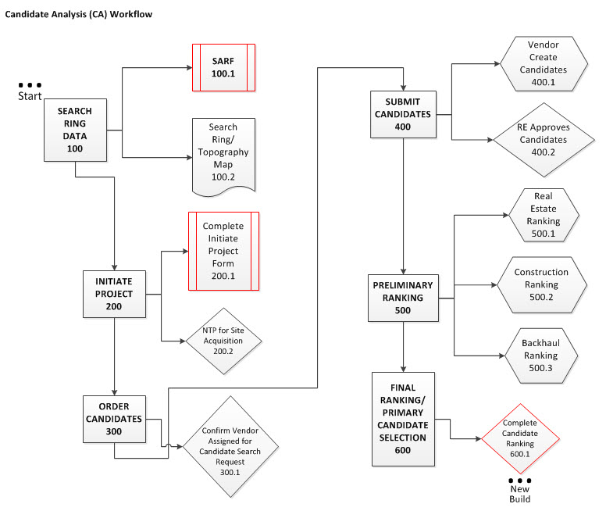

* + 100 – Search Ring Data - A Search Ring is a circle or other shape drawn on a map that indicates where a site could be located to meet the RF engineering requirements. The size of this search ring varies depending upon the topography (hilliness or flatness of the area), the demographics (where and what type of customer base) and other factors including whether the area is urban, suburban or rural in nature.
    - 100.1 SARF Form - Site Acquisition Request Form (SARF). Search ring creation occurs in Siterra. The RF Engineer will initiate a new project in Siterra by entering the GeoPlan market and latitude/longitude of the search ring. Upon completion of the form, Siterra will generate a search ring ID and record the associated market. As an active task, user may View Form, Enter/Edit Data, Mark N/A, Add Note, Subscribe, or Log.
      * Role: Regional RF Engineer

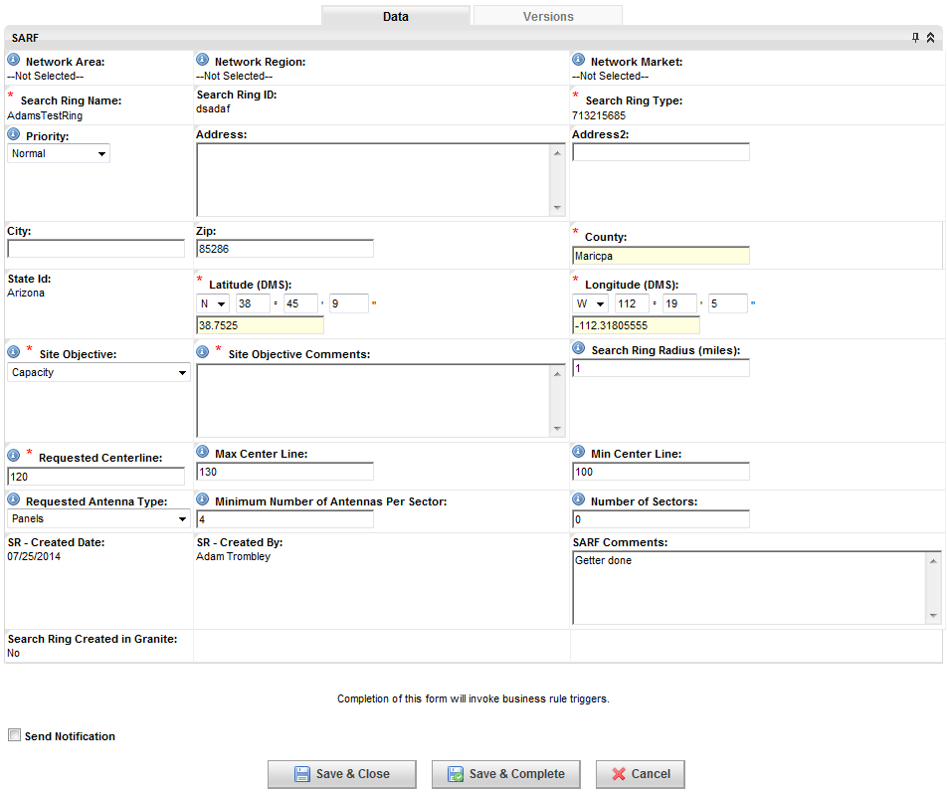

* + - 100.2 Search Ring Map - Search Ring Map is a document (map) with a circle or shape drawn on it to indicate where a site could be located to meet the RF engineering requirements. As an active task, user may Upload a document, Mark N/A, use Clipboard features, Add a Note or Subscribe.
      * Role: Regional RF Engineer
  + 200 – Initiate Project - Prepare and submit Initiate Project form, commence following Modification Change Order (3500).
    - 200.1 Complete Initiate Project form
      * Role: Regional Real Estate Specialist (RRES)

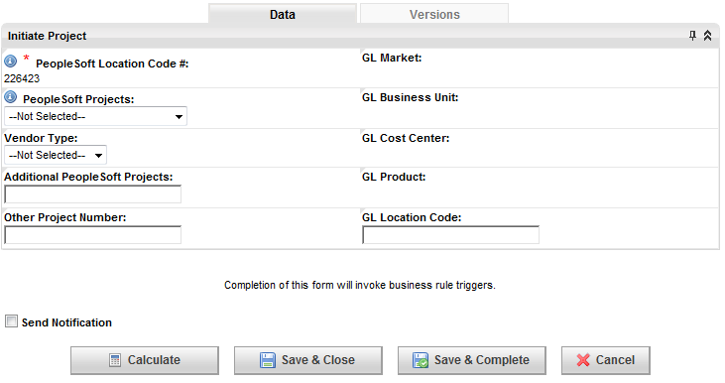

* + - 200.2 NTP for Site Acq
      * Role: Regional Project Manager(RPM)
  + 300 – Order Candidates - Overall task to select vendor to identify candidates.
    - 300.1 Notify Vendor of Candidate Search Request
      * Role: Regional Real Estate Analyst
      * Approval task to confirm vendor assigned for candidate search request.
  + 400 – Submit Candidates - Overall task to submit, review and approve candidate sites
    - 400.1 Vendor Create Candidates
      * Role: Vendor Site Acquisition
      * Vendors create candidate sites for further evaluation, approval and ranking.

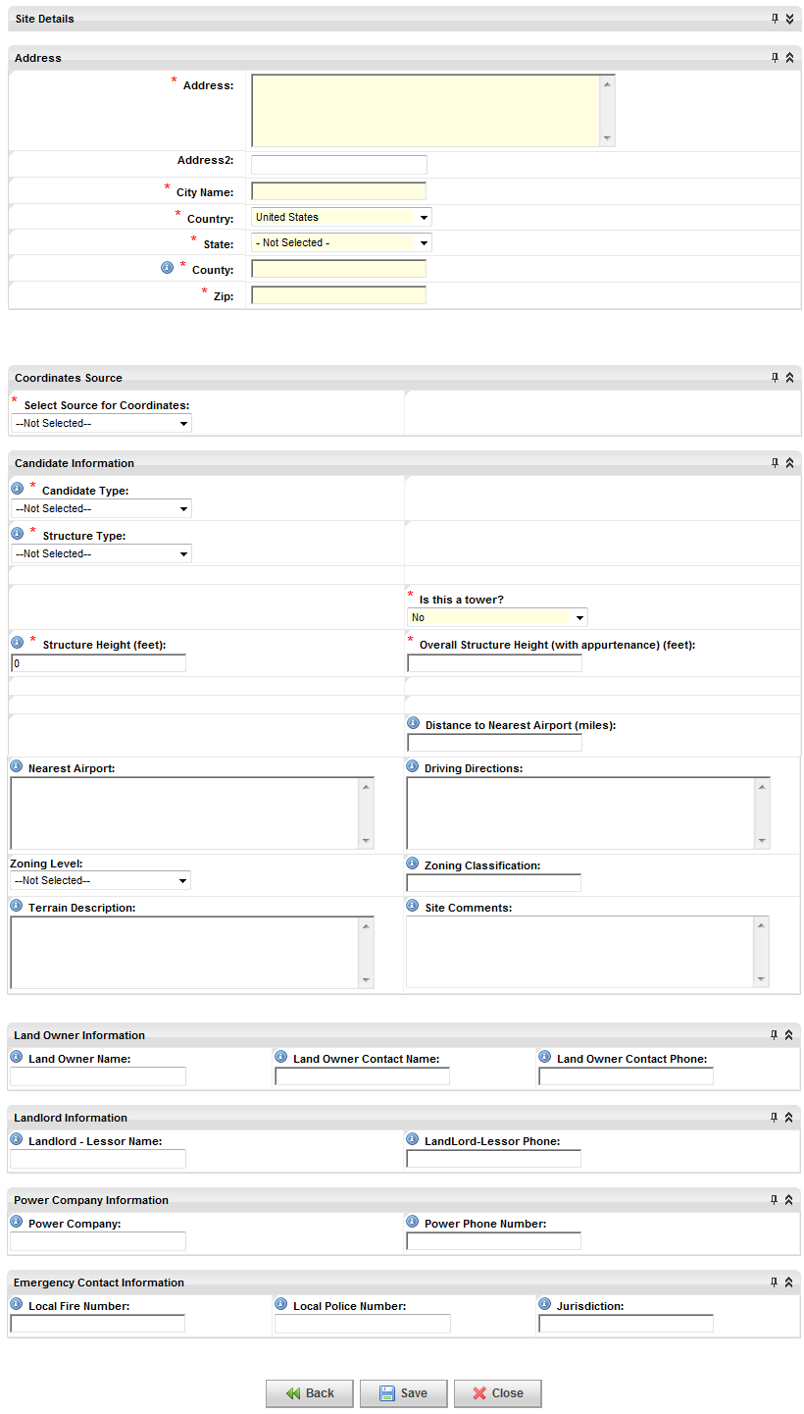

* + 500 – Preliminary Ranking
    - 500.1 Real Estate Ranking
      * Role: Regional Real Estate Analyst
      * RE managers provides a ranking of candidates.

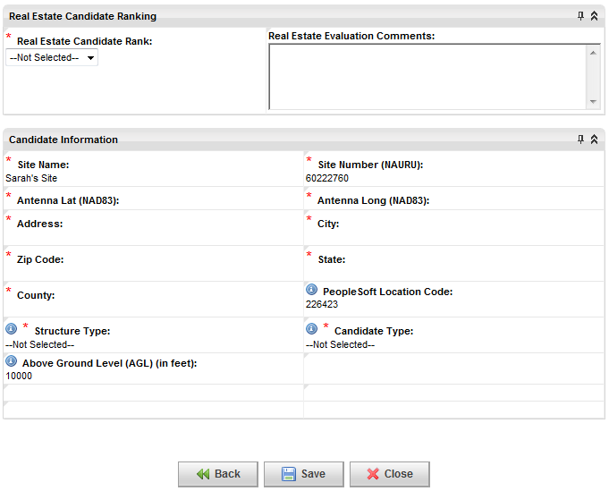

* + - 500.2 Construction Ranking
      * Role: Regional Construction Engineer
      * Construction manager provides a ranking of candidates.

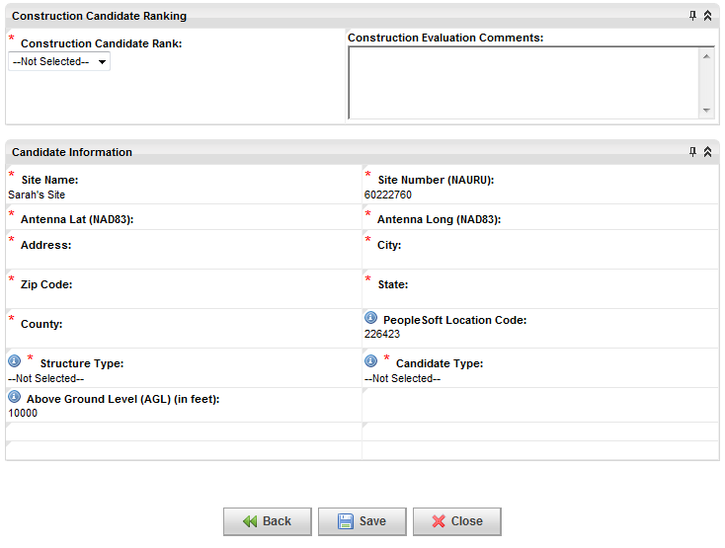

* + - 500.3 Backhaul Ranking
      * Role: Regional Transport Engineer
      * Backhaul Engineer provides a ranking of candidates.

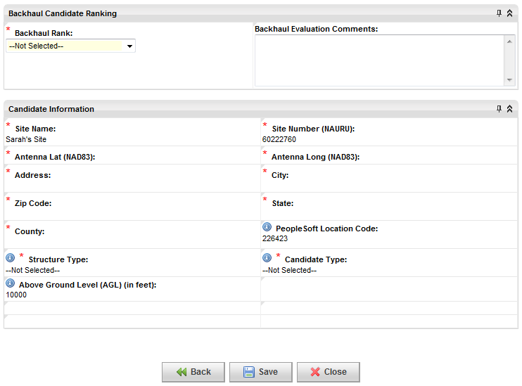

* + 600 – Final Ranking/Primary Candidate Selection - Overall final ranking is provided based on preliminary rankings.
    - 600.1 Complete Candidate Ranking
      * Role: Regional RF Engineer
      * Manager provides complete candidate ranking.

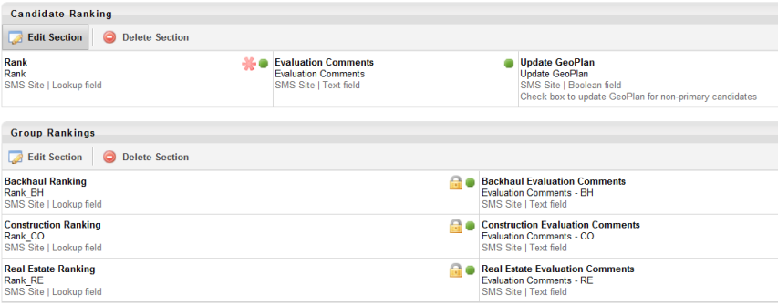

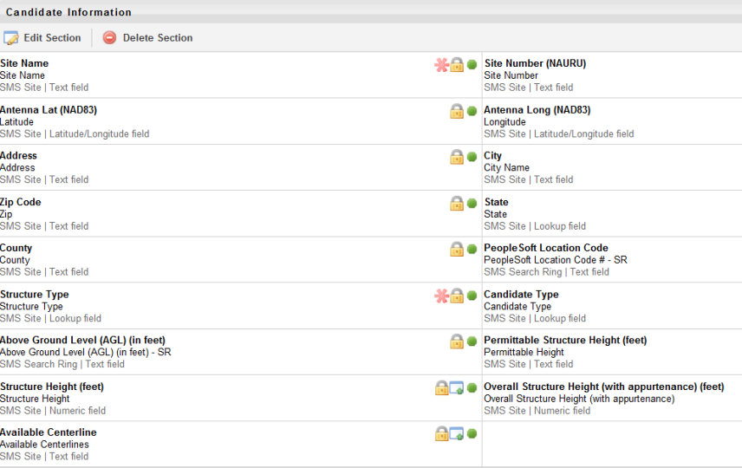

* New Build (Exhibit 2)

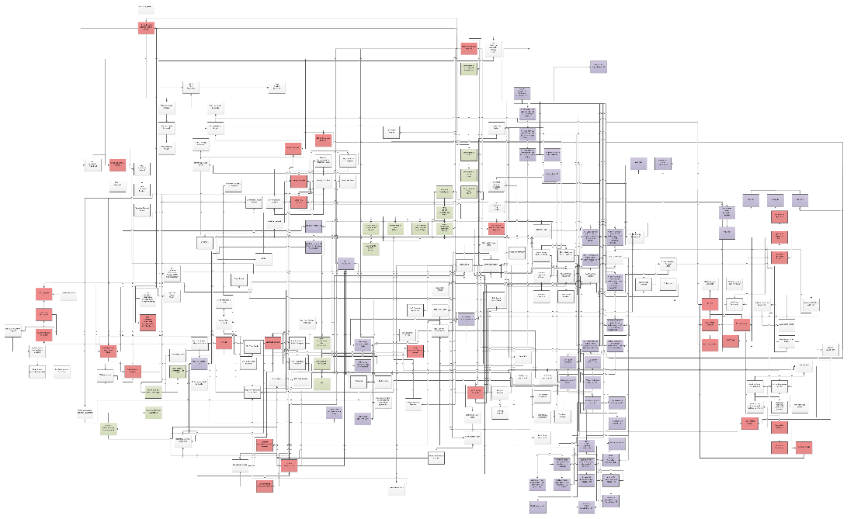

* + 100 – Primary Candidate Selected - Selection of the primary candidate site for new build.
  + 200 – RF Config and Design Forms -- Submission of the antenna design, preliminary radio frequency configuration form, and determination of backhaul candidate availability.
    - 200.1 Preliminary RF Config Design
      * Role: Regional RF Engineering

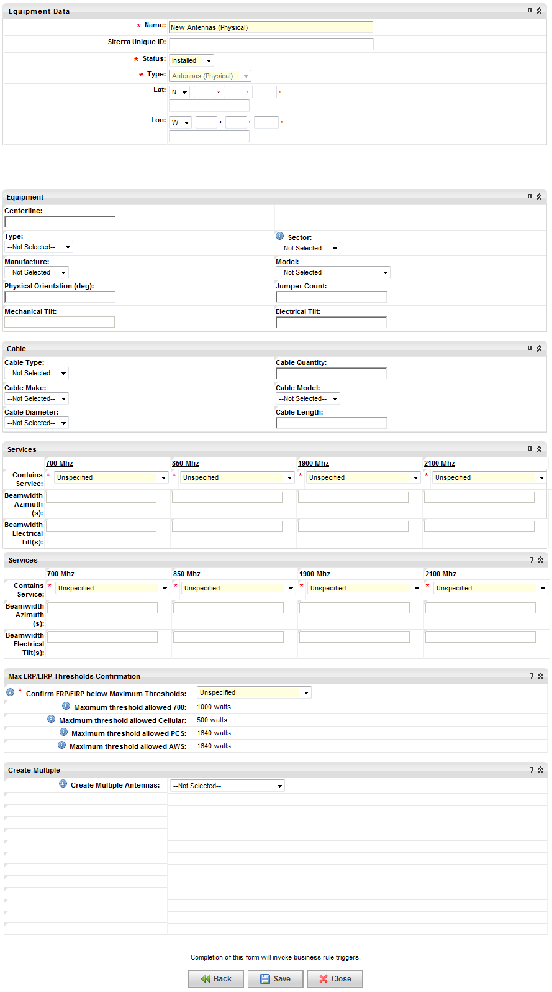

* + - 200.2 Submit Antenna Design/Plumbing Diagram
      * Role: Regional RF Engineering(RRFE)
  + 300 – Site Candidate Information Package (SCIP)
    - 300.1 SCIP
      * Role: Vendor Site Acquisition(VSA)
    - 300.2 Entry and Testing Agreement
      * Role: Vendor Site Acquisition(VSA)
    - 300.3 Order of Magnitude
      * Role: Vendor Site Acquisition(VSA)
    - 300.4 Site Sketch
      * Role: Vendor Site Acquisition(VSA)
    - 300.5 Current Deed
      * Role: Vendor Site Acquisition(VSA)
    - 300.6 Zoning Ordinance
      * Role: Vendor Site Acquisition(VSA)
    - 300.7 Wireless Ordinance
      * Role: Vendor Site Acquisition(VSA)
    - 300.8 Zoning Map
      * Role: Vendor Site Acquisition(VSA)
    - 300.9 Zoning Calendar
      * Role: Vendor Site Acquisition(VSA)
    - 300.10 Existing Permit
      * Role: Vendor Site Acquisition(VSA)
    - 300.11 Existing Structure Drawings
      * Role: Vendor Site Acquisition(VSA)
    - 300.12 Tower Structural
      * Role: Vendor Site Acquisition(VSA)
    - 300.13 Tower Inventory
      * Role: Vendor Site Acquisition(VSA)
    - 300.14 FCC Registration Data
      * Role: Vendor Site Acquisition(VSA)
    - 300.15 RE Approval
      * Role: Regional Real Estate Specialist (RRES)
  + 400 – COLO Application Submitted
    - 400.1 COLO Application
      * Role: Vendor Site Acquisition(VSA)
    - 400.2 RE Approval
      * Role: Regional Real Estate Specialist (RRES)
  + 500 – Tower Vendor Core Package -- Required documentation affiliated with the tower vendor. Initiated following COLO approval (400)
    - 500.1 1a Survey
      * Role: Vendor Site Acquisition(VSA)
    - 500.2 Existing 2C Survey
      * Role: Vendor Site Acquisition(VSA)
    - 500.3 Existing Boundary Survey
      * Role: Vendor Site Acquisition(VSA)
    - 500.4 Existing FAA Documents
      * Role: Vendor Site Acquisition(VSA)
    - 500.5 Existing ASR Documents
      * Role: Vendor Site Acquisition(VSA)
    - 500.6 Existing FCC Documents
      * Role: Vendor Site Acquisition(VSA)
    - 500.7 Existing Geotech
      * Role: Vendor Site Acquisition(VSA)
    - 500.8 Existing Ground Lease
      * Role: Vendor Site Acquisition(VSA)
    - 500.9 Existing Title
      * Role: Vendor Site Acquisition(VSA)
    - 500.10 Existing Tower Drawings
      * Role: Vendor Site Acquisition(VSA)
    - 500.11 Existing Environmental Phase I
      * Role: Vendor Site Acquisition(VSA)
    - 500.12 Existing NEPA
      * Role: Vendor Site Acquisition(VSA)
    - 500.13 Existing Section 106
      * Role: Vendor Site Acquisition(VSA)
    - 500.14 Existing Structural
      * Role: Vendor Site Acquisition(VSA)
    - 500.15 Upload NPA NTCMF
      * Role: Vendor Site Acquisition(VSA)
    - 500.16 Exclusion Form
      * Role: Vendor Site Acquisition(VSA)
    - 500.17 TCNS Certification
      * Role: Vendor Site Acquisition(VSA)
    - 500.18 Copy of Form 621
      * Role: Vendor Site Acquisition(VSA)
    - 500.19 Tower Owner Certification Letter
      * Role: Vendor Site Acquisition(VSA)
    - 500.20 Backup of No Response
      * Role: Vendor Site Acquisition(VSA)
    - 500.21 Refusal for TOCL
      * Role: Vendor Site Acquisition(VSA)
    - 500.22 Upload NPA TCMF
      * Role: Vendor Site Acquisition(VSA)
    - 500.23 RE Approval
      * Role: Regional Real Estate Specialist (RRES)
    - 500.24 Tower Core Package Data
      * Role: Regional Real Estate Specialist (RRES)
  + 600 – Title Report Ordered - Order the title report for the specified vendor property. Commence following the primary candidate selection.
    - 600.1 Confirm Title Report Ordered
      * Role: Regional Real Estate Specialist (RRES)
  + 700 – Title Report Received - Reciept of the vendor property title report.
    - 700.1 Title Report
      * Role: Vendor Site Acquisition(VSA)
  + 800 – Title Report Legal Review - Legal review and analysis of the title report.
    - 800.1 Title Review Memo
      * Role: Vendor Site Acquisition(VSA)
  + 900 – Airspace Opinion - Determine the viability of candidate airspace. Follows the successful completion of the FAA 1A/2C certification process.
    - 900.1 Airspace Opinion Letter
      * Role: Regional Regulatory Analyst(RRA)
    - 900.2 Airspace Results
      * Role: Regional Regulatory Analyst(RRA)

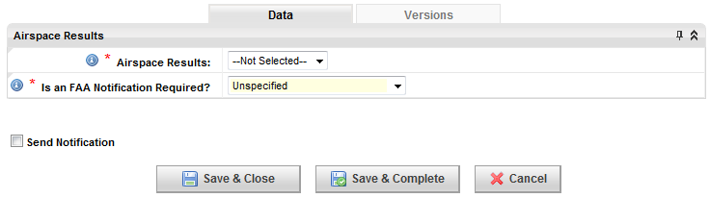

* + 1000 – A&E Site Walk/Design Visit - Architect & engineering site visit. Commence following approval of the tower core package and 1A/2C surveys.
    - 1000.1 Confirm A&E Site Walk / Design Visit
      * Role: Regional Real Estate Specialist (RRES)
  + 1100 – 1A/2C Survey Ordered - FAA 1A and 2C certification process for cell tower construction ordered.
    - 1100.1 Confirm 1A/2C Survey Ordered
      * Role: Regional Real Estate Specialist (RRES)
  + 1200 – 1A/2C Survey Complete - FAA 1A and 2C certification process for cell tower construction complete.
    - 1200.1 2C Survey
      * Role: Vendor Site Acquisition(VSA)
    - 1200.2 1A/2C Survey Form
      * Role: Vendor Site Acquisition(VSA)

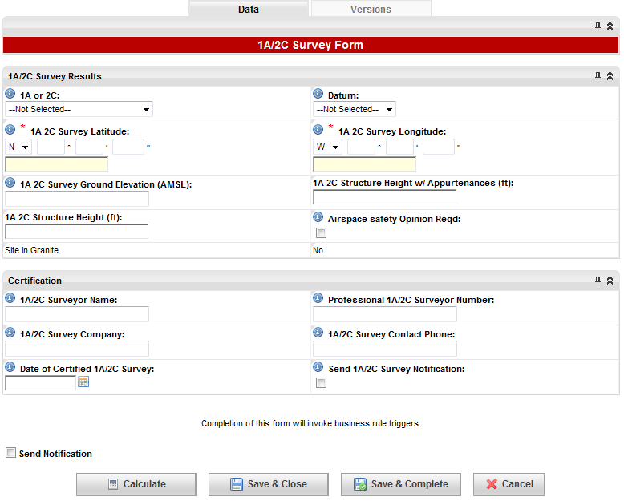

* + - 1200.3 1A Survey
      * Role: Vendor Site Acquisition(VSA)
    - 1200.4 RE Approval
      * Role: Regional Real Estate Specialist (RRES)
  + 1300 – Coordinates Revised
    - 1300.1 Revised Site Coordinates
      * Role: Regional Real Estate Specialist (RRES)

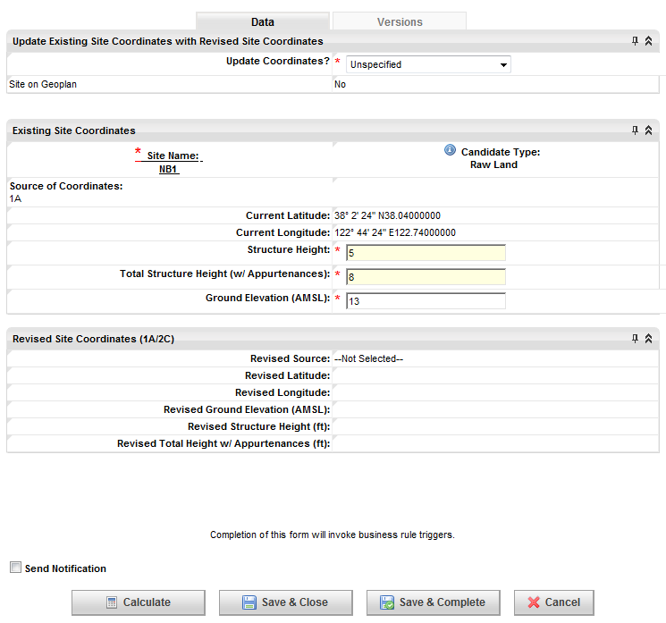

* + 1400 – Structural Evaluation Ordered - Initiate order of structural evaluation.
    - 1400.1 Confirm Structural Evaluation Ordered
      * Role: Regional Construction Engineer(RCE)
  + 1500 – Structural Evaluation - Perform and verify structural evaluation.
    - 1500.1 Structural Evaluation
      * Role: Regional Construction Engineer(RCE)
    - 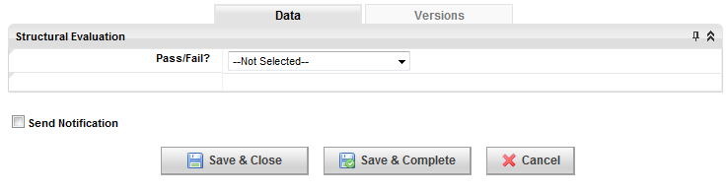
    - 1500.2 Structural Evaluation or Structural Letter
      * Role: Regional Construction Engineer(RCE)
    - 1500.3 Signed and Stamped Reinforcement/Modification Calculations
      * Role: Regional Construction Engineer(RCE)
  + 1600 – Final RF Config Form -- Final RF configuration. **Requires the preliminary review of CD's (14600).**
    - 1600.2 Final RF Configuration
      * Role: Regional RF Engineering

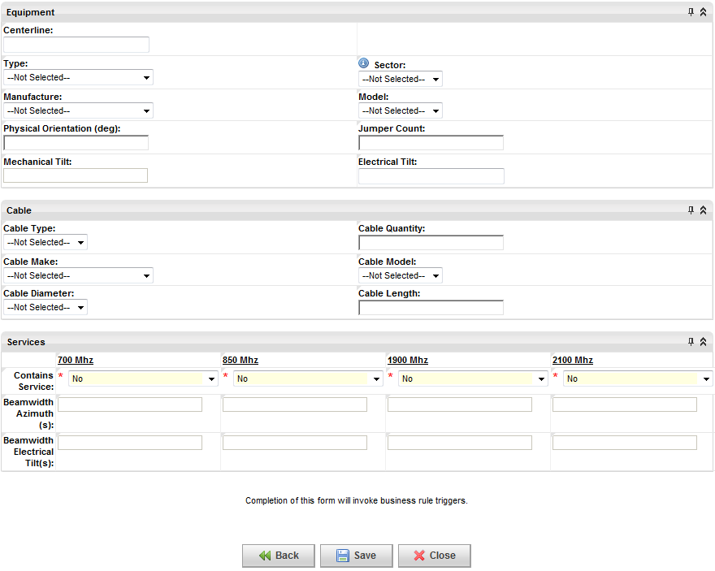

* + 1700 – International Border Evaluation - International border evaluation. Follows finalized RF configuration.
    - 1700.1 International Border Evaluation
      * Role: Regional RF Engineering(RRFE)
  + 1800 – Physical Address Ordered
    - 1800.1 Confirm Apply For / Obtain Physical Address
      * Role: Vendor Site Acquisition(VSA)
  + 1900 – Physical Address Received
    - 1900.1 Update Site Address
      * Role: Vendor Site Acquisition(VSA)
    - 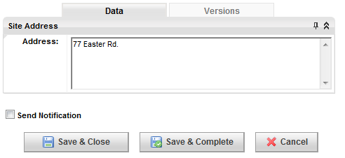
    - 1900.2 Proof of Valid E911 Address
      * Role: Vendor Site Acquisition(VSA)
  + 2000 – Backhaul Type - Selection of backhaul portion of the network.
    - 2000.1 Backhaul Selection Form
      * Role: Regional Transport Engineer(RTRSPRTE)

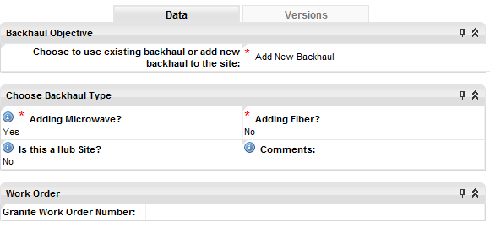

* + 2100 – AM Process – Part 1: AM Check - AM check, upload, and study order confirmation. Requires revision of site coordinates, completion of 1A/2C survey, and final configuration of the radio frequency.
    - 2100.1 Run AM Check
      * Role: Regional Regulatory Analyst(RRA)

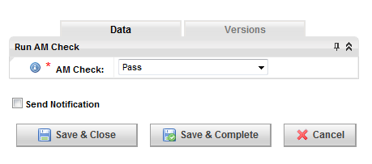

* + - 2100.2 Upload AM Pass Certificate (PDF)
      * Role: Regional Regulatory Analyst(RRA)
    - 2100.3 Confirm AM Study Ordered from Vendor
      * Role: Regional Construction Engineer(RCE)
  + 2200 – AM Process – Part 2: AM Vendor Study - Confirm the receipt of AM vendor study.
    - 2200.1 Confirm Job Accepted
      * Role: Regional Regulatory Analyst(RRA)
    - 2200.2 AM Form
      * Role: Regional Regulatory Analyst(RRA)
  + 2300 – AM Process – Part 3: AM Letter - The third task in the AM Process is the confirmed delivery and response to the AM Station Letter.
    - 2300.1 Confirm Letter send to AM Station
      * Role: Regional Regulatory Analyst(RRA)
    - 2300.2 Upload AM Letter to AM Station
      * Role: Regional Regulatory Analyst(RRA)
    - 2300.3 AM Station Response
      * Role: Regional Regulatory Analyst(RRA)

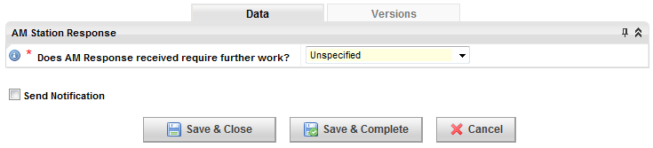

* + - 2300.4 Confirm Resolution Reached with AM Station
      * Role: Regional Regulatory Analyst(RRA)
  + 2400 – AM Process – Part 4: Pre/Post Measurement - Upload the pre and post AM measurement study. This task can be initiated following the vendor study.
    - 2400.1 Upload Pre AM Measurement Study
      * Role: Regional Regulatory Analyst(RRA)
  + 2500 – Upload Post AM Measurement Study
    - 2500.1 Upload Post AM Measurement Study
      * Role: Regional RF Engineering(RRFE)
  + 2600 – Environmental Due Diligence Prescription - Following the selection of the primary site candidate, the site project review commences to identify steps for environmental due diligence.
    - 2600.1 Site Project Review to define prescriptive steps for Due Diligence
      * Role: Regional Real Estate Specialist (RRES)

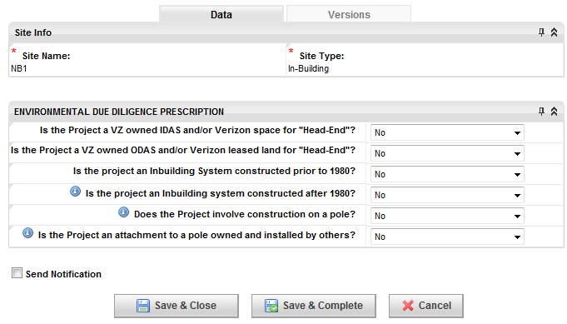

* + 2700 – Environmental Phase 1
    - 2700.1 Environmental Phase 1 Ordered
      * Role: Regional Real Estate Specialist (RRES)
    - 2700.2 Environmental Final Phase 1 Report (Must be Signed)
      * Role: Vendor Environmental Counsel (VEC)
  + 2800 – Environmental Review – Legal - Legal review of the environmental site assessment (ESA) preliminary actions and Phase I report.
    - 2800.1 Legal Review - Environmental Review
      * Role: Vendor Environmental Counsel(VEC)
  + 2900 – Environmental Phase 1 Review - Completion of the ESA Phase 1 review.
    - 2900.1 Phase 1 Environmental Assessment
      * Role: Vendor Environmental Counsel(VEC)
  + 3000 – Additional Due Diligence - Perform additional due diligence, commence following Environmental Phase 1 Review (6100).
    - 3000.1 EES (Environmental Evaluation Summary)
      * Role: Regional Real Estate Specialist (RRES)
    - 3000.2 Notice to Contractor
      * Role: Regional Real Estate Specialist (RRES)
    - 3000.3 Order Limited Site Inspection or Limited Site Investigation
      * Role: Regional Real Estate Specialist (RRES)
    - 3000.4 Limited Site Inspection or Limited Site Investigation
      * Role: Regional Real Estate Specialist (RRES)
    - 3000.5 Order ACM/LBP Survey
      * Role: Regional Real Estate Specialist (RRES)
    - 3000.6 ACM (Asbestos-containing Materials) and/or LBP (Lead Based Paint) Survey
      * Role: Regional Real Estate Specialist (RRES)
    - 3000.7 Wetlands Survey
      * Role: Regional Real Estate Specialist (RRES)
    - 3000.8 Ground Penetrating Radar (GPR)
      * Role: Regional Real Estate Specialist (RRES)
    - 3000.9 Other
      * Role: Regional Real Estate Specialist (RRES)
    - 3000.10 Environmental Phase 2 SOW
      * Role: Regional Real Estate Specialist (RRES)
    - 3000.11 Right of Entry and Testing Agreement
      * Role: Regional Real Estate Specialist (RRES)
    - 3000.12 Site Access Agreement
      * Role: Regional Real Estate Specialist (RRES)
    - 3000.13 Environmental Notice to Contractor
      * Role: Regional Real Estate Specialist (RRES)
    - 3000.14 Soils Management Plan
      * Role: Regional Real Estate Specialist (RRES)
    - 3000.15 Ground Water Management Plan
      * Role: Regional Real Estate Specialist (RRES)
    - 3000.16 Operations and Maintenance Plan (O&M)
      * Role: Regional Real Estate Specialist (RRES)
    - 3000.17 HASP - Health & Safety Plan
      * Role: Regional Real Estate Specialist (RRES)
    - 3000.18 Wetlands Delineation Study
      * Role: Regional Real Estate Specialist (RRES)
    - 3000.19 EDR NEPA Check
      * Role: Regional Real Estate Specialist (RRES)
    - 3000.20 EDR Vista Check
      * Role: Regional Real Estate Specialist (RRES)
    - 3000.21 Area Compliance Approval
  + 3100 – Area Compliance Preliminary Review - Preliminary area compliance process.
    - 3100.1 Area Compliance Preliminary Determination
      * Role: Area Environmental Compliance(AEC)

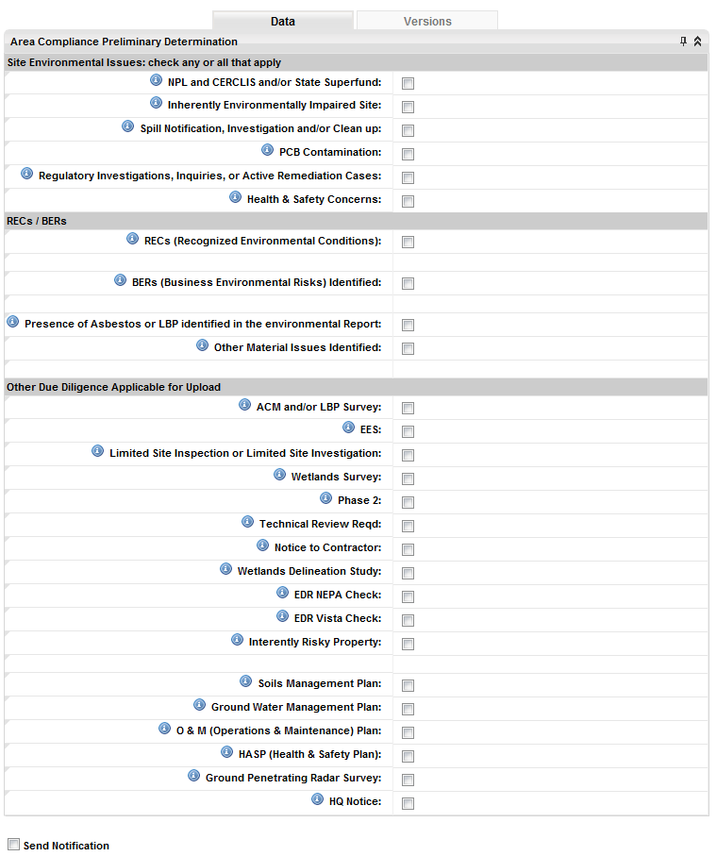

* + - 6600.2 HQ Notice
      * Role: Area Environmental Compliance(AEC)
  + 3200 – Technical Review Phase II SOW - Perform technical review Environmental Phase 2 SOW.
    - 3200.1 Order Technical Review of Environmental Phase 2 SOW
      * Role: Area Environmental Compliance(AEC)
    - 3200.2 Environmental Phase 2 SOW Review Completed
      * Role: Vendor Environmental (VE)
  + 3300 – Environmental Phase II Ordered - Phase II ESA and Technical Review are ordered and received.
    - 3300.1 Environmental Phase II Ordered
      * Role: Regional Real Estate Specialist (RRES)
    - 3300.2 Final Phase 2 Environmental Received
      * Role: Vendor Environmental Counsel(VEC)
  + 3400 – Technical Review Environmental Phase 2
    - 3400.1 Environmental Phase 2 Technical Review Order
      * Role: Regional Real Estate Specialist (RRES)
    - 3400.2 Environmental Phase 2 Technical Review
      * Role: Vendor Environmental (VE)
  + 3500 – Environmental Review – Phase II - Phase II of the Environmental Site Assessment is reviewed by legal counsel to ensure compliance.
    - 3500.1 Legal Review - Environmental Review
      * Role: Vendor Environmental Counsel(VEC)
  + 3600 – Phase II Site Assessment - Perform environmental phase 2 site assessment.
    - 3600.1 Environmental Phase 2 Review Complete
      * Role: Vendor Environmental Counsel(VEC)
  + 3700 – Area Compliance and Final Review - Perform area compliance final review, requires completion of all site review sub tasks (5500, 5701, 6600, 5702, 6500, 5700, 6400).
    - 3700.1 Area Compliance Final Review Form
      * Role: Area Environmental Compliance(AEC)

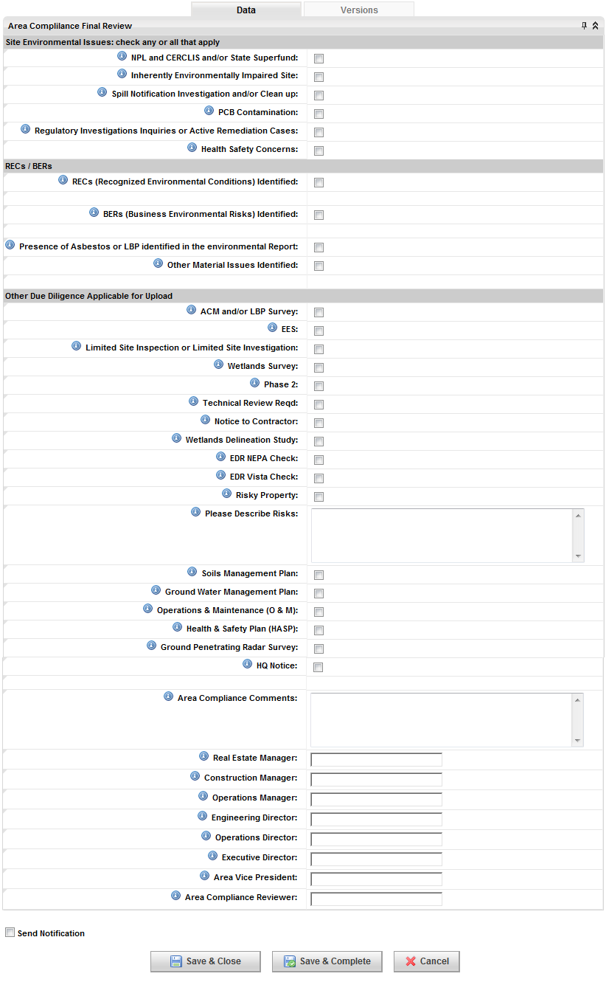

* + 3800 – EES - Final EES sign-off.
    - 3800.1 Route EES For signature
      * Role: Regional Real Estate Specialist (RRES)
  + 3900 – EMIS Site and Due Diligence Data - Process EMIS site and due diligence data.
    - 3900.1 Push EMIS Site Data and Enter Due Diligence Information
      * Role: Regional Real Estate Specialist (RRES)

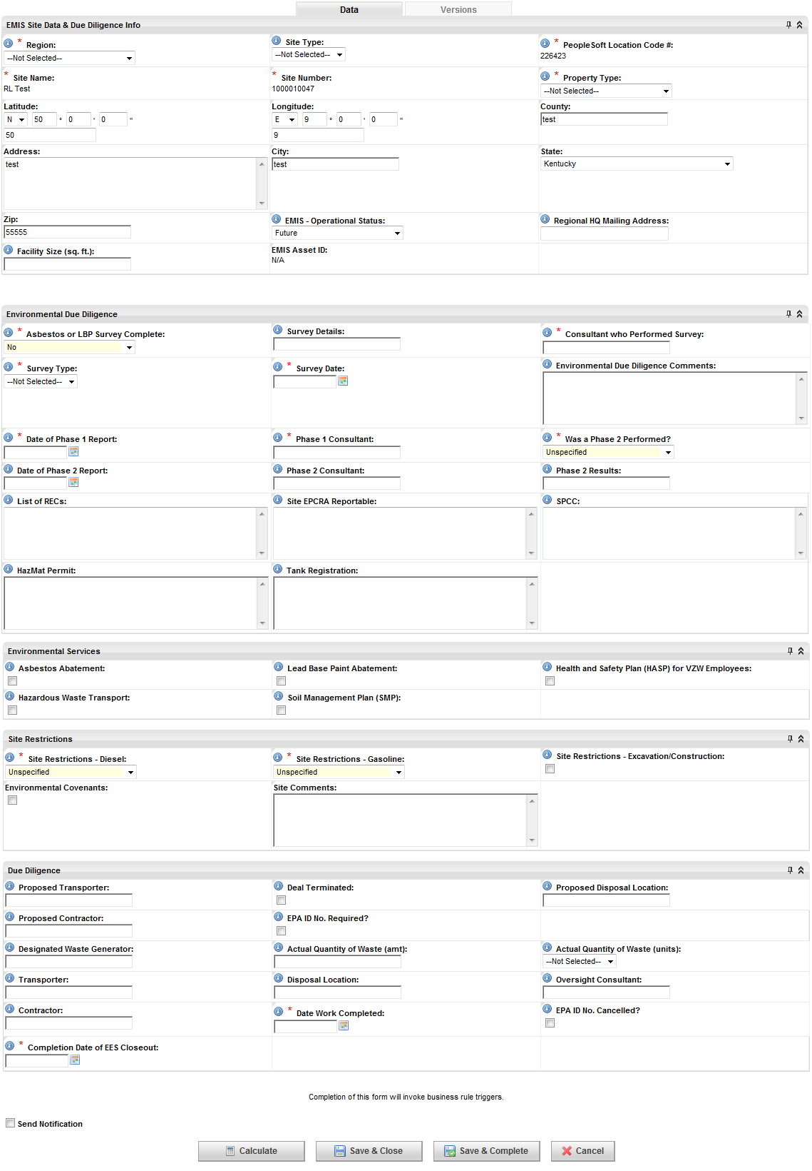

* + 4000 – Backhaul Solution Available - Make backhaul solution available, commences following selection of backhaul type (18100).
    - 4000.1 Backhaul Deployment Lead Approval - BH FCC Form 601
      * Role: Regional Transport Engineer(RTRSPRTE)
  + 4100 – LTE BAND 1 - Complete 700-IS call sign approval.
    - 41000.1 Call Sign 1 Approved
      * Role: HQ Regulatory Licensing Compliance(HQRLC)
    - 4100.2 Call Sign 2 Approved
      * Role: HQ Regulatory Licensing Compliance(HQRLC)
    - 4100.3 Call Sign 3 Approved
      * Role: HQ Regulatory Licensing Compliance(HQRLC)
    - 4100.4 Call Sign 4 Approved
      * Role: HQ Regulatory Licensing Compliance(HQRLC)
  + 4200 – LTE BAND 2 - Complete AWS IS call sign approval.
    - 4200.1 Call Sign 1 Approved
      * Role: HQ Regulatory Licensing Compliance(HQRLC)
    - 4200.2 Call Sign 2 Approved
      * Role: HQ Regulatory Licensing Compliance(HQRLC)
    - 4200.3 Call Sign 3 Approved
      * Role: HQ Regulatory Licensing Compliance(HQRLC)
    - 4200.4 Call Sign 4 Approved
      * Role: HQ Regulatory Licensing Compliance(HQRLC)
    - 4200.5 Call Sign 5 Approved
      * Role: HQ Regulatory Licensing Compliance(HQRLC)
  + 4300 – LTE BAND 3 - Approve call signs for Personal Communications Service (PCS)
    - 4300.1 Call Sign 1 Approved
      * wRole: HQ Regulatory Licensing Compliance(HQRLC)
    - 4300.2 Call Sign 2 Approved
      * Role: HQ Regulatory Licensing Compliance(HQRLC)
    - 4300.3 Call Sign 3 Approved
      * Role: HQ Regulatory Licensing Compliance(HQRLC)
    - 4300.4 Call Sign 4 Approved
      * Role: HQ Regulatory Licensing Compliance(HQRLC)
    - 4300.5 Call Sign 5 Approved
      * Role: HQ Regulatory Licensing Compliance(HQRLC)
    - 4300.6 Call Sign 6 Approved
      * Role: HQ Regulatory Licensing Compliance(HQRLC)
    - 4300.7 Call Sign 7 Approved
      * Role: HQ Regulatory Licensing Compliance(HQRLC)
    - 4300.8 Call Sign 8 Approved
      * Role: HQ Regulatory Licensing Compliance(HQRLC)
  + 4400 – LTE BAND 4 - Complete 850 IS call sign approval.
    - 4400.1 Call Sign 1 Approved
      * Role: HQ Regulatory Licensing Compliance(HQRLC)
    - 4400.2 Call Sign 2 Approved
      * Role: HQ Regulatory Licensing Compliance(HQRLC)
    - 4400.3 Call Sign 3 Approved
      * Role: HQ Regulatory Licensing Compliance(HQRLC)
    - 4400.4 Call Sign 4 Approved
      * Role: HQ Regulatory Licensing Compliance(HQRLC)
  + 4500 – Microwave IS Approval
    - 4500.1 CTA Approved
  + 4550 – Microwave Activation
    - 4550.1 - Confirm MW Activation
  + 4600 – Microwave Path Study Ordered - Order microwave path study, commences following backhaul type selection (18000).
    - 4600.1 Path Study Ordered
      * Role: Regional Microwave Engineer(RME)
  + 4700 – Microwave Path Study Received - Receive microwave path study.
    - 4700.1 Path Study Received
      * Role: Regional Microwave Engineer(RME)
  + 4800 – Microwave Antenna Design - Process microwave antenna design.
    - 4800.1 MW Antenna Design
      * Role: Regional Microwave Engineer(RME)
  + 4900 – Microwave Equipment Ordered - Order microwave equipment, commences following microwave antenna design (82).
    - 4900.1 MW Equipment Ordered
      * Role: Regional Microwave Engineer(RME)
  + 5000 – Microwave Equipment Received - MW equipment received.
    - 5000.1 MW Equipment Received
      * Role: Regional Microwave Engineer(RME)
  + 5100 – Lease Exhibit Received - Lease exhibit will be received from the A&E team following the walkthrough.
    - 5100.1 Lease Exhibit
      * Role: Vendor A & E (VA&E)
  + 5200 – FAA Tower Evaluation - Complete FAA tower evaluation, commences following airspace opinion (950).
    - 5200.1 Tower Evaluation Form
      * Role: Regional Regulatory Analyst(RRA)
    - 5200.2 Is FAA Notification Required?
      * Role: Regional Regulatory Analyst(RRA)
    - 5200.3 Enter Tower Owner's FAA Study #
      * Role: Regional Regulatory Analyst(RRA)
    - 5200.4 HQ Construction Review HQ
      * Role: Regulatory Structure Compliance(HQRSC)
  + 5300 – FAA Notification Part 1 - FAA notification Part 1: confirm the preliminary notification of tower build has been filed.
    - 5300.1 Confirm FAA Notification has been filed (File 7460-1)
      * Role: HQ Regulatory Structure Compliance(HQRSC)
  + 5400 – FAA Notification Part 2 - FAA notification Part 2: FAA determination received.
    - 5400.1 FAA Determination Received - 28 (Part 2)
      * Role: HQ Regulatory Structure Compliance(HQRSC)
  + 5500 – FAA Presumed Hazard - Determine possibility of FAA presumed hazard.
    - 5500.1 Upload Presumed Hazard Determination
      * Role: HQ Regulatory Structure Compliance(HQRSC)
    - 5500.2 HQ Construction Review of Determination and Summarize Results
      * Role: HQ Regulatory Structure Compliance(HQRSC)
    - 5500.3 Regional Review of Determination and HQ Construction Summary
      * Role: Regional Regulatory Analyst(RRA)
    - 5500.4 Confirm Response sent to FAA of Public Comment
      * Role: HQ Regulatory Structure Compliance(HQRSC)
  + 5600 – FAA No Hazard - In the event a "No Hazard" determination is made (3200), the FAA No Hazard process commences.
    - 5600.1 Upload No Hazard Determination
      * Role: HQ Regulatory Structure Compliance(HQRSC)
    - 5600.2 Review No Hazard Determination
      * Role: HQ Regulatory Structure Compliance(HQRSC)

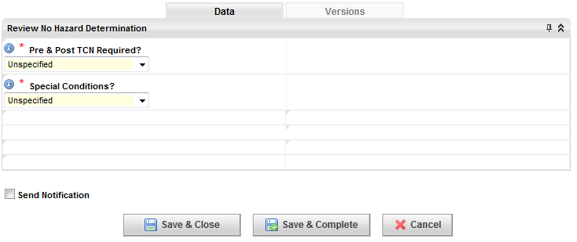

* + - 5600.3 Region Special Conditions Complete
      * Role: HQ Regulatory Structure Compliance(HQRSC)
    - 5600.4 Construction Special Conditions Complete
      * Role: HQ Regulatory Structure Compliance(HQRSC)
    - 5600.5 Confirm Appeal Submitted to FAA
      * Role: HQ Regulatory Structure Compliance(HQRSC)
  + 5700 – FAA No Response - Follow up on FAA No Response.
    - 5700.1 Follow up with FAA due to no response
      * Role: HQ Regulatory Structure Compliance(HQRSC)
  + 5800 – FAA Additional Information - Process Additional Information for FAA.
    - 5800.1 Upload Letter Requesting Additional Information
      * Role: HQ Regulatory Structure Compliance(HQRSC)
    - 5800.2 Review Additional Information Request and Summarize Results
      * Role: HQ Regulatory Structure Compliance(HQRSC)
    - 5800.3 Region Responds to HQ Construction with Additional Information
      * Role: Regional Regulatory Analyst(RRA)
    - 5800.4 HQ Construction follows up with FAA HQ
      * Role: Regulatory Structure Compliance(HQRSC)
  + 5900 – Waiver Evaluation Process - Process FCC waiver evaluation.
    - 5900.1 Waiver Evaluation Form
      * Role: Regional Regulatory Analyst(RRA)

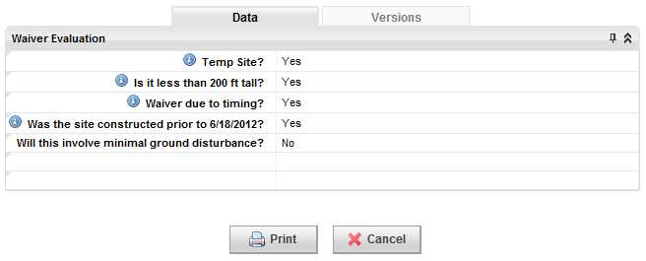

* + - 5900.2 Temp Site Exclusion Form
      * Role: Regional Regulatory Analyst(RRA)

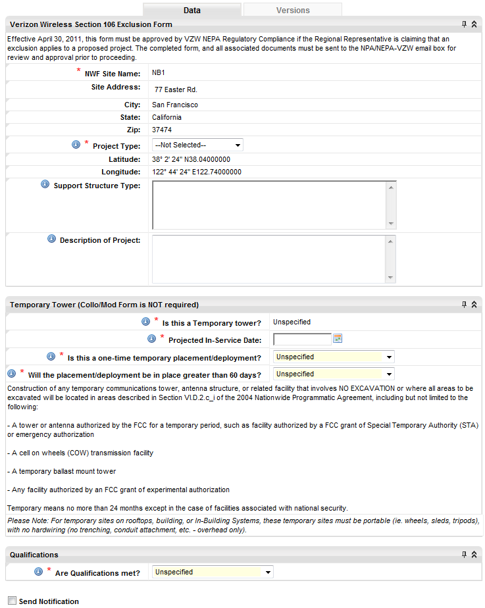

* + 6000 – Shielding Request
    - 6000.1 Shielding Request
      * Role: HQ Regulatory Structure Compliance(HQRSC)

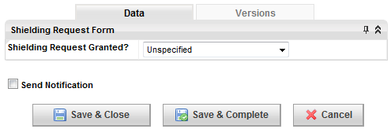

* + 6100 – FCC Waiver Process - Process FCC waiver request.
    - 6100.1 Confirm FCC Waiver has been Filed
      * Role: HQ Regulatory Structure Compliance(HQRSC)
    - 6100.2 Update Waiver Response
      * Role: HQ Regulatory Structure Compliance(HQRSC)

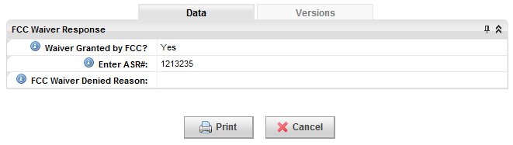

* + 6200 – ASR Local/National Public Notice Order Process (ASR Application Part 1) - FCC Antenna Structure Registration (ASR) is a seven-step process, commencing with the initial ASR application filing.
    - 6200.2 Part 1 ASR Application filed
      * Role: HQ Regulatory Structure Compliance(HQRSC)
  + 6300 -- ASR Local/National Public Notice Order Process (LPN) - Part 2 of the ASR process requires the uploading and printed verification of the Local Public Notice (LPN).
    - 6300.1 Enter LPN Posting Date
      * Role: Regional Regulatory Analyst(RRA)
    - 6300.2 Upload Newspaper Affadavit
      * Role: Regional Regulatory Analyst(RRA)
    - 6300.3 Copy of ADD if not contained on same page as affadavit
      * Role: Regional Regulatory Analyst(RRA)
  + 6400 -- ASR Local/National Public Notice Order Process (National Public Notice) - Part 3 of the ASR process requires notifying the FCC of the date to provide national notice of the project.
    - 6400.4 Enter National Public Notice Posting Date
      * Role: Regional Regulatory Analyst(RRA)
  + 6500 -- ASR Local/National Public Notice Order Process (Public Complaints Received?) - ASR Local/National Public Order Notice process, Public Complaints.
    - 6500.1 Public Complaints
      * Role: HQ Regulatory Structure Compliance(HQRSC)
  + 6600 -- ASR Local/National Public Notice Order Process (Public Complaints Response) - Part 5 of the ASR process is the response to any outstanding complaints.
    - 6600.1 Confirm response to complaint
      * Role: HQ Regulatory Structure Compliance(HQRSC)
    - 6600.2 Confirm copy of Response has been filed with FCC
      * Role: HQ Regulatory Structure Compliance(HQRSC)
    - 6600.3 Complaint Resolved?
      * Role: HQ Regulatory Structure Compliance(HQRSC)
  + 6700 -- ASR Local/National Public Notice Order Process (Programmatic Environmental Assessment - Part 6 of the ASR process requires the submitting the public feedback to the FCC via report.
    - 6700.2 Report Developed and Submitted to FCC
      * Role: Regional Regulatory Analyst(RRA)
  + 6800 -- ASR Local/National Public Notice Order Process (ASR Certification Part 2) - Part 7 of the ASR process requires FCC certification.
    - 6800.1 Part 2 Certification
      * Role: HQ Regulatory Structure Compliance(HQRSC)
  + 6900 – DOT Process - Complete DOT regulatory process.
    - 900.1 Confirm DOT Application has been filed
      * Role: HQ Regulatory Structure Compliance(HQRSC)
    - 900.2 Enter DOT Application Response
      * Role: HQ Regulatory Structure Compliance(HQRSC)
    - 900.3 Upload DOT Approval
      * Role: HQ Regulatory Structure Compliance(HQRSC)
    - 900.4 Upload DOT Rejection
      * Role: HQ Regulatory Structure Compliance(HQRSC)
    - 900.5 Choose to Refile
      * Role: Regional Regulatory Analyst(RRA)
  + 7000 – NEPA or Section 106 Exclusion Evaluation - Project must comply with the National Environmental Policy Act (NEPA) and Section 106 of the National Historic Preservation Act (NHPA). This step initiates the exclusion evaluation required in the process.
    - 7000.1 Tower Collocation/Modification Form
      * Role: Regional Regulatory Analyst(RRA)
    - 7000.2 Non-Tower Collocation/Modification Form
      * Role: Regional Regulatory Analyst(RRA)
    - 7000.3 NEPA / 106 Exclusion Evaluation Form
      * Role: Regional Regulatory Analyst(RRA)
    - 7000.4 Upload Tower Owner Certification Letter
      * Role: Regional Regulatory Analyst(RRA)
    - 7000.6 Exclusion Review
      * Role: HQ Regulatory Structure Compliance(HQRSC)
  + 7100 – NEPA/Section 106 Ordered (Full Order NEPA Review) - Order NEPA review and subsections.
    - 7100.1 Candidate Site Profile Form
      * Role: Regional Regulatory Analyst(RRA)
    - 7100.2 Submit NEPA Order
      * Role: Regional Real Estate Analyst(RREANLST)
    - 7100.3 QA/QC Review
      * Role: HQ Regulatory Structure Compliance(HQRSC)
    - 7100.4 Confirm Review and Resolution Complete
      * Role: HQ Regulatory Structure Compliance(HQRSC)
  + 7200 – NEPA/Section 106 Ordered (Full NEPA Accepts Order) - NEPA accepts the order.
    - 7200.1 NEPA Consultant Accepts Order
      * Role: Vendor NEPA(VNEPA)
  + 7300 – NEPA/Section 106 Ordered (Full NEPA Review Complete) - NEPA delivers full review.
    - 7300.1 NEPA Review
      * Role: Vendor NEPA(VNEPA)
  + 7400 – Additional Tribal Consultation (30 Day) - Following the submission of the NEPA Report and Section 106, additional tribal consultation time is allotted prior to the tribal concurrence. (Period 1).
    - 7400.2 Confirm Follow-up Package sent to Tribe
      * Role: Vendor NEPA(VNEPA)
    - 7400.3 Tribal Concurrence (30 Days)
      * Role: Vendor NEPA(VNEPA)
  + 7500 – Additional Tribal Consultation (60 Day) - Period II follow-up consultation with second tribal concurrence.
    - 7500.1 Confirm Follow-up letter sent to Tribe
      * Role: Vendor NEPA(VNEPA)
    - 7500.2 Tribal Concurrence (60 Days)
      * Role: Vendor NEPA(VNEPA)
  + 7600 – Additional Tribal Consultation (75 Day) - Period III consultation. Closure Letter sent to the FCC on day 75.
    - 7600.1 Confirm Closure Letter sent to FCC (75 Days)
      * Role: Vendor NEPA(VNEPA)
  + 7700 – Additional Tribal Consultation (90 Day) - Period IV consultation. Closure letter is sent to the tribe and confirmation of completed legal review.
    - 7700.1 Confirm Closure Letter sent to Tribe
      * Role: Vendor NEPA(VNEPA)
    - 7700.2 Tribal Concurrence (90 Days)
      * Role: Vendor NEPA(VNEPA)
    - 7700.3 Confirm Legal Review and Closeout Complete
      * Role: Vendor NEPA(VNEPA)
  + 7800 – Additional SHPO Consultation - Confirm communication with SHPO, commences following NEPA report submittal process (8800), Section 106 report submittal process (8900).
    - 7800.1 Confirm S106 form 620/621 sent to SHPO
      * Role: Vendor NEPA(VNEPA)
    - 7800.2 SHPO Concurrence
      * Role: Vendor NEPA(VNEPA)
    - 7800.3 Confirm form 620/621 sent to FCC (through e106)
      * Role: Vendor NEPA(VNEPA
    - 7800.4 SHPO Concurrence (2)
      * Role: Vendor NEPA(VNEPA)
    - 7800.5 Confirm Memorandum of Agreement (MOA) Notification Received
      * Role: Vendor NEPA(VNEPA)
    - 7800.6 Confirm Memorandum of Agreement (MOA)
      * Role: Regional Regulatory Analyst(RRA)
    - 7800.7 Regional Response
      * Role: Vendor NEPA(VNEPA)
  + 7900 – Additional Natural Resource Consultation - Comfirm additional natural resource consultation, commences following NEPA report submittal process (8800), Section 106 report submittal process (8900).
    - 7900.1 Upload Mitigation Study
      * Role: Vendor NEPA(VNEPA)
    - 7900.2 QA/QC Process Results
      * Role: Vendor NEPA(VNEPA)
    - 7900.3 Confirm Mitigation Studies Submitted to Agency
      * Role: Vendor NEPA(VNEPA)
    - 7900.4 Agency Response
      * Role: HQ Regulatory Structure Compliance(HQRSC)
    - 7900.5 Agency Response Letter(s)
      * Role: HQ Regulatory Structure Compliance(HQRSC)
    - 7900.6 Regional Response
      * Role: Vendor NEPA(VNEPA)
    - 7900.7 Natural Resource Consultation
      * Role: Regional Regulatory Analyst(RRA)
  + 8000 – Tribal Consultation – Tribal Lands - Tribal consultation - tribal land - initiate tribal outreach, commence following NEPA/Section 106 review (7800).
    - 8000.1 Confirm tribal outreach started
      * Role: Vendor NEPA(VNEPA)
    - 8000.2 Tribal Concurrence
      * Role: Vendor NEPA(VNEPA)
  + 8100 – Federal Land Consultation - Federal land consultation, commence following NEPA/Section 106 review (7800).
    - 8100.1 Confirm agency outreach started
      * Role: Vendor NEPA(VNEPA)
    - 8100.2 Agency Concurrence
      * Role: Vendor NEPA(VNEPA)
  + 8200 – EA Required - EA draft and communicate to FCC.
    - 8200.1 Draft and Upload EA
      * Role: Vendor NEPA(VNEPA)
    - 8200.2 QA/QC Review
      * Role: HQ Regulatory Structure Compliance(HQRSC)
    - 8200.3 Upload Final Version of EA that was sent to FCC
    - 8200.4 FCC Response
      * Role: HQ Regulatory Structure Compliance(HQRSC)
    - 8200.5 Upload FONSI Report
      * Role: Vendor NEPA(VNEPA)
  + 8300 – NEPA Report Submittal Process - Following all preliminary NEPA documentation (12200-12400) and reception of final CD, commence the NEPA final submission process.
    - 8300.1 Tribal Notification to FCC
      * Role: Vendor NEPA(VNEPA)
    - 8300.2 Tribal Summary Matrix
      * Role: Vendor NEPA(VNEPA)
    - 8300.3 Confirm Site Visit
      * Role: Vendor NEPA(VNEPA)
    - 8300.4 Upload Natural Resource (NR)
      * Role: Vendor NEPA(VNEPA)
    - 8300.5 NR Checklist
      * Role: HQ Regulatory Structure Compliance(HQRSC)
    - 8300.6 Upload Cultural Resource
      * Role: Vendor NEPA(VNEPA)
    - 8300.7 CR Checklist
      * Role: HQ Regulatory Structure Compliance(HQRSC)
    - 8300.8 Confirm NR Submitted to applicable agencies
      * Role: Vendor NEPA(VNEPA)
    - 8300.9 Confirm CR Submitted to Tribal
      * Role: Vendor NEPA(VNEPA)
    - 8300.11 NR Concurrence Received
      * Role: Vendor NEPA(VNEPA)
    - 8300.12 Tribal Concurrence Received
      * Role: Vendor NEPA(VNEPA)
    - 8300.16 Submit FCC E106
      * Role: Vendor NEPA(VNEPA)
    - 8300.13 Confirm S106 Manually Submitted to SHPO
      * Role: Vendor NEPA(VNEPA)
    - 8300.14 Upload S106
      * Role: Vendor NEPA(VNEPA)
    - 8300.15 SHPO Concurrence
      * Role: Vendor NEPA(VNEPA)
  + 8400 – NEPA Report Submittal Process – 19B - NEPA report submission process Part B.
    - 8400.1 Draft and Upload Final NEPA Report
      * Role: Vendor NEPA(VNEPA)
    - 8400.2 QA/QC Review
      * Role: Vendor NEPA(VNEPA)

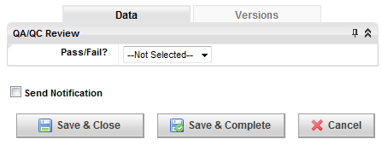

* + - 8400.3 Upload Tower Owner Certification Letter
      * Role: Vendor NEPA(VNEPA)
  + 8500 – Section 106 Report Submittal Process - After the Final CD is received and NEPA is submitted, Section 106 submission process commences.
    - 8500.1 Tribal Notification to FCC
      * Role: Vendor NEPA(VNEPA)
    - 8500.2 Confirm Site Visit
      * Role: Vendor NEPA(VNEPA)
    - 8500.3 Upload Cultural Resource
      * Role: Vendor NEPA(VNEPA)
    - 8500.4 CR Checklist
      * Role: Vendor NEPA(VNEPA
    - 8500.5 Confirm CR Submitted to Tribal
      * Role: Vendor NEPA(VNEPA)
    - 8500.6 Tribal Concurrance Received
      * Role: Vendor NEPA(VNEPA)
    - 8500.7 Submit FCC E106
      * Role: Vendor NEPA(VNEPA)
    - 8500.8 Confirm S106 Manually Submitted to SHPO
      * Role: Vendor NEPA(VNEPA)
    - 8500.9 Upload S106
      * Role: Vendor NEPA(VNEPA)
    - 8500.10 SHPO Concurrence
      * Role: Vendor NEPA(VNEPA)
  + 8600 – Section 106 Report Submittal Process – 20B
    - 8600.1 Draft and Upload Final Section 106 Report
      * Role: Vendor NEPA(VNEPA)
    - 8600.2 QA/QC Review
      * Role: Vendor NEPA(VNEPA)

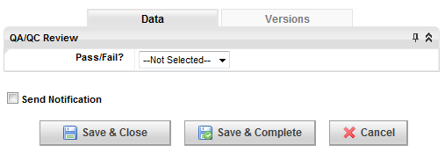

* + - 8600.3 Upload Tower Owner Certification Letter
      * Role: Vendor NEPA(VNEPA)
  + 8700 – RFE Compliance Analysis - RFE compliance analysis, including third-party EME assessment, commences once radio frequency configuration is finalized (15100).
    - 8700.1 RFE Study Requirements
      * Role: Regional RF Engineering(RRFE)
    - 8700.2 3rd Party EME Assessment
      * Role: Regional RF Engineering(RRFE)
    - 8700.3 RFE Compliance Analysis
      * Role: Regional RF Engineering(RRFE)
    - 8700.4 iBwave Electromagnetic Field Report
      * Role: Regional RF Engineering(RRFE)
    - 8700.5 RoofView Model + RF Checklist
      * Role: Regional RF Engineering(RRFE)
  + 8800 – Intermodulation Study Complete
    - 8800.1 Intermod Study Requirements
      * Role: Regional RF Engineering(RRFE)
    - 8800.2 Intermod Study
      * Role: Regional RF Engineering(RRFE)
  + 8900 – Title Cured
    - 8900.1 Title Curative Action Complete Memo
      * Role: Vendor Site Acquisition(VSA)
    - 8900.2 RE Approval
      * Role: Regional Real Estate Specialist (RRES)
  + 9000 – Title Complete
  + 9100 – Utility Information Received
    - 9100.1 Power Information Form
      * Role: Vendor Site Acquisition(VSA)
    - 9100.2 Power Drawing from Utility Company
      * Role: Vendor Site Acquisition(VSA)
  + 9200 – Subordination Non-Disturbance and Attornment Agreement - Real-estate subordination, non-disturbance and attorney aggrement, commences following title curative action complete.
    - 9200.1 Subordination, Non-Disturbance and Attornment Agreement
      * Role: Vendor Site Acquisition(VSA)
  + 9300 – Lease Setup - Configuration of lease, commences following area compliance review.
    - 9300.1 Lease Set-up Form
      * Role: Vendor Site Acquisition(VSA)
  + 9400 – Draft Ground Lease - Create ground lease agreement in accordance with lease set-up.
    - 9400.1 Draft Ground Lease
      * Role: Vendor Site Acquisition(VSA)
  + 9500 – Draft Tower Lease - Create tower lease agreement in accordance with lease set-up.
    - 9500.1 Draft Tower Lease
      * Role: Vendor Site Acquisition(VSA)
  + 9600 – Draft Water Tank Lease - Create water tank lease agreement in accordance with lease set-up.
    - 9600.1 Draft Water Tank Lease
      * Role: Vendor Site Acquisition(VSA)
  + 9700 – Draft Rooftop Lease - Create rooftop lease agreement in accordance with lease set-up.
    - 9700.1 Draft Rooftop Lease
      * Role: Vendor Site Acquisition(VSA)
  + 9800 – Draft SLA - Create service labor agreement in accordance with lease set-up.
    - 9800.1 Draft SLA
      * Role: Vendor Site Acquisition(VSA)
  + 9900 – Draft Access Agreement - Create access agreement in accordance with lease set-up.
    - 9900.1 Draft Access Agreement
      * Role: Vendor Site Acquisition(VSA)
  + 10000 – Draft Easement Agreement - Create easement agreement in accordance with lease set-up.
    - 10000.1 Draft Easement Agreement
      * Role: Vendor Site Acquisition(VSA)
  + 10100 – Draft Utility Tower Lease - Create utility tower lease agreement in accordance with lease set-up.
    - 10100.1 Draft Utility Tower Lease
      * Role: Vendor Site Acquisition(VSA)
  + 10200 – Draft First Amendment - Create first amendment agreement in accordance with lease set-up.
    - 10200.1 Draft First Amendment
      * Role: Vendor Site Acquisition(VSA)
  + 10300 – Draft Second Amendment - Create second amendment agreement in accordance with lease set-up.
    - 10300.1 Draft Second Amendment
      * Role: Vendor Site Acquisition(VSA)
  + 10400 – Draft Option Agreement - Create option agreement in accordance with lease set-up.
    - 10400.1 Draft Option Agreement
      * Role: Vendor Site Acquisition(VSA)
  + 10500 – Draft Other Agreement - Create other agreement in accordance with lease set-up.
    - 10500.1 Draft Other Agreement
      * Role: Vendor Site Acquisition(VSA)
  + 10600 – Landlord W9 & Certificate of Insurance - Create landlord vendor forms in accordance with lease set-up.
    - 10600.1 Ground - Landlord Vendor Forms - W-9
      * Role: Vendor Site Acquisition(VSA)
    - 10600.2 Tower - Landlord Vendor Forms - W-9
      * Role: Vendor Site Acquisition(VSA
    - 10600.3 Water Tank - Landlord Vendor Forms - W-9
      * Role: Vendor Site Acquisition(VSA)
    - 10600.4 Rooftop - Landlord Vendor Forms - W-9
      * Role: Vendor Site Acquisition(VSA
    - 10600.5 SLA - Landlord Vendor Forms - W-9
      * Role: Vendor Site Acquisition(VSA)
    - 10600.6 Easement - Landlord Vendor Forms - W-9
      * Role: Vendor Site Acquisition(VSA)
    - 10600.7 Utility Tower - Landlord Vendor Forms - W-9
      * Role: Vendor Site Acquisition(VSA)
    - 10600.8 First Amendment - Landlord Vendor Forms - W-9
      * Role: Vendor Site Acquisition(VSA)
    - 10600.9 Second Amendment - Landlord Vendor Forms - W-9
      * Role: Vendor Site Acquisition(VSA)
    - 10600.10 Option - Landlord Vendor Forms - W-9
      * Role: Vendor Site Acquisition(VSA)
    - 10600.11 Other - Landlord Vendor Forms - W-9
      * Role: Vendor Site Acquisition(VSA)
    - 10600.12 Ground - Certificate of Insurance (COI)
      * Role: Vendor Site Acquisition(VSA)
    - 10600.13 Tower - Certificate of Insurance (COI)
      * Role: Vendor Site Acquisition(VSA)
    - 10600.14 Water Tank - Certificate of Insurance (COI)
      * Role: Vendor Site Acquisition(VSA)
    - 10600.15 Rooftop - Certificate of Insurance (COI)
      * Role: Vendor Site Acquisition(VSA)
    - 10600.16 SLA - Certificate of Insurance (COI)
      * Role: Vendor Site Acquisition(VSA)
    - 10600.17 Easement - Certificate of Insurance (COI)
      * Role: Vendor Site Acquisition(VSA)
    - 10600.18 Utility Tower - Certificate of Insurance (COI)
      * Role: Vendor Site Acquisition(VSA)
    - 10600.19 First Amendment - Certificate of Insurance (COI)
      * Role: Vendor Site Acquisition(VSA)
    - 10600.20 Second Amendment - Certificate of Insurance (COI)
      * Role: Vendor Site Acquisition(VSA)
    - 10600.21 Option - Certificate of Insurance (COI)
      * Role: Vendor Site Acquisition(VSA)
    - 10600.22 Other - Certificate of Insurance (COI)
      * Role: Vendor Site Acquisition(VSA)
    - 10600.23 Access Agreement - Landlord Vendor Forms - W-9
      * Role: Vendor Site Acquisition(VSA)
    - 10600.24 Access Agreement - Certificate of Insurance (COI)
      * Role: Vendor Site Acquisition(VSA)
    - 10600.25 RE Approval
      * Role: Regional Real Estate Specialist (RRES)
  + 10700 – Legal Opinion – Lease Review - Complete legal review of all required lease agreements.
    - 10700.1 Ground Lease Review - Legal Opinion
      * Role: Vendor Site Acquisition(VSA)
    - 10700.2 Tower Lease Review - Legal Opinion
      * Role: Vendor Site Acquisition(VSA)
    - 10700.3 Water Tank Lease Review - Legal Opinion
      * Role: Vendor Site Acquisition(VSA)
    - 10700.4 Rooftop Lease Review - Legal Opinion
      * Role: Vendor Site Acquisition(VSA)
    - 10700.5 SLA Review - Legal Opinion
      * Role: Vendor Site Acquisition(VSA)
    - 10700.6 Easement Agreement Review - Legal Opinion
      * Role: Vendor Site Acquisition(VSA)
    - 10700.7 Utility Tower Lease Review - Legal Opinion
      * Role: Vendor Site Acquisition(VSA)
    - 10700.8 First Amendment Review - Legal Opinion
      * Role: Vendor Site Acquisition(VSA)
    - 10700.9 Second Amendment Review - Legal Opinion
      * Role: Vendor Site Acquisition(VSA)
    - 10700.10 Option Agreement Review - Legal Opinion
      * Role: Vendor Site Acquisition(VSA)
    - 10700.11 Other Agreement Review - Legal Opinion
      * Role: Vendor Site Acquisition(VSA)
    - 10700.12 Access Agreement Review - Legal Opinion
      * Role: Vendor Site Acquisition(VSA)
    - 10700.13 'Client' Market Lead
      * Role: Vendor Site Acquisition(VSA)
    - 10700.14 RE Approval
      * Role: Regional Real Estate Specialist (RRES)
  + 10800 – Landlord Executed (All leases selected) - Verify landlord execution of all lease agreements.
    - 10800.1 Confirm Landlord Executed
      * Role: Vendor Site Acquisition(VSA)
  + 10900 – Client Executed (All leases selected) - Verify client execution of all lease agreements.
    - 10900.1 Confirm Client Executed
      * Role: Vendor Site Acquisition(VSA)
  + 11000 – Lease Fully Executed - Verify full execution of all lease agreements.
    - 11000.1 Ground - Lease Fully Executed
      * Role: Vendor Site Acquisition(VSA)
    - 11000.2 Tower - Lease Fully Executed
      * Role: Vendor Site Acquisition(VSA)
    - 11000.3 Water Tank - Lease Fully Executed
      * Role: Vendor Site Acquisition(VSA)
    - 11000.4 Rooftop - Lease Fully Executed
      * Role: Vendor Site Acquisition(VSA)
    - 11000.5 SLA - Lease Fully Executed
      * Role: Vendor Site Acquisition(VSA)
    - 11000.6 Easement Agreement - Lease Fully Executed
      * Role: Vendor Site Acquisition(VSA
    - 11000.7 Utility Tower - Lease Fully Executed
      * Role: Vendor Site Acquisition(VSA)
    - 11000.8 First Amendment - Lease Fully Executed
      * Role: Vendor Site Acquisition(VSA)
    - 11000.9 Second Amendment - Lease Fully Executed
      * Role: Vendor Site Acquisition(VSA)
    - 11000.10 Option Agreement - Lease Fully Executed
      * Role: Vendor Site Acquisition(VSA)
    - 11000.11 Other Agreement - Lease Fully Executed
      * Role: Vendor Site Acquisition(VSA)
    - 11000.12 Access Agreement - Lease Fully Executed
      * Role: Vendor Site Acquisition(VSA)
    - 11000.13 'Client' Market Lead Approval
      * Role: Vendor Site Acquisition(VSA)
    - 11000.14 RE Approval
      * Role: Regional Real Estate Specialist (RRES)
  + 11100 – Recorded Memorandum of Agreement (MOA) - Establish memorandum of agreement for all lease agreement actions.
    - 11100.1 Ground Lease MOA
      * Role: Vendor Site Acquisition(VSA)
    - 11100.2 Tower Lease MOA
      * Role: Vendor Site Acquisition(VSA)
    - 11100.3 Water Tank Lease MOA
      * Role: Vendor Site Acquisition(VSA)
    - 11100.4 Rooftop Lease MOA
      * Role: Vendor Site Acquisition(VSA)
    - 11100.5 SLA MOA
      * Role: Vendor Site Acquisition(VSA)
    - 11100.6 Easement Agreement MOA
      * Role: Vendor Site Acquisition(VSA)
    - 11100.7 Utility Tower Lease MOA
      * Role: Vendor Site Acquisition(VSA
    - 11100.8 First Amendment MOA
      * Role: Vendor Site Acquisition(VSA)
    - 11100.9 Second Amendment MOA
      * Role: Vendor Site Acquisition(VSA)
    - 11100.10 Option Agreement MOA
      * Role: Vendor Site Acquisition(VSA)
    - 11100.11 Other Agreement MOA
      * Role: Vendor Site Acquisition(VSA)
    - 11100.12 Access Agreement MOA
      * Role: Vendor Site Acquisition(VSA)
    - 11100.13 RE Approval
      * Role: Regional Real Estate Specialist (RRES)
  + 11200 – Lease Summary Data Complete - Summarize schedules and conditions of all lease agreements.
    - 11200.1 Ground Lease Summary Form
      * Role: Vendor Site Acquisition(VSA)
    - 11200.2 Tower Lease Summary Form
      * Role: Vendor Site Acquisition(VSA)
    - 11200.3 Water Tank Lease Summary Form
      * Role: Vendor Site Acquisition(VSA)
    - 11200.4 Rooftop Lease Summary Form
      * Role: Vendor Site Acquisition(VSA)
    - 11200.5 SLA Lease Summary Form
      * Role: Vendor Site Acquisition(VSA)
    - 11200.6 Easement Lease Summary Form
      * Role: Vendor Site Acquisition(VSA)
    - 11200.7 Utility Tower Lease Summary Form
      * Role: Vendor Site Acquisition(VSA)
    - 11200.8 First Amendment Summary Form
      * Role: Vendor Site Acquisition(VSA)
    - 11200.9 Second Amendment Summary Form
      * Role: Vendor Site Acquisition(VSA)
    - 11200.10 Optional Agreement Summary Form
      * Role: Vendor Site Acquisition(VSA)
    - 11200.11 Other Agreement Summary Form
      * Role: Vendor Site Acquisition(VSA)
    - 11200.12 Property Manager
      * Role: Vendor Site Acquisition(VSA)
    - 11200.13 RE Approval
      * Role: Regional Real Estate Specialist (RRES)
  + 11300 – Leasing Complete - Completion of all leasing actions and reviews.
    - 11300.1 Confirm Leasing Complete
      * Role: Regional Real Estate Specialist (RRES)
  + 11400 – Geotechnical Report Ordered - Order the GEOTECH report for the specified vendor property. Commence following completion of leasing tasks.
    - 11400.1 Confirm Geotech Ordered
      * Role: Vendor Site Acquisition(VSA)
  + 11500 – Soil Testing Reports - Order the soil testing report for the specified vendor property. Commence following completion of leasing tasks.
    - 11500.1 Geo-Tech Report
      * Role: Vendor Site Acquisition(VSA)
    - 11500.2 Soil Resistivity Data Report
      * Role: Vendor Site Acquisition(VSA)
    - 11500.3 RE Approval
      * Role: Regional Real Estate Specialist (RRES)
  + 11900 – Zoning Level
    - 11900.1 Zoning Level
      * Role: Regional Real Estate Specialist (RRES)

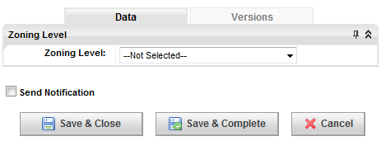

* + 12000 – Zoning Drawings Ordered - Order the zoning drawings for the specified vendor property. Commence following A&E site walk.
    - 12000.1 Confirm Zoning Dwgs Ordered
      * Role: Regional Real Estate Specialist (RRES)
  + 12100 – Zoning Drawings Received - Verify receipt of all zoning diagrams.
    - 12100.1 Drawings - .dwg
      * Role: Vendor Site Acquisition(VSA)
    - 12100.2 Drawings - .pdf
      * Role: Vendor Site Acquisition(VSA)
    - 12100.3 Confirm Zoning Drawings Received
      * Role: Regional Real Estate Specialist (RRES)
    - 12100.4 Final signed and sealed ZDs with any notations or comments
      * Role: Vendor Site Acquisition(VSA)
  + 12200 – Zoning Application Filed
    - 12200.1 Zoning Application and Related Docs
      * Role: Vendor Site Acquisition(VSA)
    - 12200.2 Photo Sims
      * Role: Vendor Site Acquisition(VSA)
    - 12200.3 Zoning Information Form
      * Role: Vendor Site Acquisition(VSA)

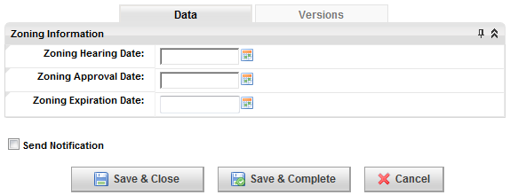

* + 12300 – Zoned - Completion of all zoning tasks.
    - 12300.1 Hearing Agendas, Minutes and Notes
      * Role: Vendor Site Acquisition(VSA)
    - 12300.2 Zoning Approval Document (CUP/SUP/Variance)
      * Role: Vendor Site Acquisition(VSA)
  + 12400 – Construction Drawings Ordered - Order the construction drawings for the specified vendor property. Commence following order of zoning drawings.
    - 12400.1 Confirm Construction Dwgs Ordered
      * Role: Vendor Construction Manager(VCM)
  + 12500 – Backhaul Design Completed - Verify completion of all backhaul design sub-tasks.
    - 12500.1 Backhaul Engineering Package
      * Role: Regional Transport Engineer(RTRSPRTE)
    - 12500.2 Confirm Backhaul Design Completed
      * Role: Regional Transport Engineer(RTRSPRTE)
  + 12600 – Preliminary Construction Drawings Available for Review - Preliminary CDs reviewed, commences following order of construction drawings.
    - 12600.1 Preliminary CDs for Review
      * Role: Vendor Construction Manager(VCM)
    - 12600.2 RF Approval
      * Role: Regional RF Engineering(RRFE)
    - 12600.3 Backhaul Approval
      * Role: Regional Transport Engineer(RTRSPRTE)
    - 12600.4 Site Acquisition Approval
      * Role: Regional Real Estate Specialist (RRES)
  + 12700 – Redlined Preliminary Construction Drawings to A&E Firm - Reviewed and redlined preliminary CDs sent to A&E firm.
    - 12700.1 Redlined CDs
      * Role: Vendor Construction Manager(VCM)
  + 12800 – 90 Percent Construction Drawings Available for Review - 90% benchmark CDs reviewed, commences after redlined preliminary CDs sent to A&E firm.
    - 12800.1 90% CDs for Review
      * Role: Vendor Construction Manager(VCM)
    - 12800.2 RF Approval
      * Role: Regional RF Engineering(RRFE)
    - 12800.3 Backhaul Approval
      * Role: Regional Transport Engineer(RTRSPRTE)
    - 12800.4 Site Acquisition Approval
      * Role: Regional Real Estate Specialist (RRES)
  + 12900 – Redlined 90 Percent Construction Drawings to A&E Firm - Following review, 90% benchmark CDs sent to A&E firm.
    - 12900.1 Redlined CDs
      * Role: Vendor Construction Manager(VCM)
  + 13000 – Final Construction Drawings Received
    - 13000.1 Signed and Stamped Construction Drawings
      * Role: Vendor Construction Manager(VCM)
    - 13000.2 Owner Approved/Signed Construction Drawings (11X17)
      * Role: Vendor Construction Manager(VCM)
    - 13000.3 Highest Point on the Tower
      * Role: Regional Construction Engineer(RCE)

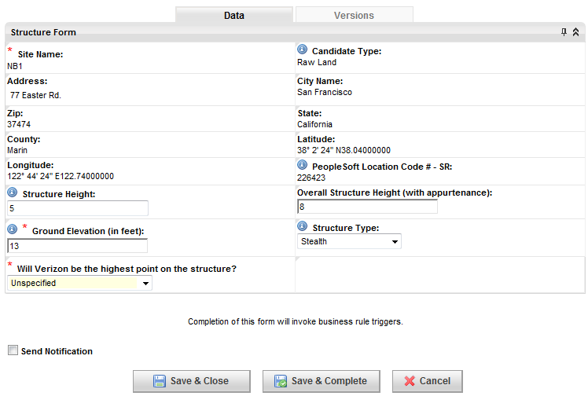

* + 13100 – Regulatory Structure Compliance – Ground – 40A - Regulatory structure compliance verified for construction approval.
    - 13100.1 Siterra Issues Ground Construction Approval
  + 13200 – Regulatory Structure Compliance – Full – 40B - Full regulatory structure compliance verified.
    - 13200.1 Siterra Issues Full Construction Approval
  + 13300 – Backhaul Ordered - Order backhaul, commences following completion of backhaul design.
    - 13300.2 Backhaul Order Form
      * Role: Regional Transport Engineer(RTRSPRTE)
  + 13400 – Building Permit Application Filed - File for the building permit application, commences following completion of all leasing tasks and all zoning tasks.
    - 13400.1 BP Application
      * Role: Regional Construction Engineer(RCE)
  + 13500 – Building Permit Application Received - Verify building permit received.
    - 13500.1 Building Permit
      * Role: Regional Construction Engineer(RCE)
  + 13601 – Pre-TCN Process
    - 13601.1 Pre-TCN Form
      * Role: Regional Regulatory Analyst(RRA)
  + 13700 – Pre-TCN Process Part 2: Construction Notification
    - 13700.1 Upload Pre-TCN (7460-2 Part 1)
      * Role: Regional Regulatory Analyst(RRA)
    - 13700.2 Confirm Pre-TCN Submitted to FAA
      * Role: Regional Regulatory Analyst(RRA)
  + 13800 – Site Acquisition Complete - Completion of site acquisition, follows completion of building permit, zoning, and leasing tasks.
    - 13800.1 Confirm Site Acquisition Complete
      * Role: Regional Construction Engineer(RCE)
  + 13900 – E911 Process Started - E911 process begins, commences following final RF configuration, approved and updated physical address and construction start.
    - 13900.1 Choose MPC Vendor and Submit E911
      * Role: Regional RF Engineering(RRFE)

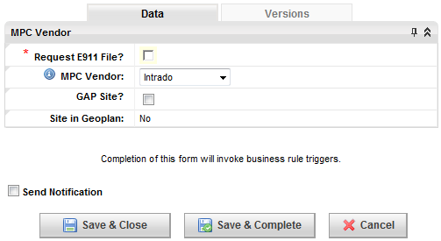

* + 14000 – NTP for Construction - Complete process for NTP for construction, commences following completion of regulatory structure compiance (2400, 2450), and determination of construction contingent on lease (11850, 11860).
    - 14000.1 NTP Form from Client
      * Role: Vendor Site Acquisition(VSA)
    - 14000.2 NTP to Construct
      * Role: Regional Real Estate Specialist (RRES)
    - 14000.3 Confirm NTP for Construction
      * Role: Regional Project Manager(RPM)
  + 14100 – NTP for Equipment Ordering
    - 14100.1 PM Approval
      * Role: Regional Project Manager(RPM)
  + 14200 – Environmental Notice to Contractor - Environmental notice sent to contractor, requires the completion of the area compliance final review.
    - 14200.1 Environmental Notice to Contractor Delivered (should be included in Bid Packet)
      * Role: Regional Construction Engineer(RCE)
  + 14300 – Bid Walk Complete - Complete bid and evaluation documentation.
    - 14300.1 Bids and Evaluation Documentation
      * Role: Regional Construction Engineer(RCE)
    - 14300.2 Confirm Bid Walk Complete
      * Role: Regional Construction Engineer(RCE)
  + 14400 – Environmental Notice to Contractor Accepted - Documented acceptance of the environmental notice by the contractor.
    - 14400.1 Contractor Signs/Accepts NTC
      * Role: Vendor Construction Manager(VCM)
  + 14500 – Award Contract - Complete award of contract.
    - 14500.1 Confirm Contract Awarded
      * Role: Regional Construction Engineer(RCE)
  + 14600 – Defined Backup Power Order Types - Following the Lease Completion, the back-up power types are defined and logged.
    - 14600.1 Define Order Types for Battery/Generator/Fuel Tank/Rectifier
      * Role: Regional Construction Engineer(RCE)

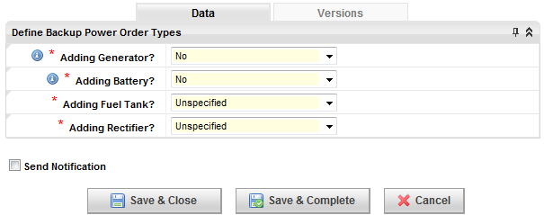

* + 14700 – RF Materials Order - Following the Lease Completion, radio frequency (RF) materials may be ordered.
    - 14700.1 Material Order Form
      * Role: Vendor Construction Manager(VCM)
    - 14700.2 Confirm RF Material Order
      * Role: Regional Equipment Engineer (REE)
  + 14800 – Order Battery/Generator/Fuel Tank - After back-up power types are defined (15750), projected power supplies are logged and new orders are placed.
    - 14800.1 Enter PROJECTED GENERATOR DATA
      * Role: Regional Equipment Engineer (REE)
    - 14800.2 Enter PROJECTED BATTERY DATA
      * Role: Regional Equipment Engineer (REE)
    - 14800.3 Enter PROJECTED FUEL TANK DATA
      * Role: Regional Equipment Engineer (REE)
  + 14900 – Order Ground Hardware and ENB/BTS - The base transceiver station (BTS) may be ordered upon Lease Completion.
    - 14900.1 Confirm Order BTS
      * Role: Regional Equipment Engineer (REE)
  + 15000 – Order Tower - Tower may be ordered following the issue of the NTP for Construction.
    - 15000.1 Confirm Tower Ordered
      * Role: Regional Construction Engineer(RCE)
  + 15100 – Order Backhaul Equipment - Backhaul equipment may be ordered following Lease Completion.
    - 15100.1 'Confirm Backhaul Equipment Ordered
      * Role: Regional Transport Engineer(RTRSPRTE)
  + 15200 – Materials Staged - Material may be staged following the confirmed RF Material Order.
    - 15200.1 Confirm Material Staged
      * Role: Regional Construction Engineer(RCE)
  + 15300 – Battery/Generator/Fuel Tank Set-Install - Installation of power generators.
    - 15300.1 COMPLETE GENERATOR DATA
      * Role: Regional Equipment Engineer (REE)
    - 15300.2 COMPLETE BATTERY DATA
      * Role: Regional Equipment Engineer (REE)
    - 15300.3 COMPLETE FUEL TANK DATA
      * Role: Regional Equipment Engineer (REE)
    - 15300.4 Confirm RECTIFIER DATA Entered in EMIS
      * Role: Regional Equipment Engineer (REE)
  + 15400 – Commercial Power Ordered - Commercial power requirements can be ordered after utility information is received and the building permit is received.
    - 15400.1 Confirm Commerical Power Ordered
      * Role: Regional Construction Engineer(RCE)
  + 15500 – Confirm CPUC Filing is Complete
    - 15500.1 Confirm CPUC Filing is Complete
      * Role: HQ Regulatory Licensing Compliance(HQRLC)
  + 15600 – Construction Start - Construction starts, commences following award of contract (12700).
    - 15600.1 Confirm Construction Start
      * Role: Regional Construction Engineer(RCE)
  + 15700 – Order Pad, Platform, or Shelter
    - 15700.1 Confirm Pad, Platform, or Shelter Ordered
      * Role: Regional Construction Engineer(RCE)
  + 15800 – Pad Platform or Shelter Completed - Pad, Platform, or Shelter installation complete.
    - 15800.1 Confirm Pad, Platform, or Shelter Complete
      * Role: Regional Construction Engineer(RCE)
  + 16000 – Site Resistance-To-Earth Test - Perform Site Resistance-to-Earth Test.
    - 16000.1 Ground Test Report
      * Role: Vendor Construction Manager(VCM)
    - 16000.2 Confirm Site Resistance-to-Earth Test
      * Role: Regional Construction Engineer(RCE)
  + 16100 – Tower Foundation Complete - Complete Tower Foundation following a successful Site Resistance-to-Earth report.
    - 16100.1 Confirm Tower Foundation Complete
      * Role: Regional Construction Engineer(RCE)
  + 16200 – Electrical Inspection Complete - Electrical inspection complete.
    - 16200.1 Electrical Inspection Tag
      * Role: Vendor Construction Manager(VCM)
  + 16300 – Electric Power Installed (Meter Installed and Active) - Electric power installation process.
    - 16300.1 Confirm Electric Power Installed
      * Role: Regional Construction Engineer(RCE)
  + 16400 – Power Account Information Received
    - 16400.1 Power Account Form
      * Role: Regional Construction Engineer(RCE)

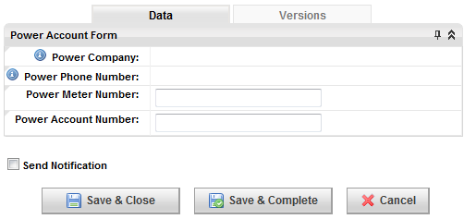

* + 16500 – Site Telcom/Fiber Ready - Site TELCO ready following power set-up.
    - 16500.1 Confirm Site Telco Ready
      * Role: Regional Construction Engineer(RCE)
  + 16600 – Site Equipment Ready - Site is room ready following generator install and electric power installed.
    - 16600.1 Confirm Room Ready
      * Role: Regional Project Manager(RPM
  + 16700 – FOC Date Received - Firm Order Commitment (FOC) date received following Room Ready.
    - 16700.1 Confirm FOC Date Received
      * Role: Regional Transport Engineer(RTRSPRTE)
  + 16800 – Tower/Pole Erected - Tower may be erected following regulatory structure compliance and tower foundation completion.
    - 16800.1 Confirm Tower / Pole Erected
      * Role: Regional Construction Engineer(RCE)
  + 16900 – Visual Monitoring Ticket
    - 16900.1 Create visual monitoring ticket
      * Role: Regional Construction Engineer(RCE)

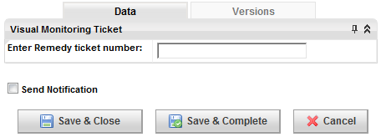

* + 17000 – Lines and Antennas Installed - Lines and antenna may be installed following tower erection.
    - 17000.1 Confirm Lines & Antennas Installed
      * Role: Regional Construction Engineer(RCE)
    - 17000.2 Antenna Placement and Orientation Verified
      * Role: Regional Performance Engineer(RSPE)
  + 17100 – Post Construction Height Verification - Verify tower height following construction.
    - 17100.1 RAD Center Height Verification
      * Role: Vendor Construction Manager(VCM)
    - 17100.2 Confirm Post Construction Height Verification
      * Role: Regional Construction Engineer(RCE)
  + 17200 – Post-TCN Process – 39 - Post-TCN process commences following tower height verification and regulatory compliance.
    - 17200.1 Post-TCN Form
      * Role: Regional Construction Engineer(RCE)

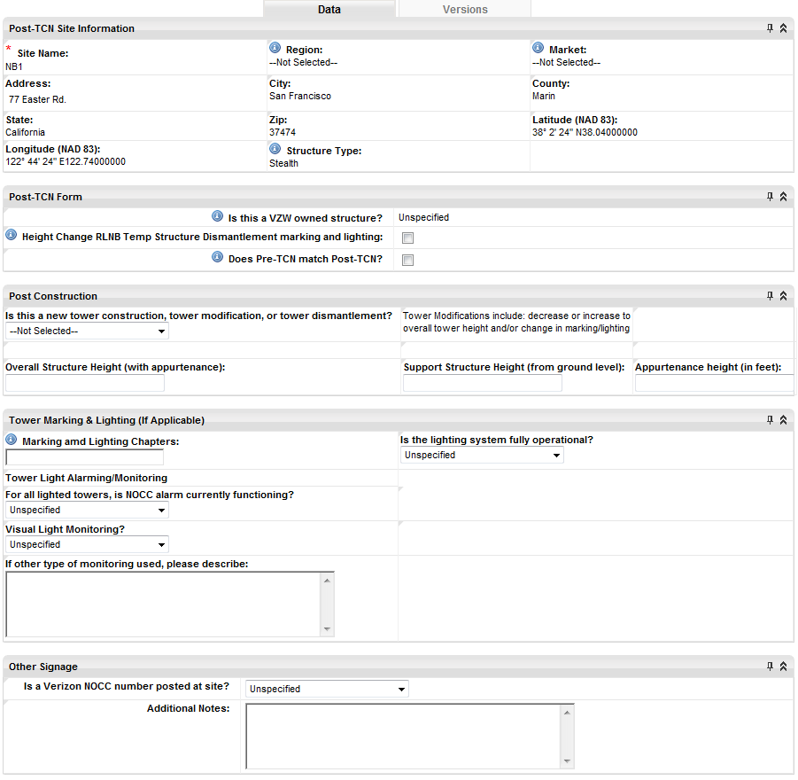

* + - 17200.2 Post-TCN Construction Review
      * Role: HQ Regulatory Structure Compliance(HQRSC)

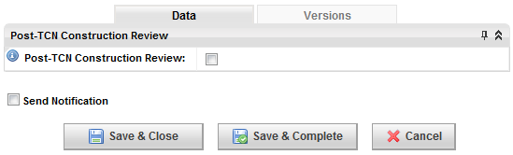

* + - 17200.3 Confirm FAA Notified
    - Role: HQ Regulatory Structure Compliance(HQRSC)
    - 17200.4 Confirm FCC Notified
    - Role: HQ Regulatory Structure Compliance(HQRSC)
    - 17200.5 Market Lead Approval
    - Role: Regional Real Estate Specialist (RRES)
  + 17400 – E911 Complete - Once E911 process is complete upload completed TVW.
    - 17400.2 Upload Completed TVW
      * Role: Regional RF Engineering(RRFE)
  + 17500 – Cabinet Installed - Base transceiver station (BTS) may be installed following tower foundation completion.
    - 17500.2 Confirm BTS Installed
      * Role: Regional Equipment Engineer (REE)
  + 17700 – Backhaul Equipment Installed - Backhaul equipment may be installed following receipt.
    - 17700.1 Confirm Backhaul Equipment Installed
      * Role: Regional Transport Engineer(RTRSPRTE)
  + 17800 – Construction Complete - Verify construction completion, commences following installation of lines and antennas (13900).
    - 17800.1 Sweeps Document
      * Role: Regional Construction Engineer(RCE)
    - 17800.2 Confirm Construction is Finished
      * Role: Regional Construction Engineer(RCE)
  + 17900 – RF Antenna Verification
    - 17900.1 Verify RF Antenna Configuration
      * Role: Regional RF Engineering(RRFE)
  + 18000 – Review Line Sweeps - Review sweeps.
    - 18000.1 Review Sweeps
      * Role: Regional Performance Engineer(RSPE)
  + 18100 – Backhaul Tested and Accepted - Backhaul test and accepted upon installation.
    - 18100.1 Test Data
      * Role: Regional Cell Tech(RCT)
    - 18100.2 Confirm Backhaul Tested and Accepted
      * Role: Regional Cell Tech(RCT)
  + 18300 – Construction Complete with Backhaul Integrated - Construction complete with backhaul integration.
    - 18300.1 Confirm Construction Complete with Backhaul Integrated
      * Role: Regional Construction Engineer(RCE)
  + 18400 – Microwave Frequency Coordination Cleared
    - 18400.1 Confirm Frequency Coordination Cleared
      * Role: HQ Regulatory RF Compliance(HQRRFC)
  + 18600 – Operations Accepts or Rejects - Operations accepts or rejects site following construction completion.
    - 18600.1 Operation Accepts or Rejects Site
      * Role: Regional Cell Tech(RCT)

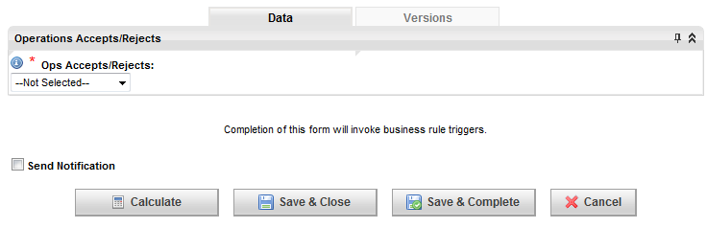

* + - 18600.2 Site Acceptance Document
      * Role: Regional Cell Tech(RCT)
  + 18700 – Resubmit to Operations - Re-submission process to operations should site be rejected.
    - 18700.1 Confirm Re-submittal
      * Role: Regional Construction Engineer(RCE)
    - 18700.2 Confirm Re-submittal Form
      * Role: Regional Construction Engineer(RCE)
  + 18800 – Confirmation Operations Accepts - Confirmation of operations acceptance.
    - 18800.1 Confirm Conditions for Acceptance are Complete
      * Role: Regional Cell Tech(RCT)
  + 18900 – NOC Ticketing - Upon acceptance, a network operations center (NOC) ticket is opened.
    - 18900.1 Confirm NOC Ticket Opened
      * Role: Regional Cell Tech(RCT)
  + 19000 – E911 Translations - Upon E911 completion, E911 translations commence.
    - 19000.1 Confirm E911 Translations Complete
      * Role: Area Translations(AT)
  + 19100 – Site/Cluster Optimization - Site/cluster optimization upon confirmation of operations acceptance.
    - 19100.2 Optimization Report
      * Role: Regional Performance Engineer(RSPE)
    - 19100.3 Optimization Approval
      * Role: Regional Performance Engineer(RSPE)
  + 19200 – Site Testing and ICI Complete - Site testing complete following E911 Translations and Site/Cluster Optimization.
    - 19200.1 Confirm Site Testing Complete
      * Role: Regional Performance Engineer(RSPE)
  + 19300 – Site is ON AIR - On Air steps being following the Backhaul Deployment call sign tasks, completion of Review Sweeps, and completion of E911.
    - 19300.1 On Air Notice
      * Role: Regional Performance Engineer(RSPE)

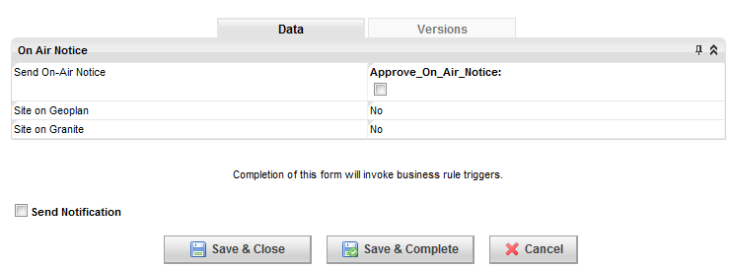

* + - 19300.2 Submit Activation Notice for 700
      * Role: Regional Performance Engineer(RSPE)
    - 19300.3 Submit Activation Notice for 850
      * Role: Regional Performance Engineer(RSPE)
    - 19300.4 Submit Activation Notice for PCS
      * Role: Regional Performance Engineer(RSPE)
    - 19300.5 Submit Activation Notice for CDMA
    - Role: Regional Performance Engineer(RSPE)
    - 19300.6 On Air Notice Form
      * Role: Regional Performance Engineer(RSPE)
  + 19400 – RFE Compliance Complete
    - 19400.1 RFE Compliance Closeout
      * Role: Regional RF Engineering(RRFE)
    - 19400.2 3rd Party EME Assessment
      * Role: Regional RF Engineering(RRFE)
    - 19400.3 RoofView Model + RF Checklist
      * Role: Regional RF Engineering(RRFE)
  + 19500 – Punchwalk Items Complete
    - 19500.1 Open Item Punch List
      * Role: Regional Construction Engineer(RCE)
  + 19700 – Environmental Asset Verification - Verify environmental assets, commences following backup power installation (12300).
    - 19700.1 Tech Completes Environmental Site Verification in EMIS
      * Role: Regional Cell Tech(RCT)
    - 19700.2 Confirm Equipment Photos uploaded in EMIS
      * Role: Regional Cell Tech(RCT)
  + 19800 – Close Out Documents Received - Upon completion of the Punch Walk List Items, commence the close out document checklist.
    - 19800.1 GC Warranty Document
      * Role: Regional Construction Engineer(RCE)
    - 19800.2 Emergency Numbers
      * Role: Regional Construction Engineer(RCE)
    - 19800.3 Emergency Checklist
      * Role: Regional Construction Engineer(RCE)
    - 19800.4 Injury Report
      * Role: Regional Construction Engineer(RCE)
    - 19800.5 Meeting Record
      * Role: Regional Construction Engineer(RCE)
    - 19800.6 Project Notes
      * Role: Regional Construction Engineer(RCE)
    - 19800.7 General Liability Report
      * Role: Regional Construction Engineer(RCE)
    - 19800.8 Vehicle Accident Report
      * Role: Regional Construction Engineer(RCE)
    - 19800.9 Sub-Unconditional Waiver & Release Upon Final Payment
      * Role: Regional Construction Engineer(RCE)
    - 19800.10 Approved Permitting Set of Drawings (.pdf)
      * Role: Regional Construction Engineer(RCE)
    - 19800.11 Agenda/Notes/Minutes from Pre-Construction Meeting
      * Role: Regional Construction Engineer(RCE)
    - 19800.12 Reinforcement Certification (Mill Certification)
      * Role: Regional Construction Engineer(RCE)
    - 19800.13 Concrete Mix Design & Product data (Tower Foundation)
      * Role: Regional Construction Engineer(RCE)
    - 19800.14 Special Inspection/City Inspection Card
      * Role: Regional Construction Engineer(RCE
    - 19800.15 Cell Site Utility Setup
      * Role: Regional Construction Engineer(RCE)
    - 19800.16 EES Closeout Form
      * Role: Regional Construction Engineer(RCE)
    - 19800.17 Construction Manager
      * Role: Regional Construction Engineer(RCE)
  + 19900 – Site is On Air and Complete - Upon completion of close out documents and RFE compliance, project is complete.
* Modification

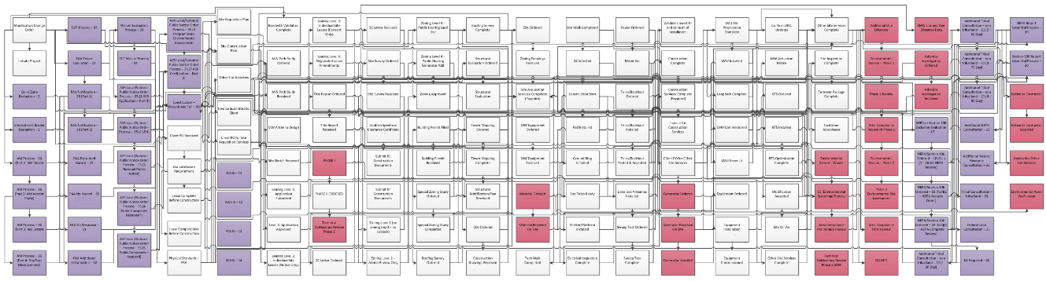

* + 100 - Modification Change Order - Prepare and submit modification change order.
    - 100.1 Submit Antenna Design/Plumbing Diagram
      * Role: Regional RF Engineering(RRFE)
    - 100.2 RF Config Form
      * Role: Regional RF Engineering(RRFE)
    - 100.3 Modification Change Order Form
      * Role: Regional RF Engineering(RRFE)

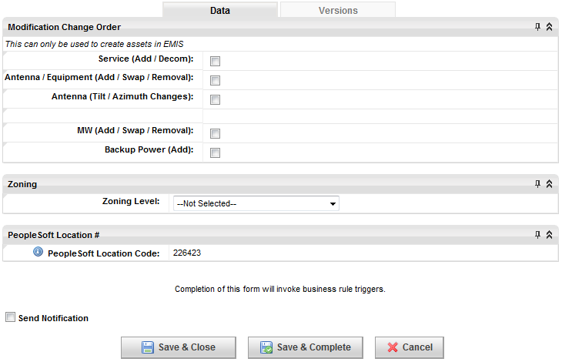

* + 200 - Initiate Project - Prepare and submit Initiate Project form, commence following Modification Change Order (3500).
    - 200.1 Complete Initiate Project form
      * Role: Regional Real Estate Specialist (RRES)



* + - 200.2 NTP for Site Acq
      * Role: Regional Project Manager(RPM)
  + 300 - Quiet Zone Evaluation - Perform Quiet Zone Evaluation, commence following Final RF Configuration (11250).
  + 400 - International Border Evaluation - Perform International Border Evaluation, commence following Final RF Configuration (11250).
    - 400.1 International Border Evaluation
      * Role: Regional RF Engineering(RRFE)
  + 500 - AM Process (Part 1: AM Check) - Perform AM Check, commence following Final RF Configuration (11250).
    - 500.1 Run AM Check
      * Role: Regional Regulatory Analyst(RRA)

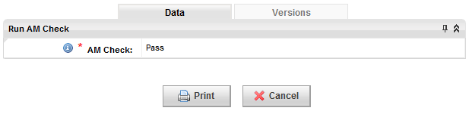

* + - 500.2 Upload AM Pass Certificate (PDF)
      * Role: Regional Regulatory Analyst(RRA)
    - 500.3 Confirm AM Study Ordered from Vendor
      * Role: Regional Construction Engineer(RCE)
  + 600 - AM Process (Part 2: AM Vendor Study) - Perform AM Vendor Study, commence following AM Process (400).
    - 600.1 Confirm Job Accepted
      * Role: Regional Regulatory Analyst(RRA)
    - 600.2 AM Form
      * Role: Regional Regulatory Analyst(RRA)
  + 700 - AM Process (Part 3: AM Letter) - Reach resolution with AM Station, commence following AM Vendor Study (500).
    - 700.1 Confirm Letter send to AM Station
      * Role: Regional Regulatory Analyst(RRA)
    - 700.2 Upload AM Letter to AM Station
      * Role: Regional Regulatory Analyst(RRA)
    - 700.3 AM Station Response
      * Role: Regional Regulatory Analyst(RRA)
    - 700.4 Confirm Resolution Reached with AM Station
      * Role: Regional Regulatory Analyst(RRA)
  + 800 - AM Process (Part 4: Pre/Post Measurement) - Perform post-resolution AM measurements, commence following AM letter (600).
    - 800.1 Upload Pre AM Measurement Study
      * Role: Regional Regulatory Analyst(RRA)
  + 900 - DOT Process - Complete DOT regulatory process.
    - 900.1 Confirm DOT Application has been filed
      * Role: HQ Regulatory Structure Compliance(HQRSC)
    - 900.2 Enter DOT Application Response
      * Role: HQ Regulatory Structure Compliance(HQRSC)
    - 900.3 Upload DOT Approval
      * Role: HQ Regulatory Structure Compliance(HQRSC)
    - 900.4 Upload DOT Rejection
      * Role: HQ Regulatory Structure Compliance(HQRSC)
    - 900.5 Choose to Refile
      * Role: Regional Regulatory Analyst(RRA)
  + 950 - Airspace Opinion - Request FAA airspace opinion.
    - 950.1 Airspace Opinion Letter
    - 950.2 Airspace Results
  + 1000 - FAA Tower Evaluation –27 - Complete FAA tower evaluation, commences following airspace opinion (950).
    - 1000.1 Tower Evaluation Form
      * Role: Regional Regulatory Analyst(RRA)
    - 1000.2 Is FAA Notification Required?
      * Role: Regional Regulatory Analyst(RRA)
    - 1000.3 Enter Tower Owner's FAA Study #
      * Role: Regional Regulatory Analyst(RRA)
    - 1000.4 HQ Construction Review HQ
      * Role: Regulatory Structure Compliance(HQRSC)
  + 1100 - FAA Notification - 28 (Part 1) - Confirm FAA Notification has been filed (File 7460-1).
    - 1100.1 Confirm FAA Notification has been filed (File 7460-1)
      * Role: HQ Regulatory Structure Compliance(HQRSC)
  + 1200 - FAA Notification - 28 (Part 2)
    - 1200.1 FAA Determination Received - 28 (Part 2)
      * Role: HQ Regulatory Structure Compliance(HQRSC)
  + 1300 - FAA Presumed Hazard – 29 - Determine possibility of FAA presumed hazard.
    - 1300.1 Upload Presumed Hazard Determination
      * Role: HQ Regulatory Structure Compliance(HQRSC)
    - 1300.2 HQ Construction Review of Determination and Summarize Results
      * Role: HQ Regulatory Structure Compliance(HQRSC)
    - 1300.3 Regional Review of Determination and HQ Construction Summary
      * Role: Regional Regulatory Analyst(RRA)
    - 1300.4 Confirm Response sent to FAA of Public Comment
      * Role: HQ Regulatory Structure Compliance(HQRSC)
  + 1400 - FAA No Hazard – 30 - In the event a "No Hazard" determination is made (3200), the FAA No Hazard process commences.
    - 1400.1 Upload No Hazard Determination
      * Role: HQ Regulatory Structure Compliance(HQRSC)
    - 1400.2 Review No Hazard Determination
      * Role: HQ Regulatory Structure Compliance(HQRSC)



* + - 1400.3 Region Special Conditions Complete
      * Role: HQ Regulatory Structure Compliance(HQRSC)
    - 1400.4 Construction Special Conditions Complete
      * Role: HQ Regulatory Structure Compliance(HQRSC)
    - 1400.5 Confirm Appeal Submitted to FAA
      * Role: HQ Regulatory Structure Compliance(HQRSC)
  + 1500 - FAA No Response – 31 - Follow up on FAA No Response.
    - 1500.1 Follow up with FAA due to no response
      * Role: HQ Regulatory Structure Compliance(HQRSC)
  + 1600 - FAA Additional Information – 32 - Process Additional Information for FAA.
    - 1600.1 Upload Letter Requesting Additional Information
      * Role: HQ Regulatory Structure Compliance(HQRSC)
    - 1600.2 Review Additional Information Request and Summarize Results
      * Role: HQ Regulatory Structure Compliance(HQRSC)
    - 1600.3 Region Responds to HQ Construction with Additional Information
      * Role: Regional Regulatory Analyst(RRA)
    - 1600.4 HQ Construction follows up with FAA HQ
      * Role: Regulatory Structure Compliance(HQRSC)
  + 1700 - Waiver Evaluation Process – 33 - Process FCC waiver evaluation.
    - 1700.1 Waiver Evaluation Form
      * Role: Regional Regulatory Analyst(RRA)



* + - 1700.2 Temp Site Exclusion Form
      * Role: Regional Regulatory Analyst(RRA)



* + 1800 - Shielding Request - Process request for shielding.
    - 1800.1 Shielding Request
      * Role: HQ Regulatory Structure Compliance(HQRSC)

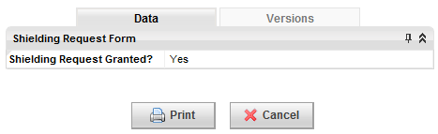

* + 1900 - FCC Waiver Process – 34 - Process FCC waiver request.
    - 1900.1 Confirm FCC Waiver has been Filed
      * Role: HQ Regulatory Structure Compliance(HQRSC)
    - 1900.2 Update Waiver Response
      * Role: HQ Regulatory Structure Compliance(HQRSC)



* + 2000 - ASR Local/National Public Notice Order Process - 35 (ASR Application - Part 1) - Begin ASR Local/National Public Order Notice process, application filing.
    - 2000.1 Part 1 ASR Application filed
      * Role: HQ Regulatory Structure Compliance(HQRSC)

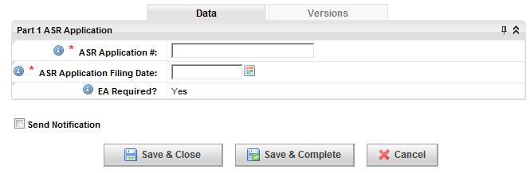

* + 2100 - ASR Public Notice Order Process - 35 (2 LPN) - ASR Local/National Public Order Notice process, LPN posting date.
    - 2100.1 Enter LPN Posting Date
      * Role: Regional Regulatory Analyst(RRA)

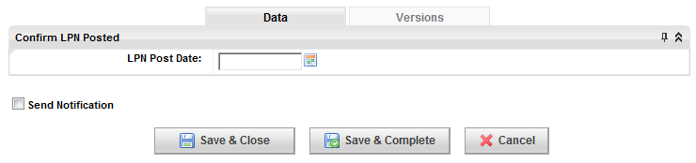

* + 2200 - ASR Public Notice Order Process - 35 (3 National Public Notice) - ASR Local/National Public Order Notice process, NPN posting date.
    - 2200.1 Enter National Public Notice Posting Date
      * Role: Regional Regulatory Analyst(RRA)

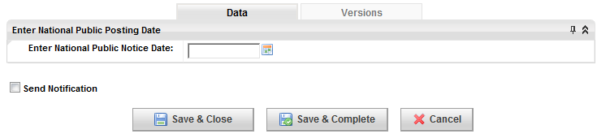

* + 2300 - ASR Local/National Public Notice Order Process - 35 (4 Public Complaints Received?) - ASR Local/National Public Order Notice process, Public Complaints.
    - 2300.1 Public Complaints
      * Role: HQ Regulatory Structure Compliance(HQRSC)

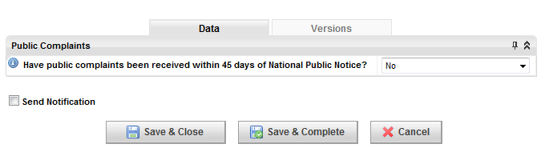

* + 2400 - ASR Local/National Public Notice Order Process - 35 (5 Public Complaints - Respond) - ASR Local/National Public Order Notice process, resolution of complaint.
    - 2400.1 Confirm response to complaint
      * Role: HQ Regulatory Structure Compliance(HQRSC)
    - 2400.2 Confirm copy of Response has been filed with FCC
      * Role: HQ Regulatory Structure Compliance(HQRSC)
    - 2400.3 Complaint Resolved?
      * Role: HQ Regulatory Structure Compliance(HQRSC)

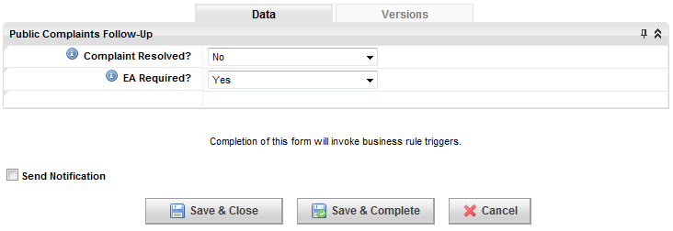

* + 2500 - ASR Local/National Public Notice Order Process - 35 (6 Programmatic Environmental Assessment)
    - 2500.1 Report Developed and Submitted to FCC
      * Role: Regional Regulatory Analyst (RRA)

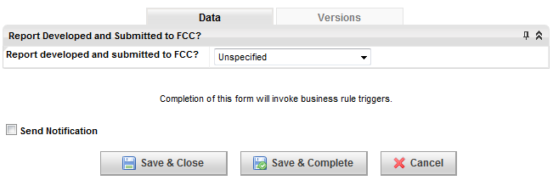

* + 2600 - ASR Local/National Public Notice Order Process - 35 (7 ASR Certification - Part 2)
    - 2600.1 Form Part 2 Certification
      * Role: HQ Regulatory Structure Compliance (HQRSC)

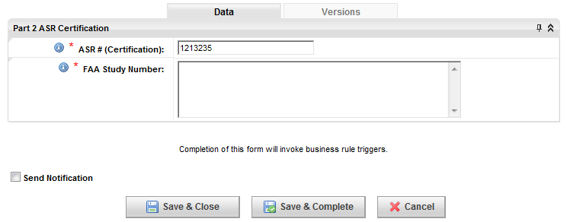

* + 2700 - Regulatory Construction Compliance - Ground – 40a - Ground construction approval process, commence following complete NEPA and tribal approval processes (7800, 7900, 7700, 8800, 7600, 7500, 8900).
    - 2700.1 Siterra Issues Ground Construction Approval
  + 2800 - Regulatory Structure Compliance - Full – 40b - Full construction approval process, commence following complete regulatory approvals (2200, 2000, 7800, 7900, 1900, 2100, 1000, 1100, 7700, 600, 8200, 8800, 8000, 1600, 8600, 700, 1500, 1800, 500, 8500, 8300, 800, 8400, 8100, 1700, 900, 1000.2, 7600, 8700, 2300, 1400, 1300, 400, 8900, 7500).
    - 2800.1 Siterra Issues Full Construction Approval
  + 2900 - Evaluate Lease Requirement - Evaluate lease requirement form.
    - 2900.1 Complete Lease Requirement form
      * Role: Regional Real Estate Specialist (RRES)

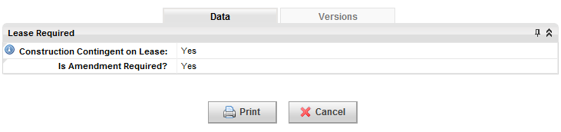

* + 3000 - 700 IS – 11 - Complete 700-IS call sign approval.
    - 3000.1 Call Sign 1 Approved
      * Role: HQ Regulatory Licensing Compliance(HQRLC)
    - 3000.2 Call Sign 2 Approved
      * Role: HQ Regulatory Licensing Compliance(HQRLC)
    - 3000.3 Call Sign 3 Approved
      * Role: HQ Regulatory Licensing Compliance(HQRLC)
    - 3000.4 Call Sign 4 Approved
      * Role: HQ Regulatory Licensing Compliance(HQRLC)
  + 3100 - AWS IS – 12 - Complete AWS IS call sign approval.
    - 3100.1 Call Sign 1 Approved
      * Role: HQ Regulatory Licensing Compliance(HQRLC)
    - 3100.2 Call Sign 2 Approved
      * Role: HQ Regulatory Licensing Compliance(HQRLC)
    - 3100.3 Call Sign 3 Approved
      * Role: HQ Regulatory Licensing Compliance(HQRLC)
    - 3100.4 Call Sign 4 Approved
      * Role: HQ Regulatory Licensing Compliance(HQRLC)
    - 3100.5 Call Sign 5 Approved
      * Role: HQ Regulatory Licensing Compliance(HQRLC)
  + 3200 - PCS IS – 13 - Complete PCS IS call sign approval.
    - 3200.1 Call Sign 1 Approved
      * Role: HQ Regulatory Licensing Compliance(HQRLC)
    - 3200.2 Call Sign 2 Approved
      * Role: HQ Regulatory Licensing Compliance(HQRLC)
    - 3200.3 Call Sign 3 Approved
      * Role: HQ Regulatory Licensing Compliance(HQRLC)
    - 3200.4 Call Sign 4 Approved
      * Role: HQ Regulatory Licensing Compliance(HQRLC)
    - 3200.5 Call Sign 5 Approved
      * Role: HQ Regulatory Licensing Compliance(HQRLC
    - 3200.6 Call Sign 6 Approved
      * Role: HQ Regulatory Licensing Compliance(HQRLC)
    - 3200.7 Call Sign 7 Approved
      * Role: HQ Regulatory Licensing Compliance(HQRLC)
    - 3200.8 Call Sign 8 Approved
      * Role: HQ Regulatory Licensing Compliance(HQRLC)
  + 3300 - 850 IS – 14 - Complete 850 IS call sign approval.
    - 3300.1 Call Sign 1 Approved
      * Role: HQ Regulatory Licensing Compliance(HQRLC)
    - 3300.2 Call Sign 2 Approved
      * Role: HQ Regulatory Licensing Compliance(HQRLC)
    - 3300.3 Call Sign 3 Approved
      * Role: HQ Regulatory Licensing Compliance(HQRLC)
    - 3300.4 Call Sign 4 Approved
      * Role: HQ Regulatory Licensing Compliance(HQRLC)
  + 3400 - MW IS Approval - Complete MW IS approval, commences following MW antenna design.
  + 3450 - Microwave Activation - Complete Microwave activation, commences following MS IS approval.
  + 3500 - Backhaul Type - Select backhaul type.
    - 3500.1 Backhaul Selection Form
      * Role: Regional Transport Engineer(RTRSPRTE)
  + 3600 - MW Path Study Ordered - Order microwave path study, commences following backhaul type selection (18000).
    - 3600.1 Path Study Ordered
      * Role: Regional Microwave Engineer(RME)
  + 3700 - MW Path Study Received - Receive microwave path study.
    - 3700.1 Path Study Received
      * Role: Regional Microwave Engineer(RME)
  + 3800 - MW Antenna Design - Process microwave antenna design.
    - 3800.1 MW Antenna Design
      * Role: Regional Microwave Engineer(RME)
  + 3900 - Leasing Level 1: Application Submitted - Submit application, leasing level 1, commences following evaluation of lease requirement (2600).
    - 3900.1 Co-Locate fees
      * Role: Vendor Site Acquisition(VSA)
    - 3900.2 Confirm Leasing Level 1: Application Submitted
      * Role: Regional Real Estate Specialist (RRES)
  + 4000 - Leasing Level 1: Application Approved - Application approval, leasing level 1.
    - 4000.1 Leasing Application
      * Role: Vendor Site Acquisition(VSA)
    - 4000.2 Confirm Leasing Level 1: Application Approved
      * Role: Regional Real Estate Specialist (RRES)
  + 4100 - Leasing Level 2: Individual Site Leases (Notice Only) - Create notice documentation, leasing level 2, commences following evaluation of lease requirement (2600).
    - 4100.1 Notice Documentation
      * Role: Vendor Site Acquisition(VSA)
    - 4100.2 Confirm Leasing Level 2: Individual Site Leases (Notice Only)
      * Role: Regional Real Estate Specialist (RRES)
  + 4200 - Leasing Level 3: Individual Site Leases (Consent Only) - Create consent documentation, leasing level 3, commences following evaluation of lease requirement (2600).
    - 4200.1 Consent Documentation
      * Role: Vendor Site Acquisition(VSA)
    - 4200.2 Confirm Leasing Level 3: Individual Site Leases (Consent Only)
      * Role: Regional Real Estate Specialist (RRES)
  + 4300 - Leasing Level 4: Negotiated Lease Amendments - Create negotiation lease amendments, leasing level 4, commences following evaluation of lease requirement (2600).
    - 4300.1 Amendment
      * Role: Vendor Site Acquisition(VSA)
    - 4300.2 Confirm Leasing Level 4: Negotiated Lease Amendments
      * Role: Regional Real Estate Specialist (RRES)
  + 4400 - Amendment Fully Executed - Final execution of amendment, commences following approval lf level 1 leasing application (4900) and area compliance final review (6800).
    - 4400.1 'Client' Market Lead Approval
      * Role: Vendor Site Acquisition(VSA)
    - 4400.2 RE Approval
      * Role: Regional Real Estate Specialist (RRES)
  + 4500 - Commencement Date - Commencement of amendment and notification.
    - 4500.1 Amendment Commence
      * Role: Regional Real Estate Specialist (RRES)

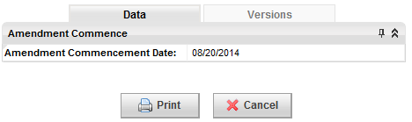

* + - 4500.2 Commencement Letter
      * Role: Regional Real Estate Specialist (RRES)
  + 4600 - NEPA or Section 106 Exclusion Evaluation – 17 - Perform NEPA or Section 106 Esclusion evaluation, commences following Final RF Configuration.
    - 4600.1 Tower Collocation/Modification Form
      * Role: Regional Regulatory Analyst(RRA)
    - 4600.2 Non-Tower Collocation/Modification Form
      * Role: Regional Regulatory Analyst(RRA)
    - 4600.3 NEPA / 106 Exclusion Evaluation Form
      * Role: Regional Regulatory Analyst(RRA)
    - 4600.4 Upload Tower Owner Certification Letter
      * Role: Regional Regulatory Analyst(RRA)
    - 4600.5 Tower Questions
      * Role: Regional Regulatory Analyst(RRA)
    - 4600.6 Exclusion Review
      * Role: HQ Regulatory Structure Compliance(HQRSC)
  + 4700 - NEPA/Section 106 Ordered - 18 (Full) (1 - Order NEPA Review)
    - 4700.1 Candidate Site Profile Form
      * Role: Regional Regulatory Analyst(RRA)
    - 4700.2 Submit NEPA Order
      * Role: Regional Real Estate Specialist (RRES)
    - 4700.3 QA/QC Review
      * Role: HQ Regulatory Structure Compliance(HQRSC)
  + 4800 - NEPA/Section 106 Ordered - 18 (Full) (2 - NEPA Accepts Order) - NEPA/Section 106 order accepted by NEPA consultant.
    - 4800.1 NEPA Consultant Accepts Order
      * Role: Vendor NEPA(VNEPA)
  + 4900 - NEPA/Section 106 Ordered - 18 (Full) (3 - NEPA Complete Review) - Complete NEPA review or order.
    - 4900.1 NEPA Review
      * Role: Vendor NEPA(VNEPA)
  + 5000 - Additional Tribal Consultation - Non Tribal Land - 21 (1 - 30 Day) - Additional tribal consultation - non-tribal land - (1 - 30 day), follow-up package sent, commences following NEPA report submittal process (8800), Section 106 report submittal process (8900).
    - 5000.1 Confirm Follow-up Package sent to Tribe
      * Role: Vendor NEPA(VNEPA)
    - 5000.2 Tribal Concurrence (30 Days)
      * Role: Vendor NEPA(VNEPA)
  + 5100 - Additional Tribal Consultation - Non Tribal Land - 21 (2 - 60 Day) - Additional tribal consultation - non-tribal land - (2 - 60 day) confirm follow-up letter sent to tribe.
    - 5100.1 Confirm Follow-up letter sent to Tribe
      * Role: Vendor NEPA(VNEPA)
    - 5100.2 Tribal Concurrence (60 Days)
      * Role: Vendor NEPA(VNEPA)

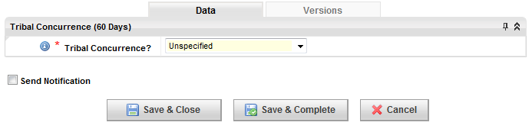

* + 5200 - Additional Tribal Consultation - Non Tribal Land - 21 (3 - 75 Day) - Additional tribal consultation - non-tribal land - (3 - 75 day) confirm closure letter sent to FCC.
    - 5200.1 Confirm Closure Letter sent to FCC (75 Days)
      * Role: Vendor NEPA(VNEPA)
  + 5300 - Additional Tribal Consultation - Non Tribal Land - 21 (4 - 90 Day) - Additional tribal consultation - non-tribal land - (4 - 90 day) confirm closure letter sent to tribe.
    - 5300.1 Confirm Closure Letter sent to Tribe
      * Role: Vendor NEPA(VNEPA)
    - 5300.2 Tribal Concurrence (90 Days)
      * Role: Vendor NEPA(VNEPA)

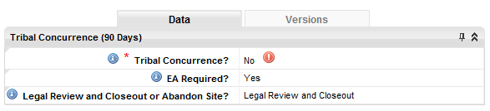

* + - 5300.3 Confirm Legal Review and Closeout Complete
      * Role: Vendor NEPA(VNEPA)

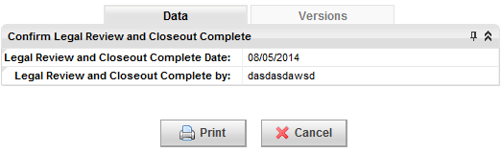

* + 5400 - Additional SHPO Consultation – 22 - Confirm communication with SHPO, commences following NEPA report submittal process (8800), Section 106 report submittal process (8900).
    - 5400.1 Confirm S106 form 620/621 sent to SHPO
      * Role: Vendor NEPA(VNEPA)
    - 5400.2 SHPO Concurrence
      * Role: Vendor NEPA(VNEPA)
    - 5400.3 Confirm form 620/621 sent to FCC (through e106)
      * Role: Vendor NEPA(VNEPA)
    - 5400.4 SHPO Concurrence (2)
      * Role: Vendor NEPA(VNEPA)
    - 5400.5 Confirm Memorandum of Agreement (MOA) Notification Received
      * Role: Vendor NEPA(VNEPA)
    - 5400.6 Confirm Memorandum of Agreement (MOA)
      * Role: Regional Regulatory Analyst(RRA)
    - 5400.7 Regional Response
      * Role: Vendor NEPA(VNEPA)
  + 5500 - Additional Natural Resource Consultation – 23 - Comfirm additional natural resource consultation, commences following NEPA report submittal process (8800), Section 106 report submittal process (8900).
    - 5500.1 Upload Mitigation Study
      * Role: Vendor NEPA(VNEPA)
    - 5500.2 QA/QC Process Results
      * Role: Vendor NEPA(VNEPA)
    - 5500.3 Confirm Mitigation Studies Submitted to Agency
      * Role: Vendor NEPA(VNEPA)
    - 5500.4 Agency Response
      * Role: HQ Regulatory Structure Compliance(HQRSC)
    - 5500.5 Agency Response Letter(s)
      * Role: HQ Regulatory Structure Compliance(HQRSC)
    - 5500.6 Regional Response
      * Role: Vendor NEPA(VNEPA)
    - 5500.7 Natural Resource Consultation
      * Role: Regional Regulatory Analyst(RRA)
  + 5600 - Tribal Consultation - Tribal Land – 24 - Tribal consultation - tribal land - initiate tribal outreach, commence following NEPA/Section 106 review (7800).
    - 5600.1 Confirm tribal outreach started
      * Role: Vendor NEPA(VNEPA)
    - 5600.2 Tribal Concurrence
      * Role: Vendor NEPA(VNEPA)
  + 5700 - Federal Land Consultation – 25 - Federal land consultation, commence following NEPA/Section 106 review (7800).
    - 5700.1 Confirm agency outreach started
      * Role: Vendor NEPA(VNEPA)
    - 5700.2 Agency Concurrence
      * Role: Vendor NEPA(VNEPA)
  + 5800 - EA Required – 26 - EA draft and communicate to FCC.
    - 5800.1 Draft and Upload EA
      * Role: Vendor NEPA(VNEPA)
    - 5800.2 QA/QC Review
      * Role: HQ Regulatory Structure Compliance(HQRSC)
    - 5800.3 Upload Final Version of EA that was sent to FCC
    - 5800.4 FCC Response
      * Role: HQ Regulatory Structure Compliance(HQRSC)
    - 5800.5 Upload FONSI Report
      * Role: Vendor NEPA(VNEPA)
  + 5900 - NEPA Report Submittal Process – 19 - Preparation for NEPA report submittal process, commences following completion of NEPA/Section 106 ORDERED process (7600, 7700, 7800).
    - 5900.1 Tribal Notification to FCC
      * Role: Vendor NEPA(VNEPA)
    - 5900.2 Tribal Summary Matrix
      * Role: Vendor NEPA(VNEPA)
    - 5900.3 Confirm Site Visit
      * Role: Vendor NEPA(VNEPA)
    - 5900.4 Upload Natural Resource (NR)
      * Role: Vendor NEPA(VNEPA)
    - 5900.5 NR Checklist
      * Role: HQ Regulatory Structure Compliance(HQRSC)
    - 5900.6 Upload Cultural Resource
      * Role: Vendor NEPA(VNEPA)
    - 5900.7 CR Checklist
      * Role: HQ Regulatory Structure Compliance(HQRSC)
    - 5900.8 Confirm NR Submitted to applicable agencies
      * Role: Vendor NEPA(VNEPA)
    - 5900.9 Confirm CR Submitted to Tribal
      * Role: Vendor NEPA(VNEPA)
    - 5900.10 NR Concurrence Received
      * Role: Vendor NEPA(VNEPA)
    - 5900.11 Tribal Concurrence Received
      * Role: Vendor NEPA(VNEPA)
    - 5900.12 Submit FCC E106
      * Role: Vendor NEPA(VNEPA)
    - 5900.13 Confirm S106 Manually Submitted to SHPO
      * Role: Vendor NEPA(VNEPA)
    - 5900.14 Upload S106
      * Role: Vendor NEPA(VNEPA)
    - 5900.15 SHPO Concurrence
      * Role: Vendor NEPA(VNEPA)
  + 6000 - NEPA Report Submittal Process – 19b - Complete submission of NEPA report submittal process.
    - 6000.1 Draft and upload Final NEPA Report
      * Role: Vendor NEPA(VNEPA)
    - 6000.2 QA/QC Review
      * Role: HQ Regulatory Structure Compliance(HQRSC)
    - 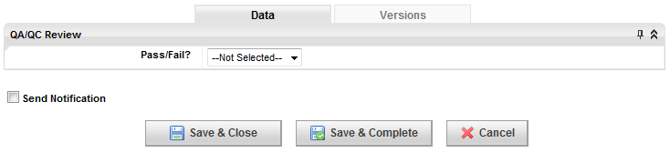
    - 6000.3 Upload Tower Owner Certification Letter

Role: Regional Regulatory Analyst(RRA)

* + 6100 - Section 106 Report Submittal Process – 20 - Preparation for Section 106 report submittal process, commences following completion of NEPA/Section 106 ORDERED process (7600, 7700, 7800).
    - 6100.1 Tribal Notification to FCC
      * Role: Vendor NEPA(VNEPA)

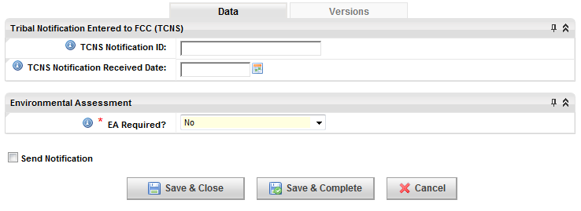

* + - 6100.2 Confirm Site Visit
      * Role: Vendor NEPA(VNEPA)

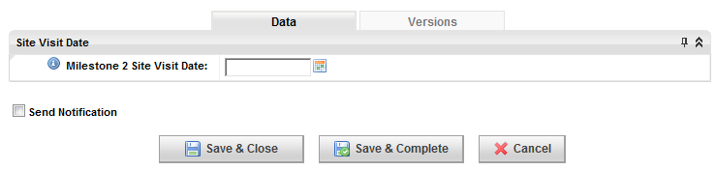

* + - 6100.3 Upload Cultural Resource
      * Role: Vendor NEPA(VNEPA)
    - 6100.4 CR Checklist
      * Role: HQ Regulatory Structure Compliance(HQRSC)

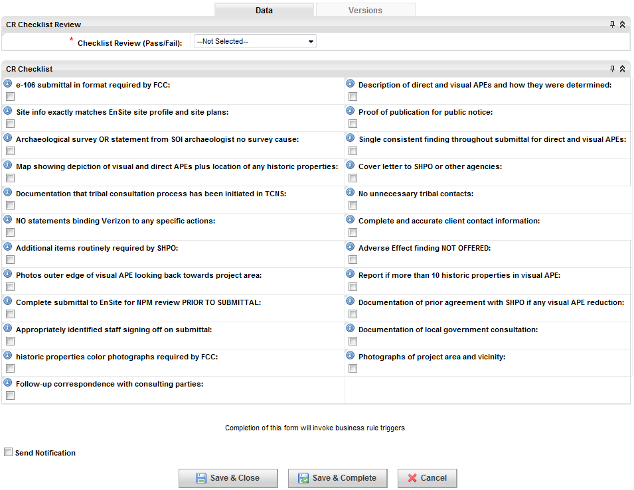

* + - 6100.5 Confirm CR Submitted to Tribal
      * Role: Vendor NEPA(VNEPA)
    - 6100.6 Tribal Concurrance Received
      * Role: Vendor NEPA(VNEPA)

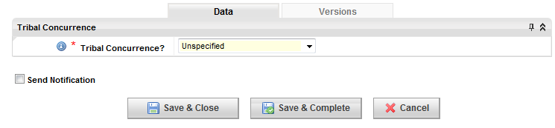

* + - 6100.7 Submit FCC E106
      * Role: Vendor NEPA(VNEPA)

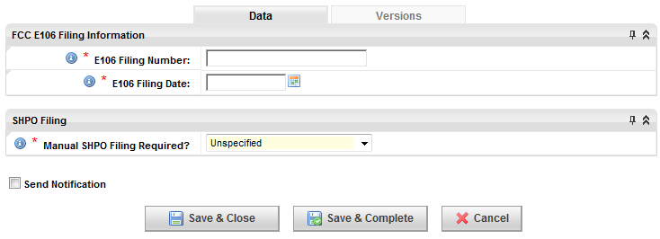

* + - 6100.8 Confirm S106 Manually Submitted to SHPO
      * Role: Vendor NEPA(VNEPA)
    - 6100.9 Upload S106
      * Role: Vendor NEPA(VNEPA)
    - 6100.10 Submit key form 620/621 to FCC
      * Role: Vendor NEPA(VNEPA)
    - 6100.11 SHPO Concurrence
      * Role: Vendor NEPA(VNEPA)

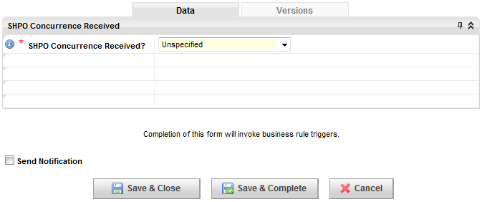

* + 6200 - Section 106 Report Submittal Process – 20b - Complete submission of Section 106 report submittal process.
    - 6200.1 Draft and Upload Final Section 106 Report
      * Role: Vendor NEPA(VNEPA)
    - 6200.2 QA/QC Review
      * Role: HQ Regulatory Structure Compliance(HQRSC)

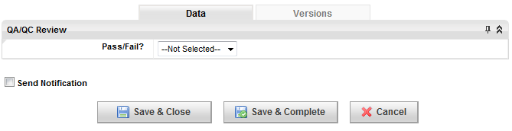

* + - 6200.3 Upload Tower Owner Certification Letter
      * Role: Regional Regulatory Analyst(RRA)
  + 6300 - RFE Compliance Analysis - Assess RFE compliance.
    - 6300.2 Pre-Installation RFE Assessment
  + 6400 - Environmental Screen – Waiver - Process environmental screen waiver.
    - 6400.1 Completion of Environmental Screen - Waiver Form
      * Role: Regional Real Estate Specialist (RRES)

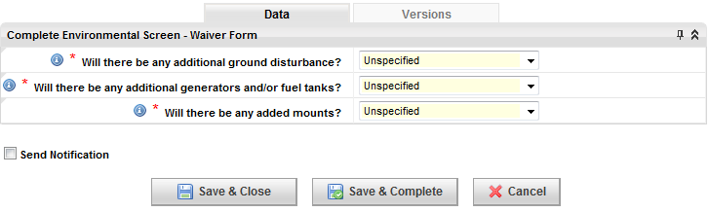

* + - 6400.2 Approval of Environmental Screen Waiver
      * Role: Regional Real Estate Manager (RREM)
  + 6500 - ES (Environmental Screening Process) - Perform environmental screening process.
    - 6500.1 Completion of the ES Form
      * Role: Regional Real Estate Specialist (RRES)
    - 6500.2 EDR Vista Check
      * Role: Regional Real Estate Specialist (RRES)
    - 6500.3 EDR NEPA Check
      * Role: Regional Real Estate Specialist (RRES)
    - 6500.4 Site Drawings
      * Role: Regional Real Estate Specialist (RRES)
    - 6500.5 Photos
      * Role: Regional Real Estate Specialist (RRES)
    - 6500.6 Other Historical Environmental documentation not currently loaded in Siterra
      * Role: Regional Real Estate Specialist (RRES)
  + 6600 - Area Compliance Preliminary Review - Preliminary area compliance process.
    - 6600.1 Area Compliance Preliminary Determination
      * Role: Area Environmental Compliance(AEC)



* + - 6600.2 HQ Notice
      * Role: Area Environmental Compliance(AEC)
  + 6700 - Technical Review Environmental Phase 2 SOW - Perform technical review Environmental Phase 2 SOW.
    - 6700.1 Order Technical Review of Environmental Phase 2 SOW
      * Role: Area Environmental Compliance(AEC)
    - 6700.2 Environmental Phase 2 SOW Review Completed
      * Role: Vendor Environmental (VE)
  + 6800 - Additional Due Diligence - Perform additional due diligence, commence following Environmental Phase 1 Review (6100).
    - 6800.1 EES (Environmental Evaluation Summary)
      * Role: Regional Real Estate Specialist (RRES)
    - 6800.2 Notice to Contractor
      * Role: Regional Real Estate Specialist (RRES)
    - 6800.3 Order Limited Site Inspection or Limited Site Investigation
      * Role: Regional Real Estate Specialist (RRES)
    - 6800.4 Limited Site Inspection or Limited Site Investigation
      * Role: Regional Real Estate Specialist (RRES)
    - 6800.5 Order ACM/LBP Survey
      * Role: Regional Real Estate Specialist (RRES)
    - 6800.6 ACM and/or LBP Survey
      * Role: Regional Real Estate Specialist (RRES)
    - 6800.7 Wetlands Survey
      * Role: Regional Real Estate Specialist (RRES)
    - 6800.8 Ground Penetrating Radar (GPR)
      * Role: Regional Real Estate Specialist (RRES)
    - 6800.9 Other
      * Role: Regional Real Estate Specialist (RRES)
    - 6800.10 Environmental Phase 2 SOW
      * Role: Regional Real Estate Specialist (RRES)
    - 6800.11 Right of Entry and Testing Agreement
      * Role: Regional Real Estate Specialist (RRES)
    - 6800.12 Site Access Agreement
      * Role: Regional Real Estate Specialist (RRES)
    - 6800.13 Environmental Notice to Contractor
      * Role: Regional Real Estate Specialist (RRES)
    - 6800.14 Soils Management Plan
      * Role: Regional Real Estate Specialist (RRES)
    - 6800.15 Ground Water Management Plan
      * Role: Regional Real Estate Specialist (RRES)
    - 6800.16 Operations and Maintenance Plan (O&M)
      * Role: Regional Real Estate Specialist (RRES
    - 6800.17 HASP - Health & Safety Plan
      * Role: Regional Real Estate Specialist (RRES)
    - 6800.18 Wetlands Delineation Study
      * Role: Regional Real Estate Specialist (RRES)
    - 6800.19 EDR NEPA Check
      * Role: Regional Real Estate Specialist (RRES)
    - 6800.20 EDR Vista Check
      * Role: Regional Real Estate Specialist (RRES)
    - 6800.21 Area Compliance Approval
  + 6900 - Environmental Phase I - Initiate Environmental Phase I, commences following environmental screen - waiver (5500).
    - 6900.1 Environmental Phase 1 Ordered
      * Role: Regional Real Estate Specialist (RRES)
    - 6900.2 Environmental Final Phase 1 Report (Must be Signed)
      * Role: Vendor Environmental Counsel(VEC)
  + 7000 - Environmental Phase I – Legal - Perform environmental review - legal.
    - 7000.1 Legal Review - Environmental Review
      * Role: Vendor Environmental Counsel(VEC)
  + 7100 - Environmental Phase I Review - Perform environmental phase 1 review.
    - 7100.1 Phase 1 Environmental Assessment
      * Role: Vendor Environmental Counsel(VEC)
  + 7200 - Area Compliance Review of Phase I - Perform area compliance review of Phase 1.
    - 7200.1 Area Compliance Review and Approval of Phase 1
      * Role: Area Environmental Compliance(AEC)
    - 7200.2 Area Compliance Phase 1 Determination
      * Role: Area Environmental Compliance(AEC)

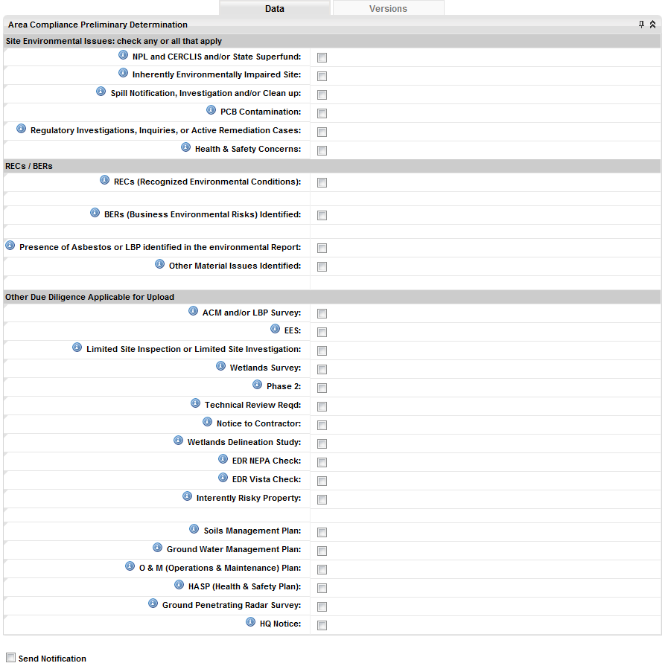

* + - 7200.3 Upload HQ Notification
      * Role: Area Environmental Compliance(AEC)
  + 7300 - Environmental Phase II Ordered - Initiate Environmental Phase II, commences following Environmental Phase I (5900), Area Compliance Preliminary Review (5700), and Technical Review of Environmental Phase II statement of work (5701).
    - 7300.1 Environmental Phase II Ordered
      * Role: Regional Real Estate Specialist (RRES)
    - 7300.2 Final Phase 2 Environmental Received
      * Role: Vendor Environmental Counsel(VEC)
  + 7400 - Technical Review Environmental Phase II - Perform technical review, environmental phase 2.
    - 7400.1 Environmental Phase 2 Technical Review Order
      * Role: Vendor Environmental (VE)
    - 7400.2 Environmental Phase 2 Technical Review
      * Role: Vendor Environmental (VE)
  + 7500 - Environmental Review - Phase II - Perform environmental phase 2 review - legal.
    - 7500.1 Legal Review - Environmental Review
      * Role: Vendor Environmental Counsel(VEC)
  + 7600 - Phase II Environmental Site Assessment - Perform environmental phase 2 site assessment.
    - 7600.1 Environmental Phase 2 Review Complete
      * Role: Vendor Environmental Counsel(VEC)
  + 7700 - Area Compliance Final Review - Perform area compliance final review, requires completion of all site review sub tasks (5500, 5701, 6600, 5702, 6500, 5700, 6400).
    - 7700.1 Area Compliance Final Review Form
      * Role: Area Environmental Compliance(AEC)



* + - 7700.2 Area Compliance Final Environmental Determination
      * Role: Area Environmental Compliance(AEC)
  + 7800 – EES - Final EES sign-off.
    - 7800.1 Route EES For signature
      * Role: Regional Real Estate Specialist (RRES)
  + 7900 - EMIS Site and Due Diligence Data - Process EMIS site and due diligence data.
    - 7900.1 Push EMIS Site Data and Enter Due Diligence Information
      * Role: Regional Real Estate Specialist (RRES)



* + 8000 - Backhaul Solution Available - Make backhaul solution available, commences following selection of backhaul type (18100).
    - 8000.1 Backhaul Deployment Lead Approval - BH FCC Form 601
      * Role: Regional Transport Engineer(RTRSPRTE)
  + 8100 - Zoning Level 1 (no zoning req'd - no subtask - Complete zoning level 1.
  + 8200 - Zoning Level 2 Admin Review Only - Complete zoning level 2 admin review.
    - 8200.1 Admin Review
      * Role: Vendor Site Acquisition(VSA)
    - 8200.2 Zoning Filing Fees
      * Role: Vendor Site Acquisition(VSA)
    - 8200.3 Confirm Zoning Level 2 - Admin Review Only
      * Role: Regional Real Estate Specialist (RRES)
  + 8300 - Zoning Level 3 - Public Hearing Land Use - Complete zoning level 3 - public hearing land use.
    - 8300.1 Zoning Application - Land
      * Role: Vendor Site Acquisition(VSA)
    - 8300.2 Zoning Filing Fees
      * Role: Vendor Site Acquisition(VSA)
    - 8300.3 Confirm Zoning Level 3 - Public Hearing Land Use
      * Role: Regional Real Estate Specialist (RRES)
  + 8400 - Zoning Level 4 - Public Hearing Generator Add - Complete zoning level 4 - public hearing generator add.
    - 8400.1 Zoning Application - Generator
      * Role: Vendor Site Acquisition(VSA)
    - 8400.2 Zoning Filing Fees
      * Role: Vendor Site Acquisition(VSA)
    - 8400.3 Confirm Zoning Level 4 - Public Hearing Generator Add
      * Role: Regional Real Estate Specialist (RRES)
  + 8500 - Zoning Approved - Document final zoning approved, commences following completion of all zoning sub-tasks (9900, 10000, 10100).
    - 8500.1 Approval Documentation
      * Role: Vendor Site Acquisition(VSA)
    - 8500.2 Confirm Zoning Approved
      * Role: Regional Real Estate Specialist (RRES)
  + 8600 - Building Permit Filed - File building permit.
    - 8600.1 Building Permit Application
      * Role: Regional Construction Engineer(RCE)
  + 8700 - Building Permit Received - Verify building permit received.
    - 8700.1 Building Permit
      * Role: Regional Construction Engineer(RCE)
  + 8800 - Pre-TCN Process –38 - Initiate Pre-TCN process.
    - 8800.1 Pre-TCN Form
      * Role: Regional Regulatory Analyst(RRA)
  + 8900 - Pre-TCN Process - 38 (Part 2: Construction Notification) - Initiate Pre-TCN process part 2, construction notification.
    - 8900.1 Upload Pre-TCN (7460-2 Part 1)
      * Role: Regional Regulatory Analyst(RRA)
    - 8900.2 Confirm Pre-TCN Submitted to FAA
      * Role: Regional Regulatory Analyst(RRA)
  + 9000 - ZDs Ordered - Order Zoning Diagrams, commences following final RF configuration (11250).
    - 9000.1 Confirm ZDs Ordered
      * Role: Regional Real Estate Specialist (RRES)
  + 9100 - ZDs Received - Verify receipt of all zoning diagrams.
    - 9100.1 Drawings - .dwg
      * Role: Vendor Site Acquisition(VSA)
    - 9100.2 Drawings - .pdf
      * Role: Vendor Site Acquisition(VSA)
    - 9100.3 Confirm Zoning Drawings Received
      * Role: Regional Real Estate Specialist (RRES)
    - 9100.4 Final signed and sealed ZDs with any notations or comments
      * Role: Vendor Site Acquisition(VSA)
  + 9200 - Structural Evaluation Ordered - Initiate order of structural evaluation.
    - 9200.1 Confirm Structural Evaluation Ordered
      * Role: Regional Construction Engineer(RCE)
  + 9300 - Structural Evaluation - Perform and verify structural evaluation.
    - 9300.1 Structural Evaluation
      * Role: Regional Construction Engineer(RCE)



* + - 9300.2 Structural Evaluation or Structural Letter
      * Role: Regional Construction Engineer(RCE)
    - 9300.3 Signed and Stamped Reinforcement/Modification Calculations
      * Role: Regional Construction Engineer(RCE)
  + 9400 - Tower Mapping Ordered - Initiate order of tower mapping.
    - 9400.1 Confirm Tower Mapping Ordered
      * Role: Regional Construction Engineer(RCE)
  + 9500 - Tower Mapping Complete - Verify completion of tower mapping.
    - 9500.1 Map
      * Role: Regional Construction Engineer(RCE)
    - 9500.2 Confirm Tower Mapping Complete
      * Role: Regional Construction Engineer(RCE)
  + 9600 - Final RF Configuration - Complete final RF configuration, commences following structural evaluation (11000).
    - 9600.1 Update RF Config
      * Role: Regional RF Engineering(RRFE)
  + 9700 - CDs Ordered - Order CDs, commences following tower mapping complete (11200), final RF configuration (11250), and structural evaluation (11000).
    - 9700.1 Confirm CDs Ordered
      * Role: Regional Construction Engineer(RCE)
  + 9800 - CDs Received - Verify receipt of all drawing CDs.
    - 9800.1 Drawings - .dwg
      * Role: Regional Construction Engineer(RCE)
    - 9800.2 Drawings - .pdf
      * Role: Regional Construction Engineer(RCE)
    - 9800.3 Landlord Signed Drawings
      * Role: Regional Construction Engineer(RCE)
    - 9800.4 Confirm Construction Drawings Received
      * Role: Regional Construction Engineer(RCE)
    - 9800.5 Submit Structure Form
      * Role: Regional Construction Engineer(RCE)

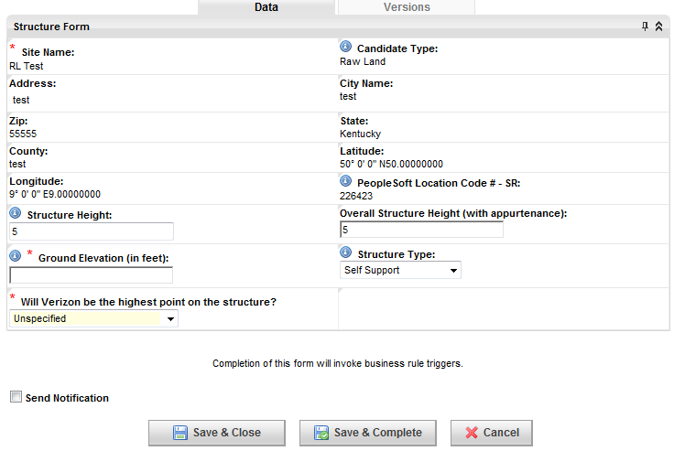

* + 9900 - Backhaul Design Completed - Verify completion of all backhaul design sub-tasks.
    - 9900.1 Backhaul Engineering Package
      * Role: Regional Transport Engineer(RTRSPRTE)
    - 9900.2 Confirm Backhaul Design Completed
      * Role: Regional Transport Engineer(RTRSPRTE)
  + 10000 - Site Acquisition Complete - Verify site acquisition complete, requires amendment fully executed (19000) and receipt of all zoning drawings (11700).
    - 10000.1 Confirm Site Acquisition Complete
      * Role: Regional Construction Engineer(RCE)
  + 10100 - Construction Contingent on Lease - Verify construction is contingent on lease, requires amendment fully executed (19000) and completed evaluation of lease requriement (2600).
  + 10200 - Construction Not Contingent on Lease - Verify construction is not contingent on lease, requires completed evaluation of lease requriement (2600).
  + 10300 - E911 Process Started - Initiate E911 process, commences following final RF configuration (11250), modification change order (3500), and construction start (12800).
    - 10300.1 Choose MPC Vendor and Submit E911
      * Role: Regional RF Engineering(RRFE)

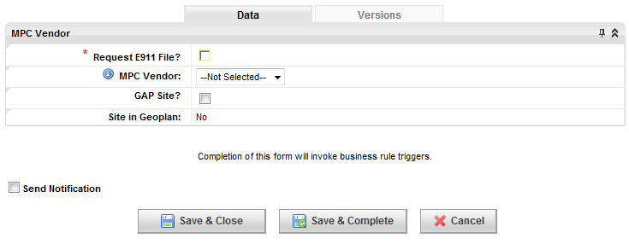

* + 10400 - NTP for Construction - Complete process for NTP for construction, commences following completion of regulatory structure compiance (2400, 2450), and determination of construction contingent on lease (11850, 11860).
    - 10400.1 NTP Form from Client
      * Role: Vendor Site Acquisition(VSA)
    - 10400.2 NTP to Construct
      * Role: Regional Real Estate Specialist (RRES)
    - 10400.3 Confirm NTP for Construction
      * Role: Regional Project Manager(RPM)
  + 10500 - NTP for Equipment Ordering - Complete process for NTP for equipment ordering, commencement follows determination of construction contingent on lease (11850, 11860).
    - 10500.1 PM Approval
      * Role: Regional Project Manager(RPM)
  + 10600 - MW Equipment Ordered - Order microwave equipment, commences following microwave antenna design (82).
    - 10600.1 MW Equipment Ordered
      * Role: Regional Microwave Engineer(RME)
  + 10700 - MW Equipment Installed - Install microwave equipment.
    - 10700.1 MW Equipment Installed
      * Role: Regional Microwave Engineer(RME)
  + 10800 - Environmental Notice to Contractor - Environmental Notice to Contractor delivered following completion of Environmental Screening (ES) (1600) and Other Due Diligence (1800).
    - 10800.1 Notice to Contractor Delivered (should be included in Bid Packet)
      * Role: Regional Construction Engineer (RCE)
  + 10900 - Bid Walk Complete - Complete bid and evaluation documentation.
    - 10900.1 Bids and Evaluation Documentation
      * Role: Regional Construction Engineer(RCE)
    - 10900.2 Confirm Bid Walk Complete
      * Role: Regional Construction Engineer(RCE)
  + 11000 - Environmental Notice to Contractor Accepted - Get final acceptance of environmental notice from contractor.
    - 11000.1 Contractor Signs/Accepts NTC
      * Role: Regional Construction Engineer(RCE)
  + 11100 - Award Contract - Complete award of contract.
    - 11100.1 Confirm Contract Awarded
      * Role: Regional Construction Engineer(RCE)
  + 11200 - Define Back-Up Power Order Types - Define order types for back-up power.
    - 11200.1 Define Order Types for Battery/Generator/Fuel Tank/Rectifier
      * Role: Regional Construction Engineer(RCE)

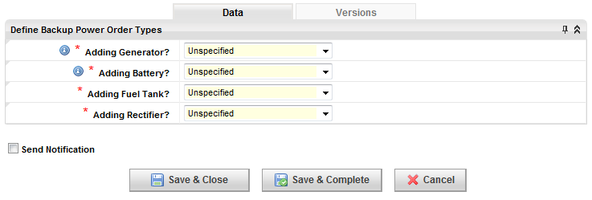

* + 11300 - RF Material Order - Approve and order RF material, commences following NTP for equipment ordering (20050).
    - 11300.1 Equipment Engineer Approval
      * Role: Regional Equipment Engineer (REE)
  + 11400 - Order Battery/Generator/Fuel Tank - Order back-up power options.
    - 11400.7 Enter PROJECTED GENERATOR DATA
      * Role: Regional Equipment Engineer (REE)
    - 11400.8 Enter PROJECTED BATTERY DATA
      * Role: Regional Equipment Engineer (REE)
    - 11400.9 Enter PROJECTED FUEL TANK DATA
      * Role: Regional Equipment Engineer (REE)
  + 11500 - Battery/Generator/Fuel Tank Set Install - Install back-up power options.
    - 11500.1 COMPLETE GENERATOR DATA
      * Role: Regional Equipment Engineer (REE)
    - 11500.2 COMPLETE BATTERY DATA
      * Role: Regional Equipment Engineer (REE)
    - 11500.3 COMPLETE FUEL TANK DATA
      * Role: Regional Equipment Engineer (REE)
    - 11500.4 Confirm RECTIFIER DATA entered in EMIS
      * Role: Regional Equipment Engineer (REE)
  + 11600 - BTS/Enode B Ordered - BTS/Enode B equipment ordered, commences following NTP for equipment ordering (20050).
    - 11600.1 BTS/E Node B Equipment Ordered
      * Role: Regional Equipment Engineer (REE)

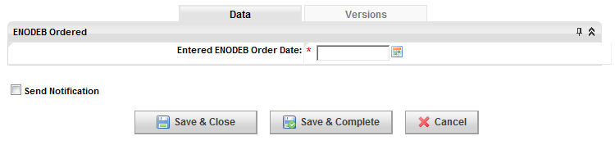

* + 11700 - Construction Start - Construction starts, commences following award of contract (12700).
    - 11700.1 Confirm Construction Start
      * Role: Regional Construction Engineer(RCE)
  + 11800 - Pad/Shelter/Platform Installed - Install pad/shelter/platform.
    - 11800.1 Confirm Pad/Shelter/Platform Installed
      * Role: Regional Construction Engineer(RCE)
  + 11900 - Backhaul Ordered - Order backhaul, commences following completion of backhaul design.
    - 11900.2 Backhaul Order Form
      * Role: Regional Transport Engineer(RTRSPRTE)
  + 12000 - Order Backhaul Equipment - Order backhaul equipment.
    - 12000.1 Confirm Backhaul Equipment Ordered
      * Role: Regional Transport Engineer(RTRSPRTE)
  + 12100 - Backhaul Equipment Installed - Install backhaul equipment.
    - 12100.1 Confirm Backhaul Equipment Installed
      * Role: Regional Transport Engineer(RTRSPRTE)
  + 12200 - BTS/Enode B Installed - Install BTS/Enode B.
    - 12200.1 BTS/E Node B Equipment Installed
      * Role: Regional Equipment Engineer (REE)
  + 12300 - Create Visual Monitoring Ticket - Create ticket for visual monitoring, commences following construction start (12800).
    - 12300.1 Create Visual Monitoring Ticket
      * Role: Regional Construction Engineer(RCE)

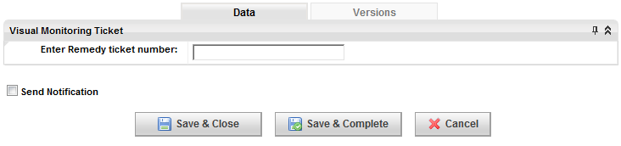

* + 12400 - Lines and Antennas Installed - Install lines and antennas.
    - 12400.1 Confirm Lines and Antennas Installed
      * Role: Regional Construction Engineer(RCE)
    - 12400.2 Antenna Placement and Orientation Verified
      * Role: Regional Performance Engineer(RSPE)
  + 12500 - Cell Site Router Ordered - Order cell site router.
    - 12500.1 Confirm Cell Site Router has been Ordered
      * Role: Regional Transport Engineer(RTRSPRTE)
    - 12500.2 Upload CSR Equipment PO
      * Role: Regional Transport Engineer(RTRSPRTE)
    - 12500.3 Upload CSR Installation PO
      * Role: Regional Transport Engineer(RTRSPRTE)
    - 12500.4 Upload CSR Quote
      * Role: Regional Transport Engineer(RTRSPRTE)
  + 12600 - Cell Site Router Installation - Install cell site router.
    - 12600.1 Confirm Cell Site Router Installed
      * Role: Regional Transport Engineer(RTRSPRTE)
  + 12700 - Cell Site Router Commissioned - Commission cell site router.
    - 12700.1 Confirm Cell Site Router Commissioned
      * Role: Regional Transport Engineer(RTRSPRTE)
  + 12800 - Construction Complete - Verify construction completion, commences following installation of lines and antennas (13900).
    - 12800.1 Sweeps Document
      * Role: Regional Construction Engineer(RCE)
    - 12800.2 Confirm Construction is Finished
      * Role: Regional Construction Engineer(RCE)
  + 12900 - Review Sweeps - Review sweeps, requires verification of construction complete.
    - 12900.2 Review Sweeps
      * Role: Regional Performance Engineer(RSPE)
  + 13000 - Backhaul Tested and Accepted - Test and accept backhaul, commences following installation of backhaul equipment (13700).
    - 13000.1 Test Data
      * Role: Regional Cell Tech(RCT)
    - 13000.2 Confirm Backhaul Tested and Accepted
      * Role: Regional Cell Tech(RCT)
  + 13100 - Construction Complete with Backhaul Integrated - Confirm construction complete with backhaul integrated.
    - 13100.1 Confirm Construction Complete with Backhaul Integrated
      * Role: Regional Construction Engineer(RCE)
  + 13200 - Microwave Frequency Coordination Cleared - Clear microwave frequency coordination, commences following installation of backhaul equipment (13700).
    - 13200.1 Confirm Frequency Coordination Cleared
      * Role: HQ Regulatory RF Compliance(HQRRFC)
  + 13300 - Confirm E911 Complete - Confirm completion of E911.
    - 13300.1 Upload Completed TVW
      * Role: Regional RF Engineering(RRFE)
  + 13400 - Post-TCN Process – 39 - Confirm completion of Post-TCN process – 39
    - 13400.1 Post-TCN Form
      * Role: Regional Construction Engineer(RCE)

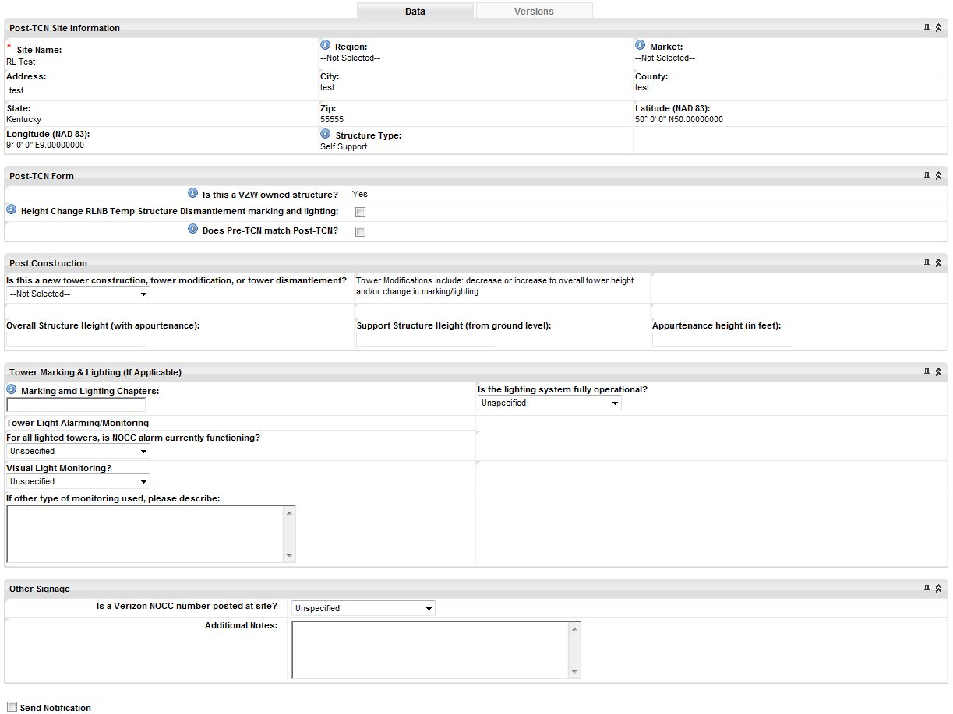

* + - 13400.2 Post-TCN Construction Review
      * Role: HQ Regulatory Structure Compliance(HQRSC)

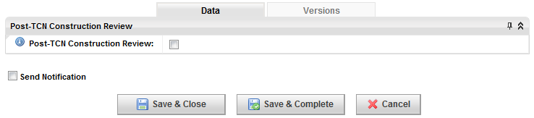

* + - 13400.3 Confirm FAA Notified
      * Role: HQ Regulatory Structure Compliance(HQRSC)
    - 13400.4 Confirm FCC Notified
      * Role: HQ Regulatory Structure Compliance(HQRSC)
    - 13400.5 Update Sign Posting Photo
      * Role: Regional Construction Engineer(RCE)
  + 13500 - Site/Cluster Optimization - Perform site/cluster optimization.
    - 13500.1 Optimization Report
      * Role: Regional Performance Engineer(RSPE)
    - 13500.2 Optimization Approval
      * Role: Regional Performance Engineer(RSPE)
  + 13600 - On Air - Perform activation process for on air, commences following 850 IS-14 (4500), Review sweeps (14100), AWS IS-12 (4300), Confirm E911 complete (15800), and 700 IS-11 (4200).
    - 13600.1 On Air Notice
      * Role: Regional Performance Engineer(RSPE)
    - 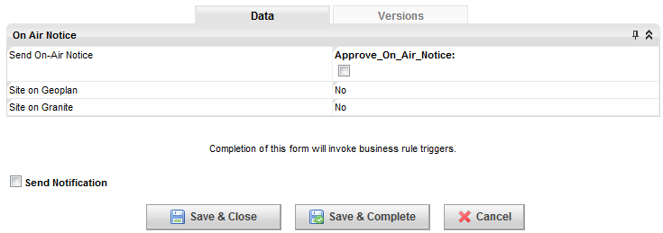
    - 13600.2 Submit Activation Notice for 700
      * Role: Regional Performance Engineer(RSPE)
    - 13600.3 Submit Activation Notice for 850
      * Role: Regional Performance Engineer(RSPE)
    - 13600.4 Submit Activation Notice for PCS
      * Role: Regional Performance Engineer(RSPE)
    - 13600.5 Submit Activation Notice for CDMA
      * Role: Regional Performance Engineer(RSPE)
    - 13600.6 On Air Notice Form
      * Role: Regional Performance Engineer(RSPE)
  + 13700 - Punch Walk Items Complete - Punch walk items complete, commences following On Air (16300).
    - 13700.1 Final Site Inspection/Acceptance Punch list/Inspection Reports
      * Role: Regional Construction Engineer(RCE)
  + 13800 - RFE Compliance Complete - RFE compliance complete, commences following RFE compliance analysis (8901) and on air (16300).
    - 13800.1 RFE Compliance Closeout
      * Role: Regional RF Engineering(RRFE)
  + 13900 - Environmental Asset Verification - Verify environmental assets, commences following backup power installation (12300).
    - 13900.1 Tech Completes Environmental Site Verification in EMIS
      * Role: Regional Cell Tech(RCT)
    - 13900.2 Confirm Equipment Photos uploaded in EMIS
      * Role: Regional Cell Tech(RCT)
  + 14000 - Close Out Documents - Compile close out documents, commences following on air (16300).
    - 14000.1 GC Warranty Document
      * Role: Regional Construction Engineer(RCE)
    - 14000.2 Emergency Numbers
      * Role: Regional Construction Engineer(RCE)
    - 14000.3 Emergency Checklist
      * Role: Regional Construction Engineer(RCE)
    - 14000.4 Injury Report
      * Role: Regional Construction Engineer(RCE)
    - 14000.5 Meeting Record
      * Role: Regional Construction Engineer(RCE)
    - 14000.6 Project Notes
      * Role: Regional Construction Engineer(RCE)
    - 14000.7 General Liability Report
      * Role: Regional Construction Engineer(RCE)
    - 14000.8 Vehicle Accident Report
      * Role: Regional Construction Engineer(RCE)
    - 14000.9 Sub-Unconditional Waiver & Release Upon Final Payment
      * Role: Regional Construction Engineer(RCE)
    - 14000.10 Approved Permitting Set of Drawings (.pdf)
      * Role: Regional Construction Engineer(RCE)
    - 14000.11 Agenda/Notes/Minutes from Pre-Construction Meeting
      * Role: Regional Construction Engineer(RCE)
    - 14000.12 Reinforcement Certification (Mill Certification)
      * Role: Regional Construction Engineer(RCE)
    - 14000.13 Concrete Mix Design & Product data (Tower Foundation)
      * Role: Regional Construction Engineer(RCE)
    - 14000.14 Special Inspection/City Inspection Card
      * Role: Regional Construction Engineer(RCE)
    - 14000.15 Cell Site Utility Setup
      * Role: Regional Construction Engineer(RCE)
    - 14000.16 EES Closeout Form
      * Role: Regional Construction Engineer(RCE)
    - 14000.17 Structure Backfill Test Results (if applicable)
      * Role: Regional Construction Engineer(RCE)
    - 14000.18 As-Built Construction Drawings (.pdf Format)
      * Role: Regional Construction Engineer(RCE)
    - 14000.19 As-Built Construction Drawings (.dwg Format)
      * Role: Regional Construction Engineer(RCE)
    - 14000.20 GC Unconditional Waiver & Release
      * Role: Regional Construction Engineer(RCE)
    - 14000.21 Confirm Close-Out Documents
      * Role: Regional Construction Engineer(RCE)
  + 14100 - RF Validation - Validate RF, commences following back-up power install.
    - 14100.1 Update RF Config
      * Role: Regional RF Engineering(RRFE)
* Site Termination
  + End users will be notified to proceed with Site Termination in the To-Dos/Activity quick link under My Siterra and in the Projects section of the Site home page.

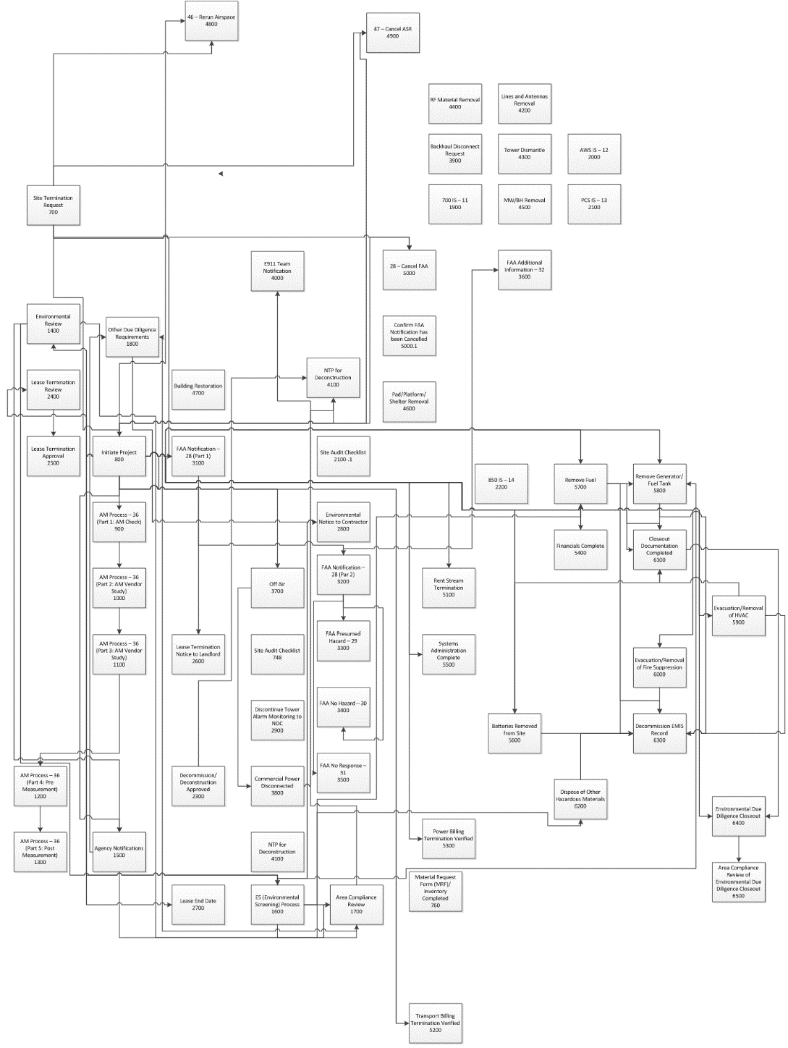

* + 700 - Site Termination Request - Site Termination process commences with Request for Termination form.
    - 700.1 Site Termination Request Form
      * Role: Regional Real Estate Specialist (RRES)

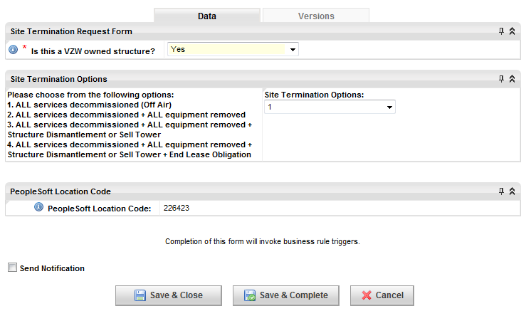

* + 800 - Initiate Project - Initiate project form is issued for the site termination.
    - 800.1 Initiate Project Form
      * Role: Regional Real Estate Specialist (RRES)

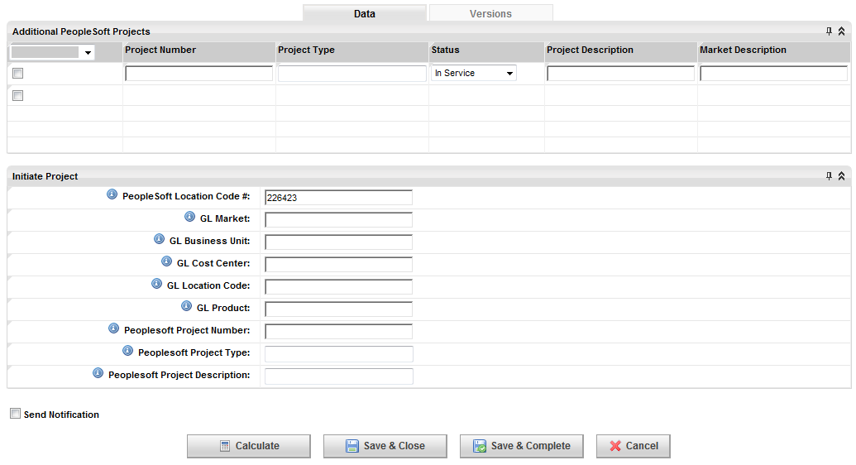

* + 900 - AM Process - 36 (Part 1: AM Check) - First part of the AM Process commences upon completion of Initiate Project form, allowing the user to proceed with AM Check.
    - 900.1 Run AM Check
      * Role: Regional Regulatory Analyst(RRA)

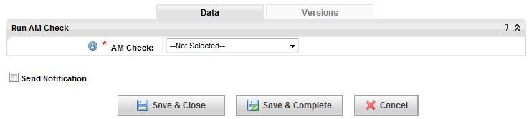

* + - 900.2 Upload AM Pass Certificate (PDF)
      * Role: Regional Regulatory Analyst(RRA)
    - 900.3 Confirm AM Study Ordered from Vendor
      * Role: Regional Construction Engineer(RCE)
  + 1000 - AM Process - 36 (Part 2: AM Vendor Study - The second part of the AM Process confirms the completion of the Vendor Study.
    - 1000.1 Confirm Job Accepted
      * Role: Regional Regulatory Analyst(RRA)
    - 1000.2 AM Form
      * Role: Regional Regulatory Analyst(RRA)

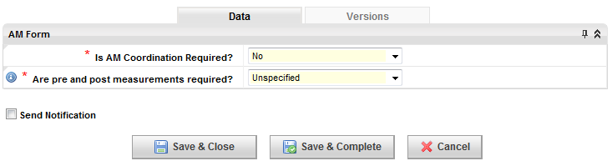

* + 1100 - AM Process - 36 (Part 3: AM Letter) - The third task in the AM Process is the confirmed delivery and response to the AM Station Letter.
    - 1100.1 Confirm Letter send to AM Station
      * Role: Regional Regulatory Analyst(RRA)
    - 1100.2 Upload AM Letter to AM Station
      * Role: Regional Regulatory Analyst(RRA)
    - 1100.3 AM Station Response
      * Role: Regional Regulatory Analyst(RRA)



* + 1200 - AM Process - 36 (Part 4: Pre Measurement) - Fourth in the AM Process, upload the Pre AM Measurement Study.
    - 1200.1 Upload Pre AM Measurement Study
      * Role: Regional Regulatory Analyst(RRA)
  + 1300 - AM Process - 36 (Part 5: Post Measurement) - Finally, step five in the AM Process is uploading the Post Measurement Study.
    - 1300.1 Upload Post AM Measurement Study
      * Role: Regional RF Engineering(RRFE)
  + 1400 - Environmental Review - The Environmental Review Process commences following Project Initiation (800).
    - 1400.1 Review and document Environmental Conditions (EMIS & Phase 1, Phase 2 Documentation)
      * Role: Area Environmental Compliance(AEC)
    - 1400.2 Applicability of Agency Notification requirements
      * Role: Area Environmental Compliance(AEC)

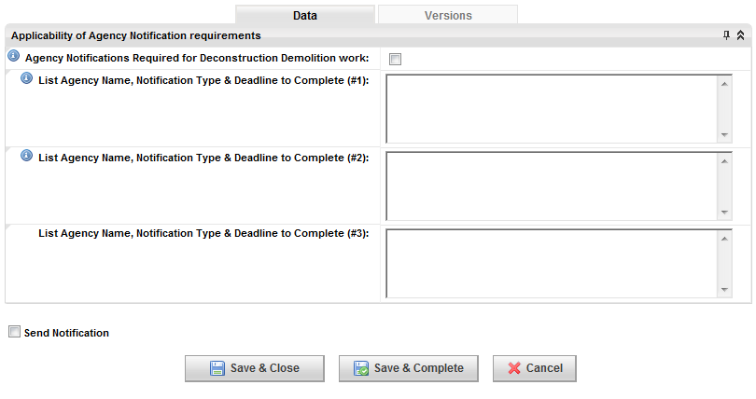

* + 1500 - Agency Notifications - Agency notifications can be completed following the Environmental Review (1400).
    - 1500.1 Completion of Agency Notifications
      * Role: Regional Real Estate Specialist (RRES)
  + 1600 - ES (Environmental Screening) Process - The Environmental Screening (ES) commences following the completion of the Environmental Review (1400).
    - 1600.1 Completion of the ES Form
      * Role: Regional Real Estate Specialist (RRES)
  + 1700 - Area Compliance Review - The Area Compliance Review commences following the completion of the Environmental Review (1400), Agency Notifications (1500), and Environmental Screening (1600).
    - 1700.1 Area Compliance Environmental Assessment
      * Role: Area Environmental Compliance(AEC)

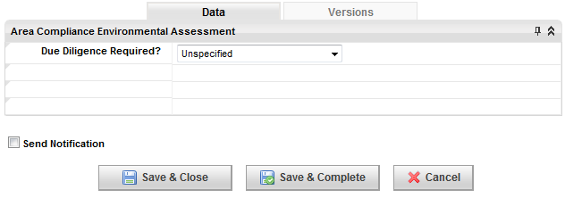

* + 1800 - Other Due Diligence Requirements - Other Due Diligence Requirements may be initiated following Agency Notifications (1500) and Area Compliance Review (1700)
    - 1800.1 Upload Notice to Contractor
      * Role: Area Environmental Compliance(AEC)
    - 1800.2 Upload Other Due Diligence Requirements
      * Role: Area Environmental Compliance(AEC)
  + 1900 - 700 IS – 11 - National Incident Management System (NIMS) approved.
    - 1900.1 Call Sign 1 Approved
    - 1900.2 Call Sign 2 Approved
    - 1900.3 Call Sign 3 Approved
    - 1900.4 Call Sign 4 Approved
  + 2000 - AWS IS – 12 - Amazon Web Services (AWS) information system approved.
    - 2000.1 Call Sign 1 Approved
    - 2000.2 Call Sign 2 Approved
    - 2000.3 Call Sign 3 Approved
    - 2000.4 Call Sign 4 Approved
    - 2000.5 Call Sign 5 Approved
  + 2100 - PCS IS – 13 - Permit Compliance System information system approved.
    - 2100.1 Call Sign 1 Approved
    - 2100.2 Call Sign 2 Approved
    - 2100.3 Call Sign 3 Approved
    - 2100.4 Call Sign 4 Approved
    - 2100.5 Call Sign 5 Approved
    - 2100.6 Call Sign 6 Approved
    - 2100.7 Call Sign 7 Approved
    - 2100.8 Call Sign 8 Approved
  + 2200 - 850 IS – 14 - 850 information system approved.
    - 2200.1 Call Sign 1 Approved
    - 2200.2 Call Sign 2 Approved
    - 2200.3 Call Sign 3 Approved
    - 2200.4 Call Sign 4 Approved
  + 2300 - Decommission/Deconstruction Approved - Decommission/Deconstruction approved.
    - 2300.1 Decommission/Deconstruction Environmental Approval
      * Role: Area Environmental Compliance(AEC)
  + 2400 - Lease Termination Review
  + 2500 - Lease Termination Approval
  + 2600 - Lease Termination Notice to Landlord
  + 2700 - Lease End Date
  + 2800 - Environmental Notice to Contractor
  + 2900 - Discontinue Tower Alarm Monitor
  + 3000 - Removal of FCC ASR Signage
  + 3100 - FAA Notification (Part I)
  + 3200 - FAA Notification (Part II)
  + 3300 - FAA Presumed Hazard
  + 3400 - FAA No Hazard
  + 3500 - FAA No Response
  + 3600 - FAA Additional Information
  + 3700 - Off Air
  + 3800 - Commercial Power Disconnected
  + 3900 - Backhaul Disconnect Request
  + 4000 - E911 Team Notification
  + 4100 - NTP for Deconstruction
  + 4200 - Lines and Antennas Removal
  + 4300 - Tower Dismantle
  + 4400 - RF Material Removal
  + 4500 - MW/BH Removal
  + 4600 - Pad/Platform/Shelter Removal
  + 4700 - Building Restoration
  + 4800 - Rerun Airspace
  + 4900 - Cancel ASR
  + 5000 - Cancel FAA
  + 5100 - Rent Stream Termination
  + 5200 - Transport Billing Termination Verified
  + 5300 - Power Billing Termination Verified
  + 5400 - Financials Complete
  + 5500 - Systems Administration Complete
  + 5600 - Batteries Removed from Site
  + 5700 - Remove Fuel
  + 5800 - Removal of Generator/Fuel Tank
  + 5900 - Evacuation and Removal of HVAC
  + 6000 - Evacuation and Removal of Fire Suppression
  + 6100 - Closeout Documentation Completed
  + 6200 - Dispose of Other Hazardous Materials
  + 6300 - Decommission EMIS Record
  + 6400 - Environmental Due Diligence Closeout
  + 6500 - Area Compliance Review of Environmental Due Diligence Closeout